ANNEXE 20 : Étapes du traitement de l'eau

Nom : __________________________________ Date : ________________________

À partir du schéma suivant, décris le rôle de chaque étape dans le traitement de l'eau.

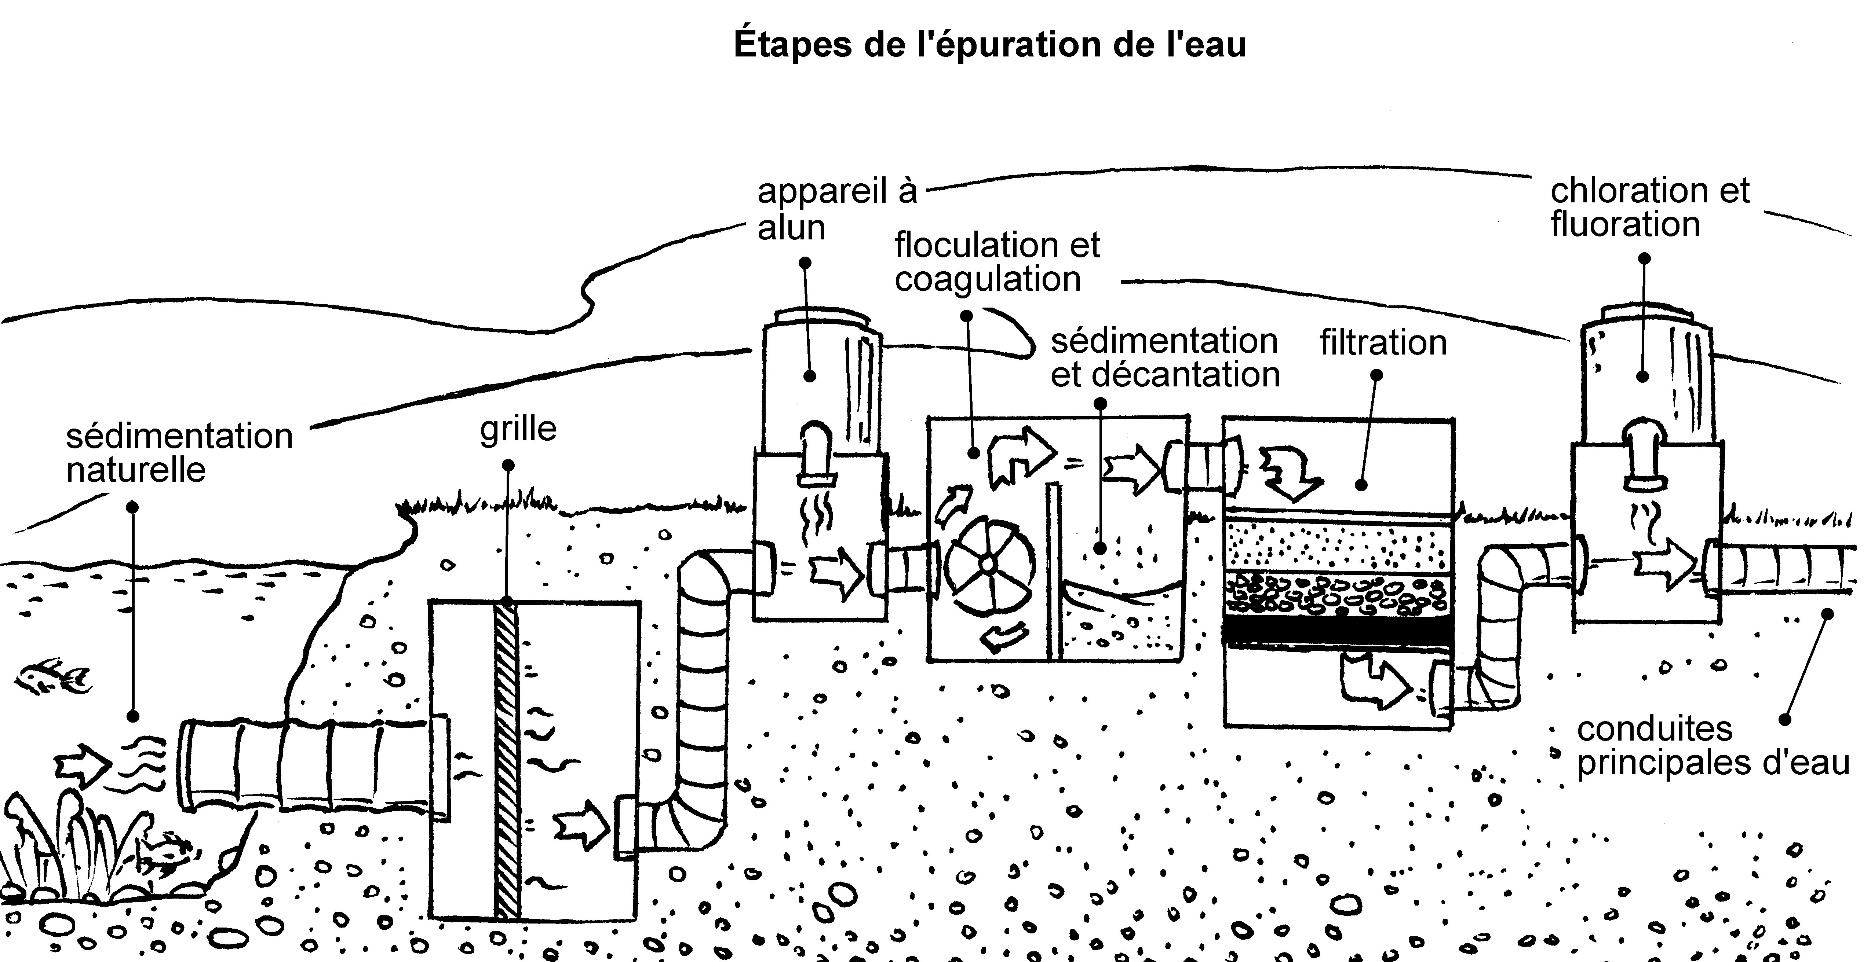

L'ajout de produits chimiques tels que l'alun : _____________________________________________
_________________________________________________________________________________
_________________________________________________________________________________
_________________________________________________________________________________
_________________________________________________________________________________

La floculation et la coagulation : _______________________________________________________
_________________________________________________________________________________
_________________________________________________________________________________
_________________________________________________________________________________
_________________________________________________________________________________

ANNEXE 20 : Étapes du traitement de l'eau (suite)

Nom : __________________________________ Date : ________________________

La sédimentation : __________________________________________________________________
_________________________________________________________________________________
_________________________________________________________________________________
_________________________________________________________________________________
_________________________________________________________________________________

La décantation : ____________________________________________________________________
_________________________________________________________________________________
_________________________________________________________________________________
_________________________________________________________________________________
_________________________________________________________________________________

La filtration : _______________________________________________________________________
_________________________________________________________________________________
_________________________________________________________________________________
_________________________________________________________________________________
_________________________________________________________________________________

La chloration : _____________________________________________________________________
_________________________________________________________________________________
_________________________________________________________________________________
_________________________________________________________________________________
_________________________________________________________________________________

La fluoration : ______________________________________________________________________
_________________________________________________________________________________
_________________________________________________________________________________
_________________________________________________________________________________
_________________________________________________________________________________

