Appendix 4a Jeu du serpentin

The game described below can be used throughout the school year and with any theme. The key is to prepare the students by modeling the games and by using the linguistic structures that the students have already used and reused on numerous occasions. It is important that students are already experiencing success with the targeted linguistic structures required to play any game. Games are not a tool for teaching French; they are a way for students to show what they already know.

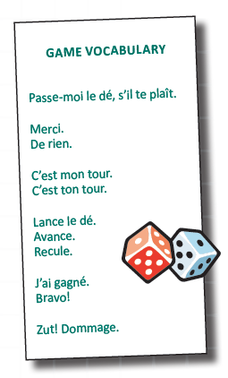
PREPAR ATION:
1 . Enlarge the image of the snake game board found on page 65 or use an interactive white board.
2 . Prepare pictures of thematic vocabulary that students can use in complete sentence and place one in
each square (use sticky notes). If using the images from the guide Au Manitoba, on s’amuse, be sure to
cut off the written word. This is a learning situation for oral communication, not reading.
3 . Find a spongy dice to play the game.

DAY 1:
1 . Model how to play the game by having the class play against the teacher.
2 . Slowly introduce some of the game vocabulary found in the box to the right (not all at once).
3 . Throw the dice and take your turn.
4 . Count the spaces en français.
5 . Use the illustrated vocabulary word in a complete sentence, in the context of a linguistic structure
that students have already been using and reusing. (e.g., Voici le chat. C’est un chat brun. J’aime les
bananes. Je n’aime pas les pommes.)

DAY 2:
1 . Explain student expectations (e.g., J’écoute bien. Je parle français).
2 . Remodel how to play the game with two student volunteers who will use the thematic vocabulary in
complete sentences.
3 . Replay the game; however this time, guide the students as they play in two teams.
4 . Remind the students to use the game vocabulary. Each time that the game is played, a new game
word can be introduced.

63
Annex es/ Appendix

64
Fr anç ais p our le s je une s dé but ant s - Mate r ne lle à la 3 e anné e /E ar ly St ar t Fr e nc h - K inde r gar te n to G r ade 3

Annexe 4a Jeu du serpentin Appendix 4a Jeu du serpentin

6 7

11 Départ
Z

12
5 arrIvée
8
13
10

1

4 9

3 2

65
Annex es/ Appendix

6 7

11 DÉPART
Z

12
5 ARRIVÉE

8
13
10

1

4 9

3 2

