P = dents permanentes

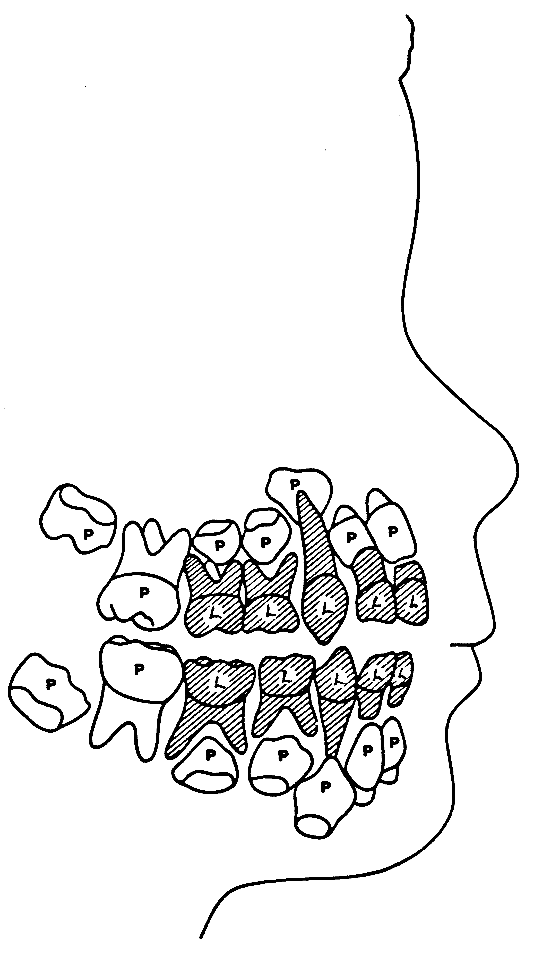
L = dents de lait

