 |  | 
INFLAMMABLE |  | CORROSIF

DANGER D’INHALATION
 |  | 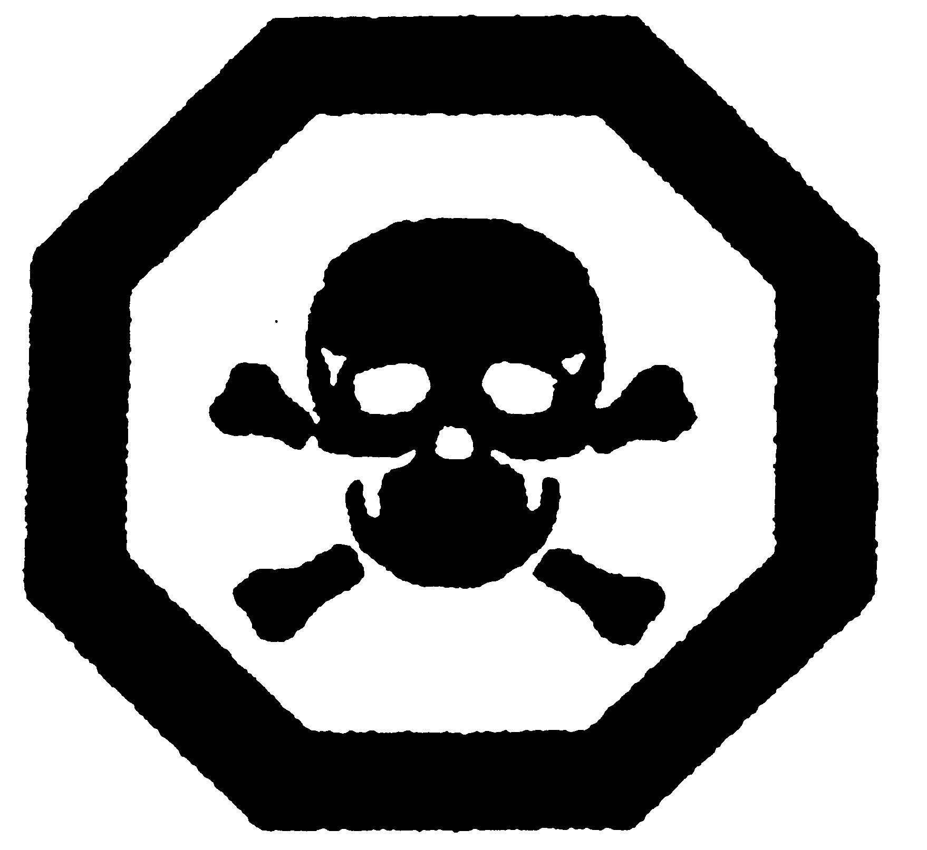
EXPLOSIF |  | POISON

