
Professional Learning Experience

Principles – INQUIRY

OVERVIEW
“Inquiry education is where… we can create opportunities for students to be engaged in active learning based on their own questions.”
http://www.inquiry.uiuc.edu/inquiry/definition.php
"For students, this method of learning ends the listen-to-learn paradigm of the classroom and gives them a real and authentic goal challenges to overcome. For the teacher, inquiry-based education ends their paradigm of talking to teach and recasts them in the role of a colleague and mentor engaged in the same quest as the other younger learners around." http://www.ncsa.uiuc.edu/Cyberia/DVE/FusionDVE/html/ inquiry_based_education.html

“Inquiry is embedded in language arts as inquiry-based learning, in mathematics as problem solving in the context of data analysis, in science as scientific inquiry and the design process, and in social studies as social studies skills.”

Literacy with ICT Across the Curriculum: A Continuum Model. Winnipeg, MB: Manitoba Education, Citizenship and Youth, 2006. P. 11.

GUIDING QUESTION(S)
- Why should I consider an inquiry-based approach to learning with my students?
- How can I use the Inquiry Process across the curriculum?

CONTINUUM / CURRICULUM CONNECTION:
Continuum for Literacy with ICT
Cognitive Domain
English Language Arts
General Outcome 3
Science
Cluster 0
Social Studies
Skills

SUGGESTED LEARNING RESOURCES
Print:
Manitoba Education and Training. Grades 5 to 8 English Language Arts: A Foundation for Implementation. Winnipeg, MB: Manitoba Education and Training, 1998.
---. Grades K to 4 English Language Arts: A Foundation for Implementation. Winnipeg, MB: Manitoba Education and Training, 1994.
Manitoba Education and Youth. Kindergarten to Grade 8 Social Studies: Manitoba Curriculum Framework of Outcomes. Winnipeg, MB: Manitoba Education and Youth, 2003.

Black Line Masters
Literacy with ICT and Inquiry Processes Across the Curriculum
Planning an Inquiry
Feelings in Inquiry
Constructing Student-Generated Criteria for Quality Work
Observation Checklist for Skimming and Scanning Skills
The Four-Column Planner

Information Links:
Concept to Classroom. What is Inquiry-Based Learning?
- concise description of the concept, how it differs from traditional teaching, benefits for the classroom. Includes video-clips.
http://www.thirteen.org/edonline/concept2class/inquiry/index.html
Lamb, Annette. Project, Problem, and Inquiry-Based Learning
- explanation of each approach, how they are alike and different, and which one might be best for an IT-rich classroom
http://annettelamb.com/tap/topic43.htm

Models of Inquiry Links
Alberta Learning. Learning and Teaching Resources Branch. Focus on Inquiry: A Teacher’s Guide to Implementing Inquiry-Based Learning. 2004.
- the newest version of this step-by-step implementation guide. Manitoba teachers will recognize curricular connections because some Manitoba and Alberta curriculum was developed within the Canadian Western and Northern Protocol. Downloadable in pdf.
http://education.alberta.ca/media/313361/focusoninquiry.pdf
Eisenberg, Mike and Bob Berkowitz. What is the Big6?
- the six steps outlined and hyperlinks to support resources. The Big6 is often mentionned in the ELA Foundation for Implementation document.
http://big6.com/pages/about/big6-skills-overview.php
Manitoba Education and Youth. Independent Together: Supporting the Multilevel Learning Community. Winnipeg, MB: Manitoba Education and Youth, 2003.
- see Chapter 6: Integrated Learning through Inquiry : A Guided Planning Model. Based on the Manitoba Curriculum.
- see also Appendix B: Planning Model
http://www.edu.gov.mb.ca/k12/docs/support/multilevel/index.html
Ontario School Library Association (OSLA). Information Studies: K-12. Appendix A: A Research-Based Information Problem-Solving Process Models.
- this chart compares the Ontario process to other known processes outlined.
http://www.accessola.com/action/positions/info_studies/html/appndxa.html

Reference Links:
Bruce, Bertram C. and Judith Davidson. An Inquiry Model for Literacy Across the Curriculum. Urbana, Il: University of Illinois, 1996.
https://www.ideals.illinois.edu/bitstream/handle/2142/13346/inquiry_model_for_literacy.pdf?sequence=2

See also: related professional learning experiences in WebCT
- Topics – COLLABORATION
- Topics – NOTEMAKING
- Topics – PLAGIARISM
- Topics – MAKING A BIBLIOGRAPHY

SUGGESTIONS FOR LEARNING
Activating My Prior Knowledge:
- Brainstorm what you currently know about Inquiry and the Inquiry Process. Use mind mapping software to represent your ideas.
- Visit Concept to Classroom and Lamb’s sites, listed above to find out about Inquiry.
- Review your brainstorming notes. Update them to include new knowledge acquired during your readings.
- Note questions you have about the Inquiry Process for which you would like answers or statements for which your would like clarification.

Acquiring Information:
- Finding out the basic information about an Inquiry Process
- Visit the websites in the Models of Inquiry Links. Look especially at the steps for Inquiry outlined on page 20 of the Alberta document and represented as a jigsaw wheel, the Big6 of Eisenberg, ‘Appendix B’ from Independent Together, the curricular chart from OSLA, and the curricular chart form the LwICT document (available below as a BLM). Did you notice that the steps of Inquiry and the vocabulary or labels used to name them are very similar? While there may be more or fewer steps, and while they may be called slightly different names (likely synonymous with one another), people engaging in Inquiry will likely follow similar processes.
- Learning more about the Inquiry Process
  - Read Chapter 6 of Independent Together. Note processes you are already using with your students. Note processes that are new to you and observe how they are integrated with each other.
  - If you want a more in-depth look at the process, or some parts of it, read Alberta’s Focus on Inquiry.

Applying in My Classroom:
- What does Inquiry look like in my classroom?
- Use BLM – The Four-Column Planner to plan an Inquiry. Look up Appendix B from Independent Together for suggestions on planning the third column.
- When you have engaged in a few successful Inquiries, use BLM – Literacy with ICT and Inquiry Processes Across the Curriculum to plan an integrated inquiry.
- See the TOPICS – Collaboration Professional Learning Experience to set up a classroom environment conducive to Inquiry.
- How do I get my students involved in Inquiry?
- Find out if other teachers if your school have selected a given model for Inquiry Process to be used school-wide? Within a school, it is helpful that teachers select a model and use it in every classroom. This will make it easier for students to be familiar with the process as there is continuity between classrooms and every year.
- Any topic in the curriculum lends itself to an Inquiry Process. If you are starting such a process, consider a short Inquiry and select a topic you are familiar and comfortable with, and one for which you have several resources.
- Consider planning with another class and sharing resources. Plan with your teacher-librarian if there is one in your school.
- To achieve a measure of success, students need to be taught the competencies involved in the Inquiry Process and they need guided practice in those competencies: accessing different information tools, notemaking, categorizing, assessing content based on criteria. Follow the process described in BLM – Planning for Inquiry. Review this process often until students are familiar with it and can follow its steps accurately and effectively.
- Read BLM – Feelings in Inquiry to become familiar with behaviour you can expect from your students in order to plan to offer them support when they need it most.
- What resources can be used to support my Inquiry planning?
  - Visit the Implementation Links and become familiar with the resources available there, such as BLMs, tools, and tips.

Implementation Links
Arkos, Helen and Wendy Sutton. Integration Station: Integrating Technology into Resource-Based Learning.
- this site, developed by teacher-librarians, is arranged following the steps of Inquiry.
http://adelaspace.tripod.com/Intergation/html/contact.htm and http://sunshinevirtuallibrary.blogspot.ca/2008/11/teacher-librarian-resources.html
Kuhlthau, Carol C. Models of the Stages of the Information Process. Arcata, CA: Humboldt State University Library.
- this model is important because it describes the feelings students experience as they engage in the inquiry process. Understanding this informs the teacher on steps to take to better enable the process.
http://library.humboldt.edu/ic/general_competency/kuhlthau.html
Manitoba Education and Youth. Independent Together: Supporting the Multilevel Learning Community. Winnipeg, MB: Manitoba Education and Youth, 2003.
- guided planning Model for Inquiry, based on the Manitoba Curriculum
http://www.edu.gov.mb.ca/ks4/docs/support/multilevel/chap6.pdf
Ontario School Library Association. Information Studies: K-12. ‘Inquiry and Research’.
- this page gives an overview of Inquiry within the curricular context.
http://www.accessola.com/action/positions/info_studies/html/research.html
Stimson, Margaret. Infozone Research Skills Area. Pembina Trails School Division, 2006.
- developed by a teacher-librarian, this site is arranged by steps of inquiry.
http://www.pembinatrails.ca/program/MediaCentre/Infozone/index.htm

Project Links
Galileo Educational Network Association. Student and Teacher Projects.
- The projects featured here are all Inquiry-based.
http://www.galileo.org/tips/inquiry.html

SUGGESTIONS FOR ASSESSMENT
- Personal Journaling:
  - What have I learned that I was not previously aware of?
  - What has been clarified?
  - What do I want to pursue to find out more?
  - Is there any issue I feel I should share with my colleagues? How to I plan to do that?
- Providing Feedback:
  - Please share with the Literacy with ICT project team, any issue that was not clear, any questions you have, or suggestions for a future update.
- Observing Students:
  - How does using the Inquiry Process with my students help me to release responsibilitiy for learning in their hands?
  - How does using the Inquiry Process with my students help them work towards becoming independent learners?
  - Both assessment of self and others, and teacher observation of student behaviour serve to inform the evaluation process. While students work as a group, the contribution of each student must be noted and reflected in each individual evaluation.
  - Use BLM – Constructing Student-Generated Criteria for Quality Work.
  - Use BLM – Observation Checklist for Skimming and Scanning Skills to note how effective students are at finding relevant information.
  - Use the BLMs listed in related Professional Learning Experiences to observe student behaviour as they follow an Inquiry Process.

BLM – Literacy with ICT and Inquiry Processes
Across the Curriculum

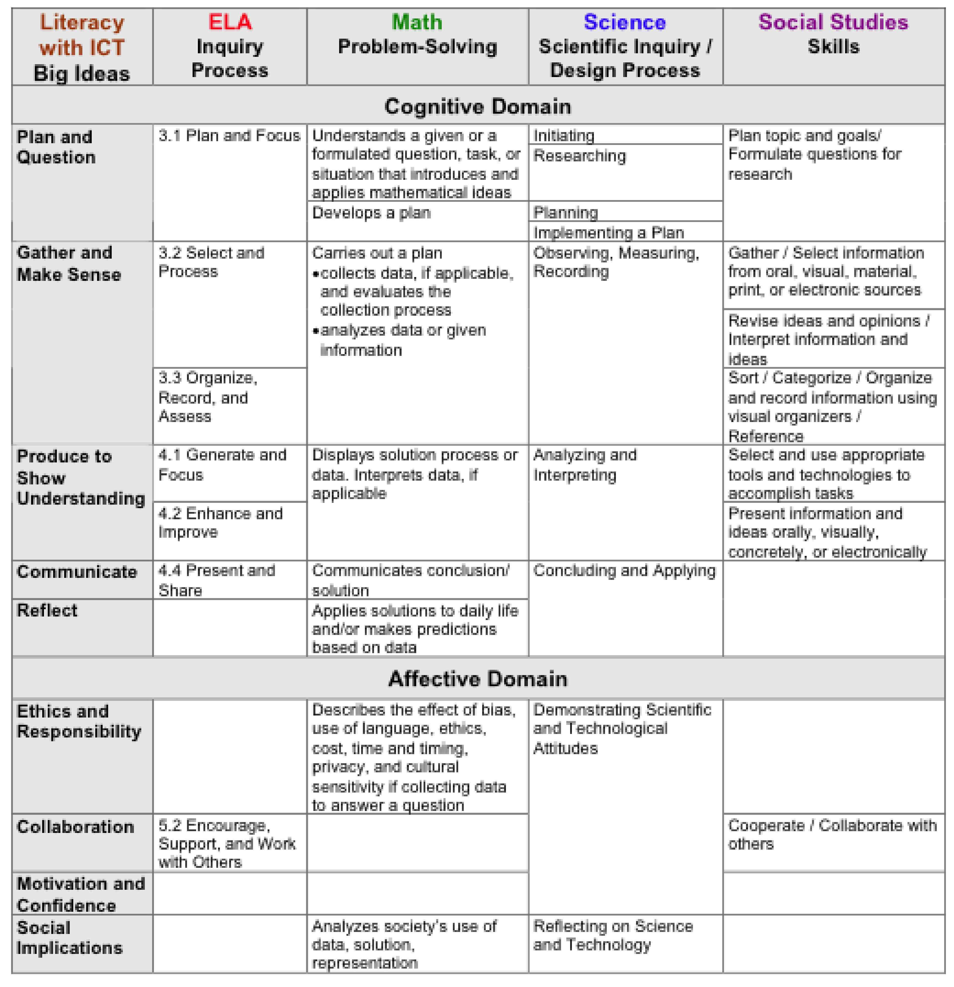

Reproduced from Literacy with ICT Across the Curriculum, p. 12.

BLM – Planning an Inquiry

Planning for a successful Inquiry involves establishing a structure, helping students acquire essential skills that will facilitate the Inquiry Process, teaching them, with sufficient practice time, a methodology that they will continue to use as independent learners. Setting such a framework will also support the students as they experience a range of feelings associated with the Inquiry Process (See BLM – Feelings in Inquiry).

It is important to note that the following process is essentially them same, whether in Early Years students or High School. Students at each of these levels will need instruction in skills that are specific to that level. As the complexity of skills increases with the years, students still need some scaffolding.

- Brainstorm with the class to determine their collective knowledge on a given topic. Students share their personal knowledge and formulate relevant questions appropriate to the audience and purpose of the inquiry. (P-1.1, 2.1, 3.1)
- Follow or modify a plan to organize and guide the inquiry. (P-1.2, 2.2, 3.2)
- Have students seek answers to inquiry questions using a variety of information sources including print, oral, visual, and electronic sources. (G-1.1, 2.1)
- Model and provide guided practice in the use of reference tools (e.g., atlases, encyclopedia, etc.). (G-1.1, 2.1)
- Model how to and develop with the class, criteria for assessing the accuracy, currency, reliability, and usefulness of information. (G-2.2)
- Model and provide guided practice in writing a bibliography. (G-1.2)
- Model and provide guided practice in the use comprehension strategies such as SQ3R or Skim and Scan to enable students to make sense of information and use a notemaking strategy such as Summarizing, Two Column Notes, Cornell or Slim Jims. (G-1.3, 2.2, 2.5)
- Model and provide guided practice to help students organize and record their information in categories using a variety of strategies such as compare/contrast, cause and effect, main idea/details, problem/solution, sequence, hierarchical map, step map, Pyramid Map, Stages of Development Map, or story map. (G-2.3)
- Model and provide guided practice to help students recognize gaps in the information they have gathered by referring to the plan or organizational frame used. Assist students to locate additional information. (G-2.4)

See also related files:
- Topics – NOTEMAKING
- Topics – PLAGIARISM
- Topics – MAKING A BIBLIOGRAPHY

See also related information on strategies mentionned in this BLM in:
- Manitoba Education and Training. English Language Arts: Foundation for Implementation. Strategies That Make a Difference.
- Manitoba Education and Training. Success for All Learners: A Handbook on Differentiating Instruction.

BLM – Feelings in Inquiry

As students engage in an Inquiry Process, they experience a range of feelings that teachers need to be aware of. Dr. Kuhlthau observed students and identified those feelings and when they tended to occur.

This informs teachers that what they observe in students is normal and to be expected. It allows the teacher to plan ahead to meet the needs of the students and offer support when they need it to carry them through to a happy conclusion.

Students who are scaffolded and can use inquiry tools effectively (See BLM – Planning an Inquiry) will tend to show a lesser range of feelings and will be more confident throughout the process.

Inquiry | Question | Plan | Gather |  | Make Sense | Produce | Communicate | Reflect
Feelings | Uncertain | Optimistic |  | Confused  Frustrated  Doubtful |  | Clarity | Direction  Confidence | Satisfaction  Disappointment

References:

Alberta Learning. Focus on Inquiry. 2004.
http://education.alberta.ca/media/313361/focusoninquiry.pdf

Humboldt State University Library. Kuhlthau's Model of the Stages of the Information Process. 1993.
http://library.humboldt.edu/ic/general_competency/kuhlthau.html

BLM – Constructing Student-Generated Criteria for Quality Work

The process of constructing student-generated criteria for quality work is a four- to six-week learning-teaching sequence. Develop only three to five criteria to reflect the targeted learning outcomes or essential learnings. Keep in mind that “less is more.”

- Clarify the purpose of a task and target the appropriate learning outcome(s).

- Share “exemplary” models of quality work.

- Guide students to identify and respond to “What’s powerful?” from a model or exemplar.

- Invite students to share “What’s powerful?” from their own work. Discuss “What is quality work?”

- Record responses on a class experience chart.
A quality _______________ looks/sounds like:

- Continue to chart responses over several days/weeks to “see” the differences and gain a grounded sense of the qualities, characteristics, and development of the criteria.

- Use charted responses to Sort and Predict the BIG ideas (significant aspects of the task, essential questions, skills or behaviours being assessed). Repeat this process throughout the theme or unit over four to six weeks to enhance and deepen reflective thinking and raise expectations for quality work.

- Post a checklist or T-chart such as the following:

Criteria for Quality Work | Met (M) | Not Yet Met (NY)

- Have students use the checklist or T-chart for self-assessment and peer assessment. Use the same criteria for monitoring observations and summative assessments.

- Revise criteria constantly as learning becomes more sophisticated, always raising the bar.

___________
Reproduced from Independent Together: Supporting the Multilevel Learning Community. BLM-2
BLM – Observation Checklist
for Skimming and Scanning Skills

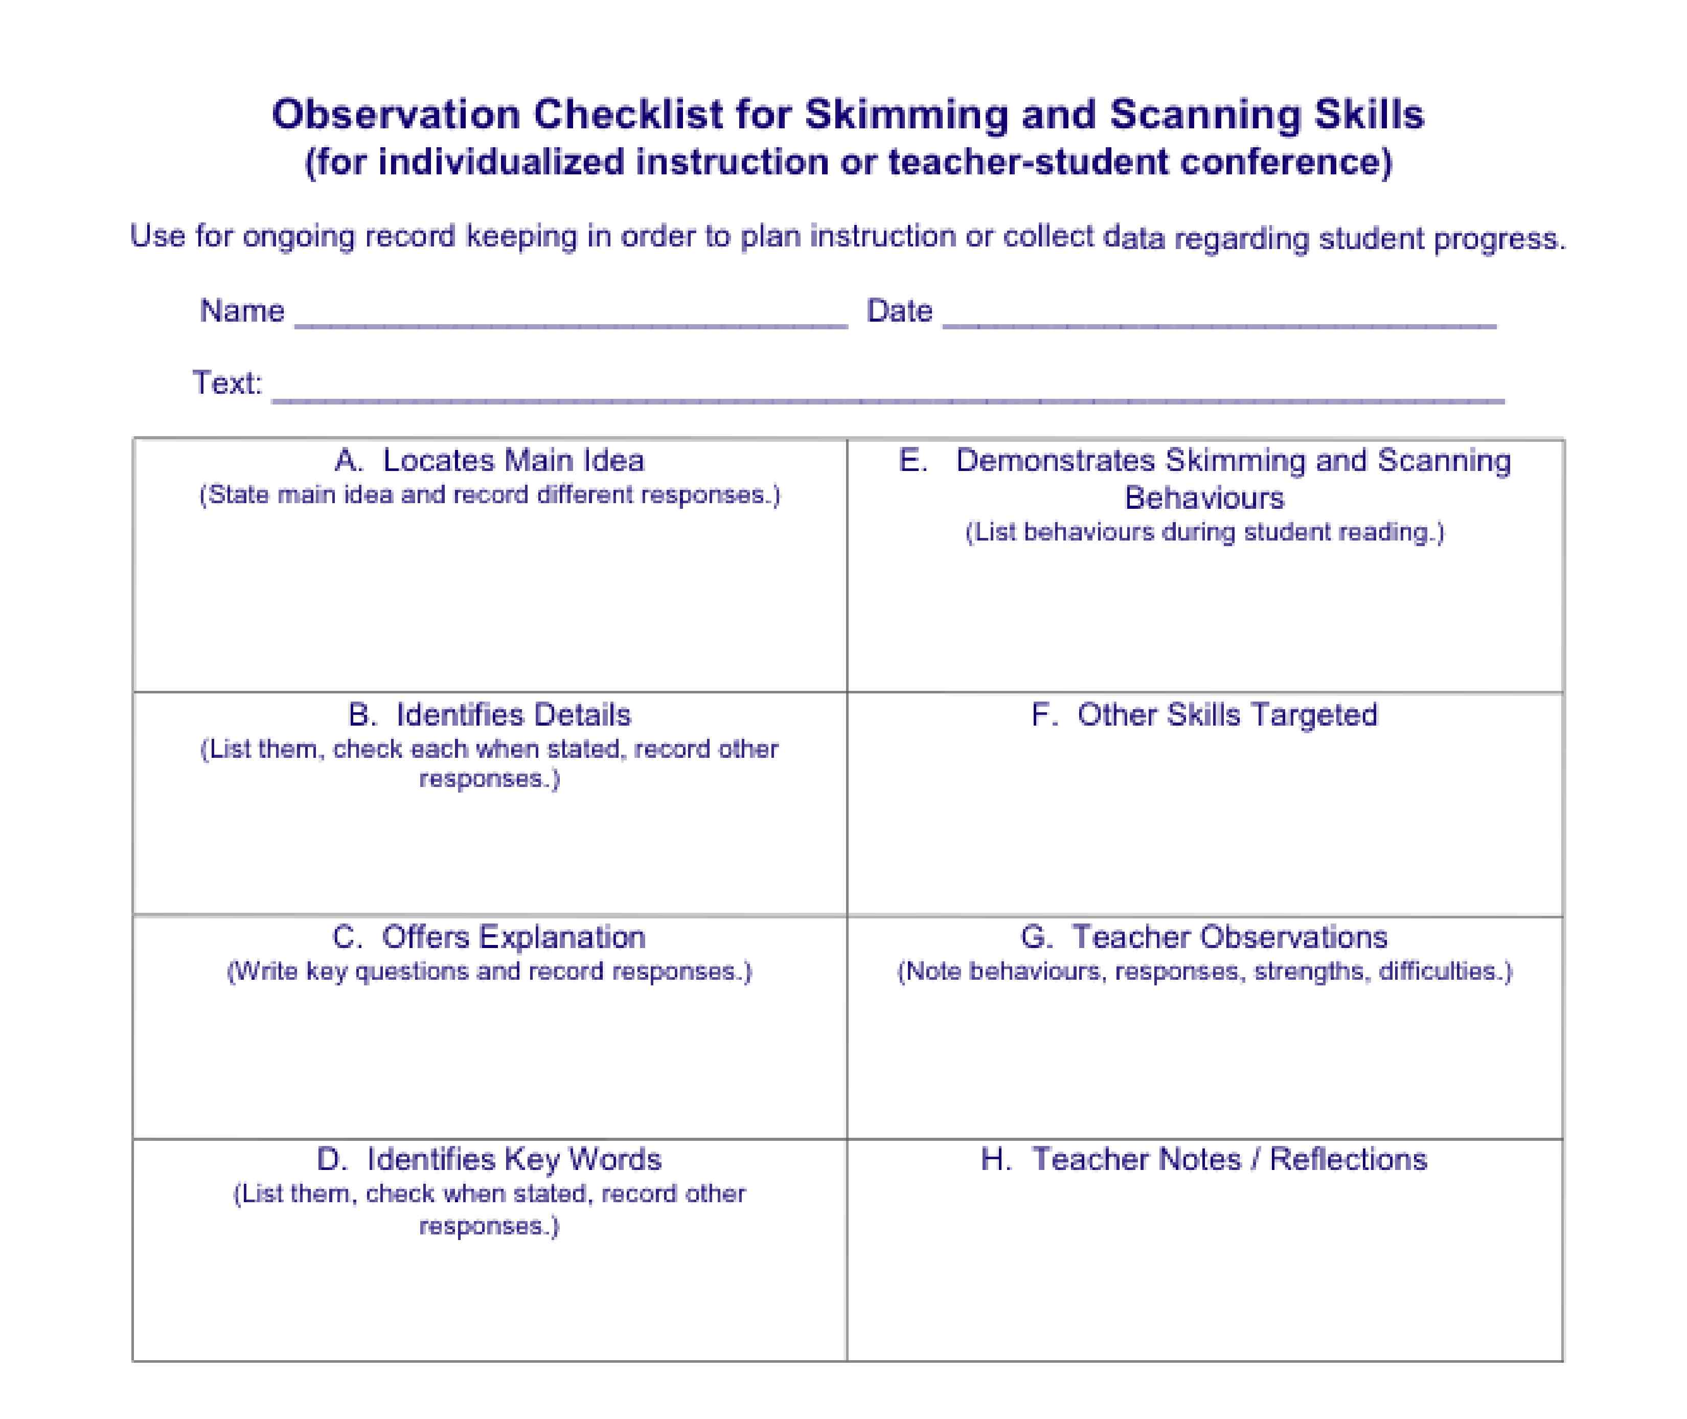

Reproduced from English Language Arts: Foundation for Implementation. Strategies That Make a Difference. BLM-5.

BLM - The Four-Column Planner

Integrated Theme/Topic |  |  | Duration

Goals
Performance(s)/
Demonstration(s)/Product(s)
Classroom Processes
Curricular Connections | Curricular  Outcomes |  | Instruction:  Learning, Teaching, and Assessment Strategies* |  |  |  | Learning  Resources/ Sources
 |  |  | Inquiry Process
  Primary Sources
  Field Trip
  Expert
  Artifacts
  Secondary Sources
  (Text Set)
  Multimedia
  Print
  Web
  English Language Arts
  Mathematics
  Science
  Social Studies
  Physical Education/ Health Education
  Information and Communication Technologies
  The Arts
 |  |  | Activating | Teacher-Led | Shared/ Negotiated | Student-Led
 |  |  | - Choosing a theme or topic.
 |  |  | - Identifying and recording prior knowledge.
 |  |  | - Asking initial questions.
 |  |  | - Exploring and selecting primary and secondary sources.
 |  |  | - Planning for inquiry.
 |  |  | Acquiring
 |  |  | - Gathering, processing, and recording information.
 |  |  | - Focusing the inquiry.
 |  |  | Applying
 |  |  | - Planning to express learning.
 | Summative Assessment  - Criteria  - Task: performance/ demonstration/product  - Reflection |  | - Creating performance(s)/ demonstration(s)/product(s).
 |  |  | - Celebrating and reflecting.
 |  |  | Optional
 |  |  | - Culminating Event

