
Professional Learning Experience

Topics – FOCUSSED OBSERVATION OF LEARNING IN LwICT

OVERVIEW
Student learning, with information and communication technology, should be assessed within curricular context. Just as teachers target a number of specific learning outcomes in any particular subject area when they assess students, teachers should also target specific big ideas in the continuum for LwICT when they observe student behaviour to create individual student profiles.

GUIDING QUESTION(S)
- What is Literacy with ICT?
- What is ICT Literacy?
- What is assessment FOR learning, AS learning, OF learning?
- How can I observe my students to assess their learning?

CONTINUUM / CURRICULUM CONNECTION:
Continuum for Literacy with ICT
Big Idea: Reflect

SUGGESTED LEARNING RESOURCES
Print:
Davies, Anne. Finding Proof of Learning in a One-to-One Computing Classroom. Courtenay, BC: Connections Publishing, 2004.
This publication reports on a year of observation of students in Maine engaged in a pilot project. Components of authentic assessment are highlighted. A DVD is included.
___. Making Classroom Assessment Work. Courtenay, BC: Connections, 2000.
Overview of assessment with practical suggestions. Includes a discussion of Triangulation.
Gregory, Kathleen, Caren Cameron and Anne Davies. Conferencing and Reporting: For Use in Middle and Secondary School Classrooms. Courtenay, BC: Connections, 2001.
___. Self-Assessment and Goal-Setting: For Use in Middle and Secondary School Classrooms. Courtenay, BC: Connections, 2000.
___. Setting and Using Criteria: For Use in Middle and Secondary School Classrooms. Courtenay, BC: Connections, 1997.
Manitoba Education, Citizenship and Youth. A Continuum Model for Literacy with ICT. “Assessing, Evaluating, and Reporting on Student Progress”. 2007. P. 24-7.
Available online at http://www.edu.gov.mb.ca/k12/tech/lict/resources/handbook/index.html
___. Independent Together: Supporting the Multilevel Learning Community. “Chapter 3: Assessment and Learning in the Multilevel Classroom”. 2003.
Available online at http://www.edu.gov.mb.ca/k12/cur/multilevel/index.html
___. Rethinking Classroom Assessment with Purpose in Mind. “Section II: Three Purposes of Assessment.” 2007.
Available online at http://www.edu.gov.mb.ca/k12/assess/wncp/index.html
Stiggins, Richard J. et al. Classroom Assessment for Student Learning: Doing It Right – Doing It Well. Portland, OR: Assessment Training Institute, 2004.

Black Line Masters
Admit / Exit Slip
Overview of Planning Assessment
Assessing Student Literacy – Triangulation
Assessment Flow Chart
Relationship between ICT and Curriculum
Assessment Is Like
Assessment – Give and Get
Give and Get Slip
Characteristics of a Continuum

Information Links:
Manitoba Education, Citizenship and Youth. Assessment and Evaluation; Kindergarten to Grade 12.
http://www.edu.gov.mb.ca/k12/assess/index.html
Communicating Student Learning: Guidelines for Schools – Draft. 2007.
Available shortly.
Rethinking Classroom Assessment with Purpose in Mind. 2007.
http://www.edu.gov.mb.ca/k12/assess/wncp/index.html
___. Literacy with ICT. 2007.
“Glossary”.
http://www.edu.gov.mb.ca/k12/tech/lict/resources/glossary.html
Includes Assessment-related vocabulary.
“Policy. Implementing Literacy with ICT Across the Curriculum”.
http://www.edu.gov.mb.ca/k12/tech/lict/overview/imple.html
“Snapshots”
http://www.edu.gov.mb.ca/k12/tech/lict/overview/show_me/index.html
“Student Friendly Continuum”.
http://www.edu.gov.mb.ca/k12/tech/lict/overview/show_me/student_friendly.html

See also: related online professional learning experiences
Principles – GRADUAL RELEASE OF RESPONSIBILITY
Topics – ELECTRONIC PORTFOLIOS

SUGGESTIONS FOR LEARNING
Activating My Prior Knowledge about Assessment:
- Reflect on the following questions:
  - What do I know about assessment?
  - What kinds of assessment strategies do I use in my classroom? Take notes of your strategies.
  - What tools do I use for assessing my students?
  - How do I involve my students in assessment?
- To surface some of your beliefs about and attitudes toward assessment, read BLM – Assessment is Like… and choose one or more of the toys illustrated in the BLM, such as Legos or a Slinky: think about how is assessment like one of these toys?

Acquiring Information:
- Finding out the basic information about assessment of students in Manitoba
- Read BLM – Overview of Planning Assessment. What is new to me?
- Go to the document Rethinking Classroom Assessment with Purpose in Mind. Look up the sections new to you as you reviewed the BLM.
- Review the definitions for any unfamiliar assessment terms in the Glossary found on the Literacy with ICT website.
- Learning more about assessing learning in LwICT
  - Why do you have to assess student learning with ICT? A provincial policy requires it. Read the Policy at the Literacy with ICT website.
  - Use BLM – Admit / Exit Slip. Fill out #1, and the Admit boxes of #s 2 and 3.
  - Read Section 1 of the Literacy with ICT Handbook, Pp 7-10. Go back to your Admit / Exit slip. Do you have to review the definitions you wrote for Admit?
  - Consider BLM – Relationship Between ICT and Curriculum. Which representation reflects the model used in your school? What do you think is the impact of the model presently in your school on your observation of student learning with ICT?
- Read BLM – Characteristics of a Continuum to be more familiar with what constitutes a continuum. Are you aware of other continuums and have you used one before?
- Consider BLM – Assessing Student Literacy – Triangulation. Are you familiar with each of the three components of the triangle? If you do not currently use one of them, how can you learn about that one in order to include it in your assessment practice?

Applying in My Classroom:
- What does focussed observation of student learning look like in my classroom?
- Read BLM – Assessment Give and Get. As it suggests, note your current assessment practices. How can these practices be adjusted to other kinds of assessment? i.e., how can the use of a rubric represent assessment AS learning, FOR learning and OF learning?
- Consider BLM – Assessment Flow Chart. Are your current assessment practices congruent with this representation? Target one new area to develop this year.
Consider the inquiry process:
- Target Big Ideas according to that process. For the fall reporting period, consider putting the emphasis on observation on the Big Ideas: Plan and Question, and Gather and Make Sense; consider Produce to Show Understanding for the spring reporting period; consider Communicate, and Reflect for the last reporting period.
- Target specific descriptors you want to observe in those Big Ideas, in the same manner as you might target specific learning outcomes.
- While students engage in an inquiry, they will complete all five stages of the process. However, at each reporting period, consider spending more time teaching and practicing the skills specific to each Big Idea you target. In the fall for example, emphasize the questioning and notemaking skills (See BLM – Questioning and BLM – Notemaking) required for “Plan and Question” and “Gather and Make Sense”. These skills are inherent to the inquiry process. Focussing on these Big Ideas and teaching their specific skills in the fall ensures that students have a strong base for inquiry. This in turn makes observing their learning more manageable as the focus of observation is narrowed.
- Target descriptors in the Affective domain as it seems appropriate to the learning task in the classroom. (See “Suggestions for Observing Behaviour Described in the Affective Domain”
- Furthermore, consider the snapshots. These have been suggested for groups of grade levels and they are labelled in terms of what students CAN do: Emerging, Developing, Transitioning, Expanding. Use the one(s) most appropriate for your grade level as another means of narrowing the number of descriptors as you focus your observations.
Note: Students may not show a behaviour associated with a descriptor in a consistent fashion, especially at the beginning. This is why it is important to observe students often, to do it over a period of time, and to observe as students learn across the curriculum, that is in ELA, math, social studies, and science. It is this three-fold observation that will give a true picture of the student’s literacy with ICT.
- How do I get my students involved in assessing their learning?
- Engage students in setting their own criteria for learning. Use BLM-2 from Independent Together as a guide. With guidance, and discussion of what constitutes a criterion as well as by viewing examples, students can start setting simple criteria as early as kindergarten.
- Use the student friendly version of the Continuum. As with focussed observation, target a group of descriptors suitable for either a task at hand, or the Big Ideas(s) targeted for a reporting period, keeping in mind the appropriate snapshot for your grade level.
Note: Do this often. Target no more than 3-5 descriptors at each time. Each time, use a few familiar descriptors and a few new ones.
- Ask students to self-reflect on the targeted descriptors on a regular basis: for example, after they have completed a task within an Inquiry, once a week, or at any other appropriate and meaningful time. A timely reflection will elicit richer comments.
- Ask students to be very descriptive in their observations, rather than evaluative. You will need to teach them that descriptive comments include what they feel they did well, what they think they need to do more of, and/or what they should do less of to improve.
- Ask students to date their comments and to identify them in the context of a project or an inquiry.
- Consider “cutting out” the section from the student-friendly version of the continuum that you want students to reflect on, rather than handing them the complete version. You can use the Word version available at the LwICT website.
- Discuss their comments and reflections with the student-friendly version in conversations with individual students, or in groups no larger than three or four, until students become comfortable with the process.
- What resources can you use to assess and report on student development of literacy with ICT?
  - Consider BLMs 5 or 11 from Independent Together as a format to note observations of student literacy with ICT.
  - Snapshots appropriate for your grade level(s) will place the learning in context of ELA, math, science, and social studies curriculum and inform you on the progress or needs of each student.
  - The student-friendly continuum allows students to reflect on their learning and to participate in setting goals for future learning.
  - Portfolios and electronic portfolios are tools that collect evidence and showcase student learning and reflections. (See Topic – ELECTRONIC PORTFOLIOS)

Implementation Links
Manitoba Education, Citizenship and Youth. Independent Together: Supporting the Multilevel Learning Community. “BLM 2: Constructing Student-Generated Criteria for Quality Work”. 2003.
___“BLM 5: Focused Observation Form”.
___”BLM 11: Record-Keeping Form; for Grade 6 to Senior 4 Assessments”.
http://www.edu.gov.mb.ca/k12/cur/multilevel/blm/index.html
___Literacy with ICT. “Learning Experiences. Suggestions for Observing Behaviour Described in the Affective Domain”. 2007.
http://www.edu.gov.mb.ca/k12/tech/lict/overview/imple.html
“Student Friendly Continuum”. Word version.
http://www.edu.gov.mb.ca/k12/tech/lict/resources/posters/index.html

SUGGESTIONS FOR ASSESSMENT
- Personal Journaling:
  - What have I learned that I was not previously aware of?
  - What has been clarified?
  - What do I want to pursue to find out more?
  - Is there any issue I feel I should share with my colleagues? How do I plan to do that?
- Providing Feedback:
  - Consider BLM – Relationship Between ICT and Curriculum. Can this representation also be a reflection on the relationship between assessment FOR – AS – OF learning and the curriculum?
  - Please share with the Literacy with ICT project team, any issue that was not clear, any questions you have, or suggestions for a future update.
- Observing Students:
  - Read the comments students write on their student-friendly reflections. Help them make those comments as descriptive as possible.
  - Have a conversation with each student at regular times about how their literacy with ICT is developing.
  - Review the students’ portfolios and their reflections about the products they chose to include as a representation of their learning.

BLM – Admit / Exit Slip

Name: |  |  | Date:

1. What is ICT?

2. What is Literacy with ICT?

ADMIT

EXIT

3. What is ICT literacy?

ADMIT

EXIT

4. Write a statement to compare and contrast the two terms.

BLM – Overview of Planning Assessment

Appendix 2

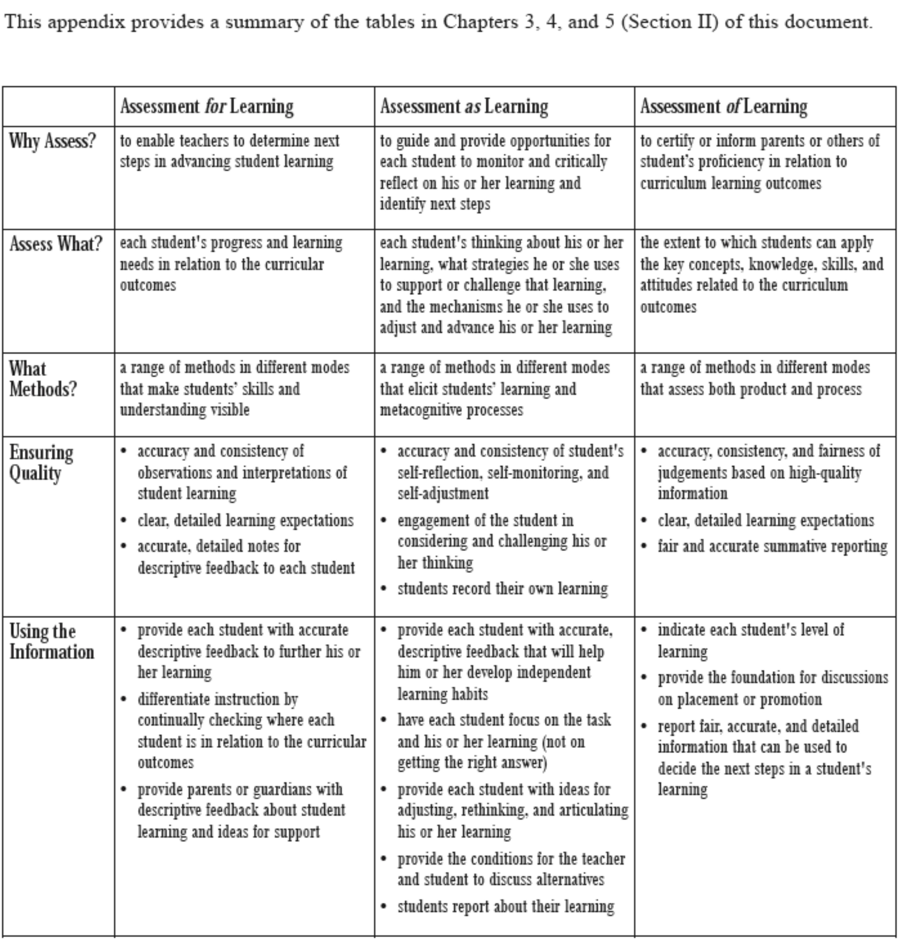
From: Manitoba Education, Citizenship and Youth. Rethinking Classroom Assessment with Purpose in Mind. 2007. P. 85

BLM – Assessing Student Literacy – Triangulation

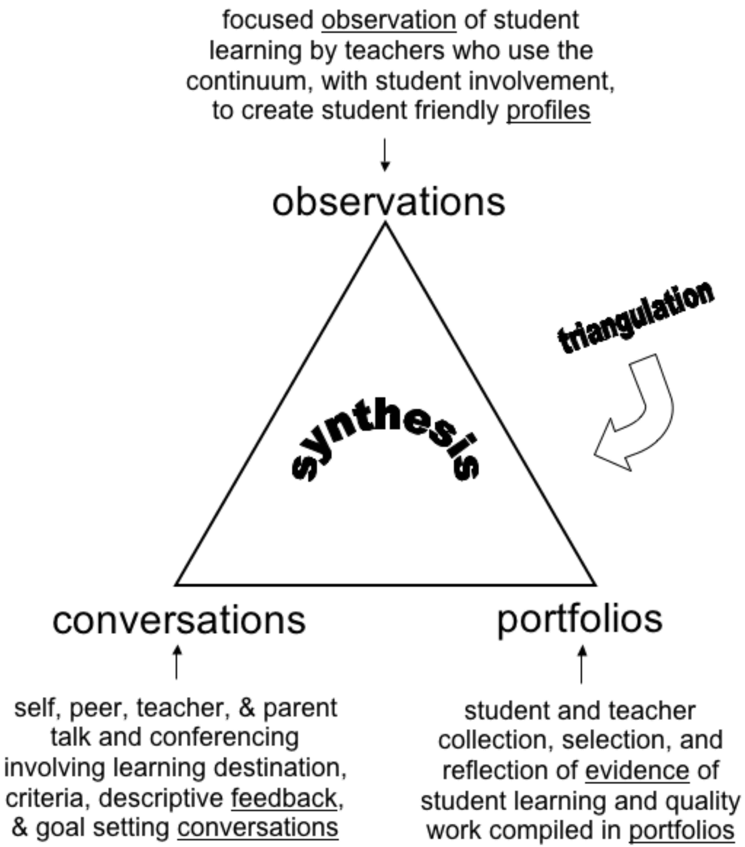

BLM – Assessment Flow Chart

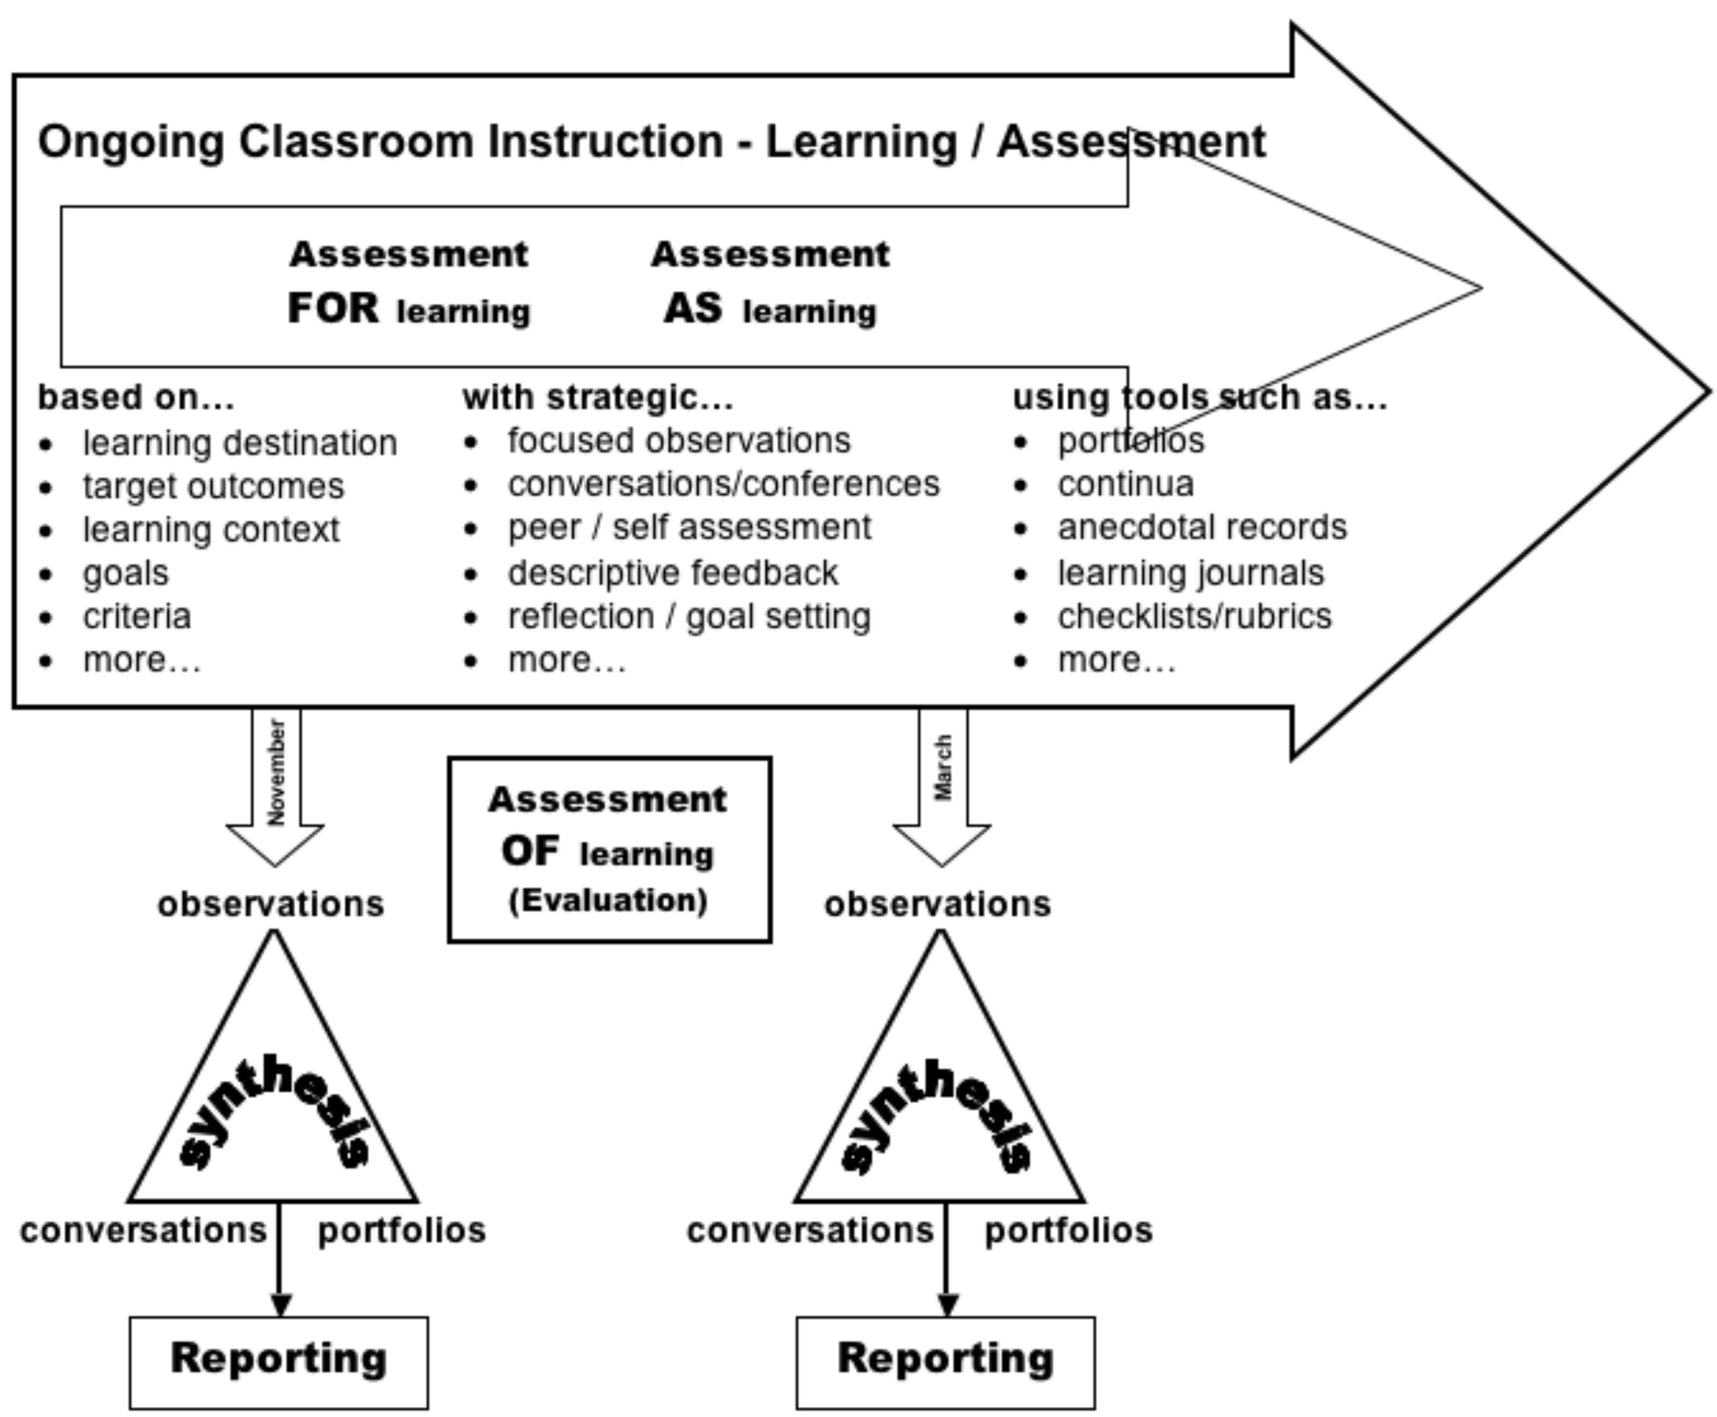

Based on a presentation by Shelley Warkentin, ELA Consultant, January 26, 2006.

BLM – Relationship Between ICT and Curriculum

“A supplementary relationship separates ICT and curriculum in space, time, and personnel —separate computer labs, computer classes, and computer teachers. A complementary relationship begins to connect ICT with curriculum in various ways. An integrated relationship allows the classroom teacher to bring ICT into the classroom so it is available at teachable moments. An infused relationship allows the transparent application of ICT, wherever and whenever appropriate, to enhance critical and creative thinking.”
Manitoba Education, Citizenship and Youth. A Continuum Model for Literacy with ICT. 2007. P. 10

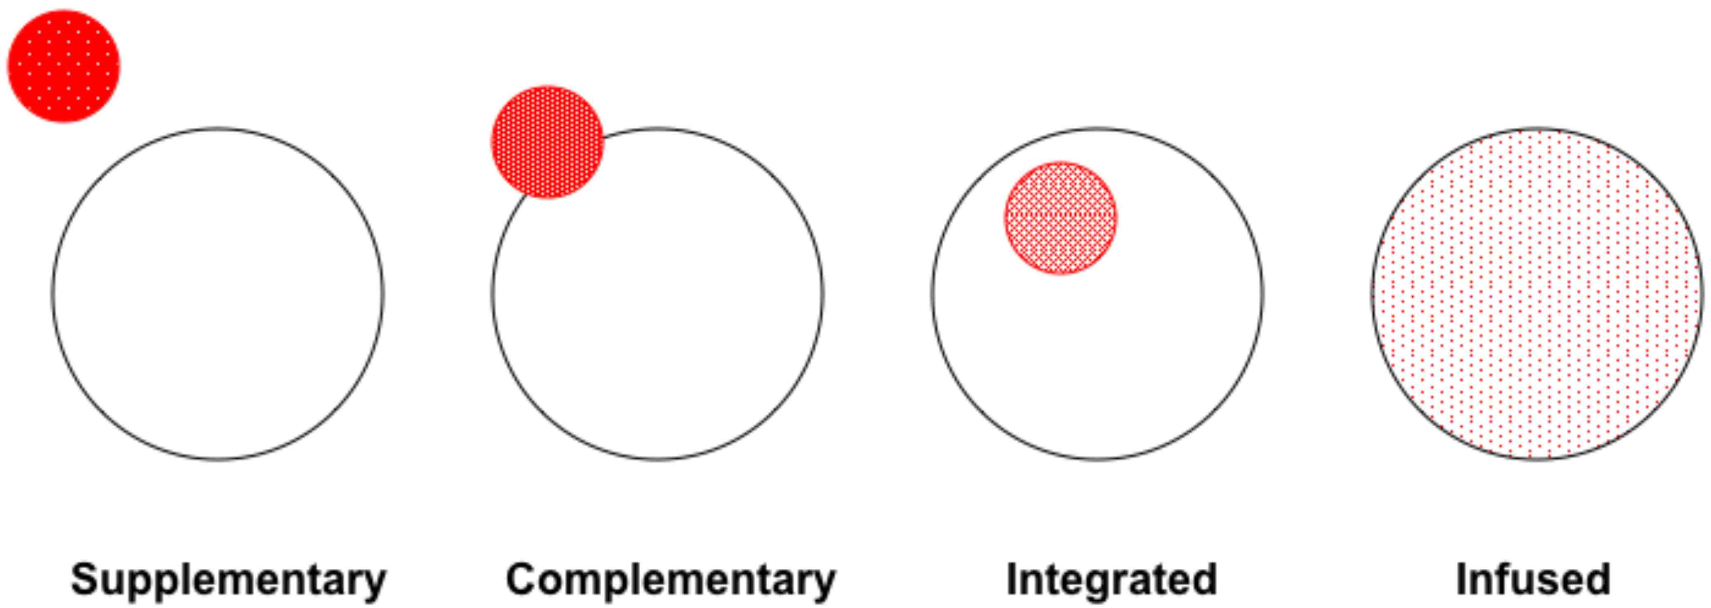

“Research in the last 20 years has shown that the most effective way to infuse ICT is to focus on pedagogy rather than on technology.” P. 10.

BLM – Assessment Is Like…

Professional Learning Experience Goal
To activate prior knowledge of assessment. The purpose is to draw out feelings, attitudes, beliefs and understandings of assessment by making analogies and using metaphors. This type of activator appeals to the linguistic intelligence and allows the user the opportunity to 'think outside the box'.

Continuum Connections
P-1.1 – recalls and/or records prior knowledge and asks topic-related questions
P-2.1 – constructs “how and why” questions, predictions, hunches, educated guesses, and hypotheses and identifies information needs
P-3.1 – evaluates original inquiry questions and creates new questions for future inquiry

Materials
- a toy such as: slinky, top, lego, marbles, and yo-yo; other ideas might include etch-a-sketch, spirograph,…

Directions
- Introduce the learning experience and explain the purpose.
- Explain that you will be handing out an object to each table and that each table group will have 5 minutes to ‘play’ with their toy and to come up with ways that “assessment is like” the object you will be handing out. Suggest that each table pick someone to record the responses. Let the group know that after 5 minutes or so they will be sharing their responses with the whole group.
- Walk around and place one toy on each table. Give groups 5 minutes or more to talk and share their thoughts and ideas.
- When the groups seem done, get them to pay attention up front again. Have each group read out loud their ideas (or the top 3 – 5 ideas). Record their ideas in the Assessment is Like… BLM up in the front of the room on the computer and projector so everyone can see them.
Debriefing
Teachers often have strongly held beliefs about assessment. This learning experience gives them a chance to discuss and debate these with colleagues. Wrap-up the learning experience by inviting participants to share any comments or questions they might have about assessment.

Suggested Readings
Rethinking Classroom Assessment with Purpose in Mind. “Section II: Three Purposes of Classroom Assessment”
http://www.edu.gov.mb.ca/k12/assess/wncp/index.html

____________________________________
Based on Literacy with ICT Facilitator Guide – Assessment Is Like…

BLM – Assessment – Give and Get

Professional Learning Experience Goal
Think about an effective assessment strategy you have used in the past, write an adaptation of that strategy for each of FOR learning /AS learning /OF learning. Share that assessment strategy with colleagues in your school.

Continuum Connections
Pr-1.1 – participates in establishing criteria for student-created electronic work
R-1.1 – participates in guided conferences to think about using ICT to learn
R-2.1 – invites and shares constructive feedback, related to established criteria, to reflect on using ICT to learn
R-3.1 – self-monitors learning goals, reflects on the value of ICT to complete learning tasks, and sets personal goals for using ICT to learn

Links
Manitoba Education, Citizenship and Youth. Literacy with ICT Across the Curriculum. 2007. Pp. 24-25.
http://www.edu.gov.mb.ca/k12/tech/lict/resources/handbook/index.html
___. Rethinking Classroom Assessment with Purpose in Mind - Three Purposes of Classroom Assessment.
http://www.edu.gov.mb.ca/k12/assess/wncp/section2.pdf

Directions
- Using BLM – Give and Get Slip, record an effective assessment strategy you currently use.
- Write an adaptation for the strategy for each of FOR learning /AS learning /OF learning.
- Share your strategy and adaptations with colleagues.
- Ask them for input of strategies they use.

Debriefing
- Use an opportunity for a large group sharing session, during grade-level or staff meetings, in which you can talk about any insights you may have gained during this sharing.
- Recognize that most assessment strategies can serve any of the three purposes of assessment, depending on how you apply them.

Extending the Learning Experience
- Distribute a hard copy of the strategies to all colleagues at a later date.

Suggested Readings
Manitoba Education, Citizenship and Youth. Rethinking Classroom Assessment with Purpose in Mind. 2006.
http://www.edu.gov.mb.ca/k12/assess/wncp/index.html

____________________________________
Based on Literacy with ICT Facilitator Guide – Give and Get

BLM – Give and Get Slip

Think about an assessment strategy that you have found successful. Describe it in the first quadrant, then write adaptations for the strategy describing
- how it might look if it is used as assessment FOR learning
- how it might look if it is used as assessment AS learning
- how it might look if it is used as assessment OF learning

My
Strategy
FOR
AS
OF

Now use the remainder of this form to gather assessment strategies from your colleagues:

BLM – Characteristics of a Continuum

- describes what students literate with ICT can do (descriptors)

- clusters descriptors into Big Ideas — the essentials

- outlines stages which are critical developmental benchmarks or “milestones” along a learning journey over a number of years

- is not grade-level specific

- is congruent with curriculum

- is written in teacher/student friendly language

- everyone can be profiled with a continuum

