BLACK LINE MASTERS

Online Learning Experiences

BLMs in Ongoing Learning Experiences (OLEs)
BLM OLE.1#1: Binder Reminder Learning Centre
BLM OLE.1#2: Electronic OLE Binder Maintenance Learning Centre
BLM OLE.1#3: Personal OLE Binder Checklist
BLM OLE.1#4: Overview of Ongoing Learning Experiences (OLEs)
BLM OLE.3#1: Problem-Solving Learning Centre
BLM OLE.3#2: Problem-of-the-Week Chart
BLM OLE.4#1: Reading Circle Learning Centre
BLM OLE.4#2: Guess the Role
BLM OLE.4#3: Reading Circle Discussion Notes
BLM OLE.4#4: Reading Log
BLM OLE.4#5: Suggested Writing Topics for Reading Circle Response Log (Fiction)
BLM OLE.4#6: Reading Circle Response Log
BLM OLE.4#7: Rubric for Peer/Group Assessment and Self-Assessment of Reading Circle Discussion
BLM OLE.4#8: Retelling
BLM OLE.4#9: Student Self-Assessment for Responding to Literature
BLM OLE.4#10: Reading Strategies Self-Check
BLM OLE.4#11: Group Work Assessment
BLM OLE.5#1: Share the Learning Centre
BLM OLE.5#2: Share the Learning Journal
BLM OLE.5#3: Oral Presentation Checklist
BLM OLE.5#4: A Viewer’s Discussion Guide for Narrative and Informational Films/Videos
BLM OLE.6#1: Group Work Self-Reflection Log
BLM OLE.6#2: Collaborative Group Work Reflection Log
BLM OLE.6#3: Task Recording Sheet
BLM OLE.6#4: Set Your Goal
BLM OLE.6#5: We Reached Our Goal! Let’s Review
BLM OLE.7#1: Speech Delivery Assessment Form
BLM OLE.7#2: Self-Assessment of Active Listening
BLM OLE.7#3: You Are the Pollster
BLM OLE.7#4: Book Talk
BLM OLE.7#5: Secretary’s Report Form
BLM OLE.7#6: Chairperson’s Agenda
BLM OLE.8#1: Reflection Journal Learning Centre
BLM OLE.8#2: What Have I Learned?
BLM OLE.8#3: Metacognitive Reflection
BLM OLE.8#4: Goal Setting
BLM OLE.9#1: Characteristics of Our Newspapers
BLM OLE.9#2: Newspaper Learning Centre
BLM OLE.9#3: 5Ws + H Chart
BLM OLE.10#1a: Sample Concept Map—Web
BLM OLE.10#1b: Sample Concept Map—Top-Down Tree
BLM OLE.10#2: Sample Outline Based on Concept Map—Web
BLM OLE.10#3: Electronic Collection Learning Centre
BLM OLE.10#4: Electronic Collection Checklist
BLM OLE.10#5: Creating an Electronic Portfolio
BLM OLE.10#6: Electronic Portfolio Checklist
BLM OLE.10#7: Electronic Portfolio: Peer Feedback
BLM OLE.1#1: Binder Reminder Learning Centre

Overview
At this learning centre, you will work in a collaborative group to help each other with the organization and upkeep of your Personal OLE Binders.

Resources
  - BLM OLE.1#3: Personal OLE Binder Checklist
  - Master OLE Binder (set up and maintained by the teacher as a model)
  - teacher’s lists of due dates and expectations

Tasks
  - Use the table of contents provided by the teacher to organize each Personal OLE Binder. Consult the Master OLE Binder set-up as a model, if needed.
  - Help each other complete assignments as needed.
  - Help each other update the binder according to the list of expectations and due dates given by the teacher.

Suggestions for Collaboration
  - Use the expertise of each group member while organizing and enhancing the binders.
  - Practise working as a member of a collaborative group.

What to Do with the Results of This Learning Centre
  - Keep a record of questions for the teacher to address in a class discussion.
  - Keep the BLM OLE.1#3: Personal OLE Binder Checklist at the front of the Personal OLE Binder for ease of access and for teacher assessment.

Assessment Criteria
  - The Personal OLE Binder content is up to date and the information is easy to access.

BLM OLE.1#2: Electronic OLE Binder Maintenance Learning Centre

Overview
At this learning centre, you will work with your group to maintain and organize your Electronic OLE Binders or folders.

Resources
  - Master Electronic OLE Binder and Read-Me file (set up and maintained by the teacher as a model)
  - Teacher’s lists of due dates and expectations

Tasks
  - Review the table of contents and Read-Me file describing the organization of each folder provided by the teacher.
  - Update your work, files, and Personal OLE Binder according to the lists of due dates and expectations provided by the teacher.
  - Use BLM OLE.1#3: Personal OLE Binder Checklist for monitoring the Electronic OLE Binder. Keep it in the Personal OLE Binder for updates and teacher assessment.

Suggestions for Collaboration
  - Divide the learning centre time into equal portions, so that all members of the group will receive some time for maintaining their Electronic OLE Binder.
  - Use the expertise of each group member while organizing personal Electronic Binders.

What to Do with the Results of This Learning Centre
  - Keep a record of questions for the teacher to address in a class discussion.

Assessment Criteria
  - The Electronic OLE Binder content is up to date and complete and the information is easy to access.
BLM OLE.1#3: Personal OLE Binder Checklist

Name

Add a check mark () when you have updated each section.

 | Date | Date | Date | Date
Table of Contents is up to date for
  - Personal Binder Reminder
  - Daily Edit
  - Daily Math and Problem Solving
  - Reading Circles
  - Share the Learning
  - Collaborative Learning
  - Reflection Journal
  - Speak Ye! Hear Ye!
  - Newspapers
  - Electronic Collection
Pages are in order and numbered
based on Table of Contents for
  - Personal Binder Reminder
  - Daily Edit
  - Daily Math and Problem Solving
  - Reading Circles
  - Share the Learning
  - Collaborative Learning
  - Reflection Journal
  - Speak Ye! Hear Ye!
  - Newspapers
  - Electronic Collection
Teacher Comments

BLM OLE.1#4: Overview of Ongoing Learning Experiences (OLEs)

OLE | Overview
OLE.1: Personal Binder Reminder | Organize and keep your OLE work in your Personal OLE Binder. Use Personal Binder Reminder time to update your binder and to check with your classmates and your teacher about assignments or projects.
OLE.2: Daily Edit | Review and practise basic spelling, punctuation, grammar, and capitalization skills in your daily writing. Participate in Daily Edits. Add words you have misspelled in your writings and new vocabulary to the class Vocabulary Database. Use the Spelling and Grammar Checker and the Thesaurus tools of the word processor.
OLE.3: Daily Math and Problem Solving | Practise daily estimation, mental-math, and problem-solving skills. Discuss the strategies you use, and record your results using a spreadsheet. Select a Problem of the Week and work in a collaborative group to find a solution to the problem. Record comments about your math and problem-solving experiences in your Math Journal.
OLE.4: Reading Circles | Reading Circles help you to explore and appreciate a variety of texts. Talking with others about your reading helps you to increase your understanding, develop reading skills, and hear others’ ideas. Keep notes such as Reading Circle Logs or journal entries throughout the year.
OLE.5: Share the Learning | As you gain knowledge and skills, share your learning with classmates, friends, and/or parents once a week, or more often. Keep a Share the Learning Journal and participate in Share the Learning Centres.
OLE.6: Collaborative Learning | Work in collaborative groups to become familiar with the roles, responsibilities, and expectations of being an effective group member. You will learn the differences between competition and cooperation. The ground rules set for group work will be used throughout the year.
OLE.7: Speak Ye! Hear Ye! | Develop speaking, listening, and discussion skills as you plan, prepare, and give presentations on different topics. Each student takes a different role at each Speak Ye! Hear Ye! session. You will have a chance to prepare for your roles through group work and learning centres before you participate in Speak Ye! Hear Ye! sessions.
OLE.8: Reflection Journal | Take time to reflect on your learning in general and your learning in the Community and Diversity unit by writing reflections in your Reflection Journal. You will take turns posting your reflections on the class website.
OLE.9: Newspapers | Take part in activities that will help you learn about newspapers. Find out what is newsworthy, how a newspaper is organized, and why you can benefit from reading newspapers.
OLE.10: Electronic Collection | Create and maintain an Electronic Collection of your work in the Community and Diversity unit to assess your own learning and to reflect upon your strengths. Choose samples of your work that show how you have improved. Include them in your Electronic Portfolio.

BLM OLE.3#1: Problem-Solving Learning Centre

Overview
At this learning centre, you will work together with your group to solve the selected math problem.

Resources
  - math problem solving website
  - BLM OLE.3#2: Problem-of-the-Week Chart

Tasks
  - Check the class website for the problems to solve.
  - Discuss the selected problem with group members and record the solution.
  - Use BLM OLE.3#2: Problem-of-the-Week Chart to record the group’s answer and describe how the group solved the problem.

Suggestions for Collaboration
  - Group members decide who works at the keyboard and who records the problem and solution. Ensure that all members take turns with each role.

What to Do with the Results of This Learning Centre
  - File the BLM OLE.3#2: Problem-of-the-Week Chart in the Personal OLE Binder.

Assessment Criteria
  - Group members stay on task and work together.
  - The problem is completed correctly, and a description of the strategies used to solve the problem is provided.
BLM OLE.3#2: Problem-of-the-Week Chart

Name |  |  | Date

Group Members

Summary of the Problem

Group’s Answer

Computational Strategies Used to Solve the Problem | Correct Answer  (If Different from the Above)

BLM OLE.4#1: Reading Circle Learning Centre

Overview
At this learning centre, you will access websites where reviews of texts are posted, and you will write and post your own book reviews.

Resources
  - Internet
  - BLM OLE.4#11: Group Work Assessment

Tasks
  - Access a website, already bookmarked, for reviews of texts.
  - Work with your group to identify the characteristics of a good book review.
  - In your collaborative group, write a book review for the book you have read in your Reading Circle.
  - The recorder of your group writes up the information and posts it on a book review website or on the book review page of the school website.

Suggestion(s) for Collaboration
  - Each member of the group should be a recorder at one time or another.

What to Do with the Results of This Learning Centre
  - Add your book review to the appropriate website.
  - Publicize the school website and the student book review page on the website in the school newsletter.

Assessment Criteria
  - Use BLM OLE.4#11: Group Work Assessment to rate your group work.
  - The group’s book review is included on a website.

BLM OLE.4#2: Guess the Role

Name |  |  | Date

In the column on the right, record the name of the student playing the role described in the middle column.
Role | Description | Student
Discussion Director | With the help of the teacher, develop a list of questions to help the group discuss the selected reading. Help the group talk about the big ideas in the reading and share their reactions without worrying about small details. Usually the best discussion questions come from personal thoughts, feelings, and concerns related to the reading. These can be noted during the reading or as a reflection after the reading.
Summarizer | Prepare and present a brief summary of the day's reading in a short (one or two minute) statement. Be sure to cover the key points and/or the main highlights or ideas of the reading. If there are several main ideas or events to remember, number the key points.
Literary Luminary  (For Fictional Text) | Find a few special sections of the text that the group might like to hear read aloud. The idea is to help the group remember some sections of the reading that are interesting, powerful, funny, puzzling, important, and so on. Decide which passages are worth hearing, and then jot plans for how they should be shared. Read passages aloud, ask someone else to read them, or have the group read them silently. Discuss that section with the group.
Information Interpreter  (For Informational Text) | Find a few sections of the reading that  - are especially relevant to the topic  - explain the subject very concisely and clearly  - shed new light on the issue  - communicate information previously unavailable  - are controversial or thought provoking
Connector | Find connections between the reading and the real world. This means connecting the reading to  - personal life  - happenings at school or in the community  - similar events at other times and places  - other people or situations  Possible connections may also be found between this reading and other writings on the same topic, or by the same author.
Vocabulary Enricher | Be on the lookout for important words in the day's reading or for words that are puzzling or unfamiliar. While reading, jot down the words, and add their definition later. Point out to the group familiar words that stand out in the reading, such as words that are repeated often, that are used in an unusual way, or that are key to the meaning of the text.
Illustrator | Draw an illustration of something specifically discussed in the reading or related to it, or of a feeling experienced from the reading. It can be a sketch, cartoon, comic, diagram, flow chart, or stick-figure scene, and may be labelled. Show the illustration to the others in the group without commenting on it. One at a time, group members speculate on the meaning of the illustration and connect it to their own ideas about the reading. After everyone has expressed his or her opinion, explain the drawing, describing how it came about or what it represents.
Recorder | Take notes of what all group members say during a discussion of the text. Use notes to write a review of the text, including an opinion of why other students might want to read it. Post the review on a suitable website or on the class website.
BLM OLE.4#3: Reading Circle Discussion Notes

Name |  |  | Date

Reading Circle Selection
Title |  | Author
Summary of Text |  | Read-Aloud Section
 |  | Page Numbers
 |  | Reason for Choice

Discussion Questions and Notes

New Vocabulary | Connections  (To real world or to Community and Diversity unit) | Illustration
BLM OLE.4#4: Reading Log

Name

Date Started | Date Finished | Genre | Author | Title | Stars  (Out of 5)
BLM OLE.4#5: Suggested Writing Topics for Reading Circle Response Log (Fiction)

Choose one or more of the following ideas and questions to assist you in responding to texts, using BLM OLE.4#6: Reading Circle Response Log.
- What predictions can be made about the story using the cover of the book, the table of contents, and the illustrations?
- Who wrote this story? When was it written? What purpose did the author have in writing this story?
- Describe the setting of the story using words and pictures.
- Describe the main character using words and pictures. Write a paragraph to compare this character to yourself.
- What is the story about? What is the story’s main conflict? Predict how it may be resolved.
- What do you like about the story? Give the author suggestions for improvements.
- Make a comic strip showing the main events in the story.
- Write a different ending to the story.
- Is this a feel happy, feel sad, feel angry, or feel . . . kind of story? Explain.
- Choose a passage that appeals to as many senses as possible. Prepare to read this passage aloud in your Reading Circle group.
- Think about this week’s reading selection. Which events or people are most vivid? Make a sketch illustrating a vivid event or person.
- Choose a character. List at least 10 adjectives that describe that person. Give a reason for the choice of adjectives.
- A cinquain poem has five lines and a definite pattern, but it does not rhyme. Here is an example:
  - Line 1: 1 word Michael
  - Line 2: 2 words Gentle giant
  - Line 3: 3 words Helping many people
  - Line 4: 4 words His courage is unique
  - Line 5: 1 word Policeman
- Select a character from the text. Write a cinquain poem about this character. Share it in your Reading Circle group.
- Make a list of 10 new words you learned from the story. Beside each word, write a synonym and a sentence using the word correctly.
- Write a friendly letter (minimum of 100 words) to the author of the story, giving personal ideas and opinions about the story. Put the letter in an envelope and send it to the publisher.
- Make a travel brochure to advertise the setting of the story.
- Does this story resemble real life? Explain in personal terms.
- Write a reading response for the section of the story just completed. The response should consist of three paragraphs:
  - The first paragraph is a summary.
  - The second paragraph is a prediction of what will happen next.
  - The third paragraph is a comment about an issue or problem that is happening in the story.

BLM OLE.4#6: Reading Circle Response Log*

Name |  |  | Date

Title |  |  |  | Pages Read This Session
As Retold By

Sample  Signal Words |  | Select one of the writing topics from  BLM OLE.4#5: Suggested Writing Topics for  Reading Circle Response Log (Fiction)  Write your response below. Use at least three of the sample signal words on the left.
once
one
first
then
but
when
so
after
next
soon
as soon as
afterwards
later
also
suddenly
however
after that
meanwhile
at last
finally

________
* Source: Manitoba Education and Training. Kindergarten to Grade 4 English Language Arts: A Foundation for Implementation. Winnipeg, MB: Manitoba Education and Training, 1998. BLM–75.
BLM OLE.4#7: Rubric for Peer/Group Assessment and Self-Assessment
of Reading Circle Discussion

Name |  |  |  |  | Date

Author
Text |  |  |  |  |  | Pages Discussed

Rating Scale | 4 = |  | 3 = |  | 2 = |  | 1 =

Name(s): | Rating |  |  |  | Total
Name(s): | 4 | 3 | 2 | 1 | Total
The student
  - is prepared
  - listens to others
  - contributes ideas
  - respects others
  - stays on topic
  - encourages others to share

Comments
BLM OLE.4#8: Retelling*

Name |  |  |  |  |  | Date
Title |  |  |  |  |  |  | Author

As Retold By

Sample  Signal Words |  | Retelling
once
one
first
then
but
when
so
after
next
soon
as soon as
afterwards
later
also
suddenly
however
after that
meanwhile
at last
finally
________
* Source: Manitoba Education and Training. Kindergarten to Grade 4 English Language Arts: A Foundation for Implementation. Winnipeg, MB: Manitoba Education and Training, 1998. BLM–75.

BLM OLE.4#9: Student Self-Assessment for Responding to Literature*

Name |  |  | Date

Title Discussed |  |  | Author

Use the rating scale below to describe your experience in your Literature Study group. Write any comments that will help clarify your rating.

Rating Scale High Low
5 4 3 2 1

Response to Literature | Rating |  |  |  |  | Comments
Response to Literature | 5 | 4 | 3 | 2 | 1 | Comments
  - I was willing to express my interpretations of the literature.
  - I listened to and respected the comments and questions of others.
  - I used the comments of others to extend my understanding of the literature.
  - I asked questions and reviewed the selection to try to understand it better.
  - I cooperated with my peers to prepare a group interpretation of the selection.
  - I enjoyed the experience of responding with the group.

________
* Source: Saskatchewan Education. English Language Arts: A Curriculum Guide for the Elementary Level. Regina, SK: Saskatchewan Education, 1992.162. Adapted with permission.

Reference
Manitoba Education and Training. Kindergarten to Grade 4 English Language Arts: A Foundation for Implementation. Winnipeg, MB: Manitoba Education and Training, 1998. BLM–88.

BLM OLE.4#10: Reading Strategies Self-Check*

Name |  |  | Date

Check the strategies you use to help you read.

Before I begin to read, I . . . | □ read the title  □ read the back cover  □ look at the pictures  □ predict what the book will be about  □ check to see if it is too easy  □ check to see if it is too hard  □ ask friends if they have read it  Some other things I do before I read a book are  □ ___________________________________________________
When I get stuck on a word, I . . . | □ skip it and read on  □ reread  □ use another word that makes sense  □ try to sound it out  □ look it up in a dictionary and/or ask someone  □ reread  Some other things I do when I get stuck on a word are  □ ___________________________________________________
When I do not understand, I . . . | □ look back at what I have already read  □ reread  □ use what I already know about the story  □ look at the pictures  □ ask for help  Some other things I do when I do not understand are  □ ___________________________________________________
After I finish a book, I . . .
□
□
□
________
* Source: Kindergarten to Grade 4 English Language Arts: A Foundation for Implementation. Winnipeg, MB: Manitoba Education and Training, 1998. BLM–16.
BLM OLE.4#11: Group Work Assessment*

Name |  |  | Date

Group Members

Think about how your group performed. Read each of the following points and rate your cooperative group work by marking or colouring in the appropriate box.

Cooperative Group Work | Rating
Cooperative Group Work | Always | Sometimes | Rarely | Never
We listened to each other’s opinions and ideas.
We contributed our ideas and opinions.
We discussed our viewpoints and feelings.
We paraphrased each other’s viewpoints and feelings.
We disagreed politely.

We were able to reach consensus.
We used our time effectively.

What did you or members of your group do to create group harmony?

________
* Source: Kindergarten to Grade 4 English Language Arts: A Foundation for Implementation. Winnipeg, MB: Manitoba Education and Training, 1998. BLM–37.
BLM OLE.5#1: Share the Learning Centre

Overview
At this learning centre, you will email your peers, parents, teachers, Elders, or key pals to share your learning.

Resources
  - BLM OLE.5#2: Share the Learning Journal
  - email

Tasks
  - Think about a learning discovery (a piece of information or a newly developed skill) that you would like to write about and to share with someone.
  - Share and discuss your ideas in your collaborative group. Make any changes to your plan that you think are necessary.
  - Write a letter sharing your new learning. Edit your letter, and have a partner from your group edit it as well.
  - Email your letter to your identified person.

Suggestion(s) for Collaboration
  - Set up a group schedule and a timeframe to access the computer to send the email.

What to Do with the Results of This Learning Centre
  - File email replies in the Personal OLE Binder or the Electronic OLE Binder along with the Share the Learning Journal entry that prompted it.

Assessment Criteria
  - Letters reflect use of proper formatting and writing conventions.
  - Letters include your assessment of your skills, understanding, and participation in group work, as well as questions you may still have.
BLM OLE.5#2: Share the Learning Journal

Name |  |  | Week of

Write down the most extraordinary thing or the best tip or skill you learned each day for five days. Select one learning discovery from the five you recorded and make notes to prepare for a Share the Learning presentation.

Date | Topic | Notes
 |  | Question
 |  | Question
 |  | Question
 |  | Question
 |  | Question
Notes on what to present this week, and why.
BLM OLE.5#3: Oral Presentation Checklist

Name |  |  | Date

Use this checklist to decide whether you are ready to share your presentation with the class or whether some points need your attention. When you have attended to the Needs Attention column, tell your teacher you are ready to give your oral presentation.

Presentation Components | Ready | Needs Attention

Content
  - Is my presentation organized?
  - Does it have a beginning, a middle, and an end?
  - Have I read the presentation to ensure that
- all content is relevant to the topic?
- no further editing is needed?
  - Have I made sure that the vocabulary is
- specific to the topic?
- used appropriately?
  - Have I planned something special to make my presentation creative and unique?
  - Have I prepared visuals (e.g., poster, photographs) that
- enhance my presentation?
- show what they are supposed to show?

Delivery
  - Do I need
- cue cards?
- a pointer?
- handouts?
  - Have I read my presentation, and reminded myself to
- speak clearly and enunciate well?
- use interesting tones of voice?
- speak at a normal speed?
- pause at appropriate places?
- speak loud enough so all can hear?
- be enthusiastic, show interest, and smile?
- look at audience members?

BLM OLE.5#4: A Viewer’s Discussion Guide
for Narrative and Informational Films/Videos*

Name |  |  | Date

A Viewer’s Discussion Guide for Narrative Films/Videos

The following general questions are suggested as a guide for discussing a film or video.
The questions may be adapted to use with specific material.

Title

1. Who was (were) the main character(s) in the film/video?
2. When did the story happen?
3. Where did it take place?
4. What was the problem or goal?
5. How was the problem solved or the goal reached?
6. What was your favourite part? Why?
7. Would you recommend this film/video to others? Why? Why not?
8. How would you rate this film/video? Circle one number below.

_{Low} _{High}
| | | | | | | | | |
1 2 3 4 5 6 7 8 9 10

Date Parent’s/Guardian’s Signature

A Viewer’s Discussion Guide for Informational Films/Videos

The following general questions are suggested as a guide for discussing a film or video.
The questions may be adapted to use with specific material.

Title

1. What did you already know about the topic before you viewed the film/video selection?
2. What three interesting facts did you learn?
3. What was the most interesting fact? Why was it most interesting?
4. What would you still like to learn about the topic?
5. Would you recommend this film/video to others? Why? Why not?
6. How would you rate this film/video? Circle one number below.

_{Low} _{High}
| | | | | | | | | |
1 2 3 4 5 6 7 8 9 10

Date Parent’s/Guardian’s Signature
_______
* Source: Manitoba Education and Training. Kindergarten to Grade 4 English Language Arts: A Foundation for Implementation. Winnipeg, MB: Manitoba Education and Training, 1998. BLM–73.
BLM OLE.6#1: Group Work Self-Reflection Log

Name |  |  | Date

Group Members

Rate your group participation using the following rating scale.

Group-Participation  Criteria | 3  Always | 2  Sometimes | 1  Rarely
  - I shared my ideas and answers with my group.
  - I asked questions when I did not understand something.
  - I helped people to understand when they had problems.
  - I tried to make people feel good in the group.
  - I stayed on the assigned task.
  - I tried to find out why I did not agree with someone else.

Write brief comments about yourself as a group member.

In my group, I am good at . . .
Next time I will try to be better at . . .
I feel my group was . . .
(Use one word to describe your group.)
BLM OLE.6#2: Collaborative Group Work Reflection Log

Recorder |  |  | Date

Group Members

Think about how your group performed. Read each of the following points and rate your collaborative group work using the rating scale provided.

Collaborative Group Work | 3  Always | 2  Sometimes | 1  Rarely
  - We listened to each other’s opinions and ideas.
  - We gave appropriate time to allow others to think before they answered.
  - We contributed our own ideas and opinions.
  - We disagreed politely.
  - We were able to reach consensus.
  - We performed our roles in the group.
  - We completed the assigned task within the given amount of time.
  - We used our time effectively.

Write a comment about how you or members of your group achieved group harmony.
What do you think your group needs to do to improve group harmony and your ability to complete the assigned task?
BLM OLE.6#3: Task Recording Sheet

Name |  |  | Date

Group Members

Task | Group Member Assigned to Task | Date Task to Be Completed | Task Done  ✓
BLM OLE.6#4: Set Your Goal*

Group Members |  |  |  |  | Date

Our group goal is to:
Steps we need to take to reach our goal:

What help do we need to reach our goal? (Who or what?)

We will try to reach our goal by the following date:
Did we make it?
Yes
No
If not, why not?

Try again!

________
* Source: Manitoba Education and Training. Kindergarten to Grade 4 English Language Arts: A Foundation for Implementation. Winnipeg, MB: Manitoba Education and Training, 1998. BLM–33.
BLM OLE.6#5: We Reached Our Goal!
Let's Review*

Group Members |  |  |  |  | Date

Our group goal was to:

The steps we took to reach our goal were:

When we achieved our goal, we felt:

We found this out about our group:

Signature of each group member:

________
* Source: Manitoba Education and Training. Kindergarten to Grade 4 English Language Arts: A Foundation for Implementation. Winnipeg, MB: Manitoba Education and Training, 1998. BLM–34.
BLM OLE.7#1: Speech Delivery Assessment Form

Name of Student |  |  | Name of Evaluator

Topic of Speech |  |  | Date

Item | Rating Scale |  |  | Total
Item | 3 | 2 | 1 | Total
Enunciation | - All words are spoken clearly. | - Most words are spoken clearly. | - Many words are not spoken clearly.
Voice | - Uses effective modulation. | - Uses satisfactory modulation. | - Uses minimal modulation.
Rate of Speech | - Rate of speech is well paced. | - Rate of speech is, at times, too fast. | - Rate of speech is too fast or too slow.
Volume of Speech | - Volume is loud enough to be heard easily. | - Volume is inconsistent. | - Volume is too low.
Enthusiasm | - Displays enthusiasm for the topic. | - Displays interest in the topic. | - Exhibits minimal interest in the topic.
Eye Contact  (Consider cultural appropriateness.) | - Makes effective eye contact. | - Makes some eye contact. | - Makes no eye contact.

Grand Total

BLM OLE.7#2: Self-Assessment of Active Listening

Name |  |  | Date

Active Listening Behaviours | Yes | No
  - I listened attentively.
  - I looked at the speaker all the time.
  - I showed interest by smiling or nodding.
  - I asked an appropriate question at question time.
  - I offered an appropriate comment.
  - I thought about the presentation and tried to understand it.
  - I took notes on what I did not understand.
What I do not understand . . .

Teacher Comments

BLM OLE.7#3: You Are the Pollster

Decide on a survey question. Word your question clearly so that no further explanation is required once it is asked. A survey that simply asks for a favourite . . . is not suitable.

1. Survey Question

a. I chose this question because

b. I predict that the results of the survey will show that

because

2. Data Collection

Number of People Interviewed | Gender |  | Age Range | Grade Range
Number of People Interviewed | Number of Females | Number of Males | Age Range | Grade Range

Explain how the terms “total population” and “sample population” are part of your survey.

3. Data Organization

Decide how you will organize and record the survey data. Will you tally the results, record data in a chart, or use some other organizer? Explain.

Continued

You Are the Pollster (Continued)

4. Graph

a. Decide what type of graph (e.g., pictograph or bar graph created by hand or by computer) would best represent the data.

Type of graph

Created by

b. What is one disadvantage of the chosen method of representation?

5. Interpretations, Inferences, and Conclusions

a. If the collected data is numerical, discuss
- the smallest and largest values
- the middle number
- the most frequent numbers
- any other patterns observed

b. Was the data reasonable? Explain.

c. Compare the results to the predictions.

d. Make inferences about the results, draw a conclusion, and state an opinion on the final results.

At the Speak Ye! Hear Ye! session, be prepared to explain how the survey was conducted, display the graph, and explain the conclusion.
BLM OLE.7#4: Book Talk

Share a little about the selected book with the class. Make an exciting speech, attempting to convince classmates to rush out and read the book. Show the book during the book talk.

Suggested Format

1. The title of the book is

2. It was written by

3. The story takes place in

4. The main character in the book is

5. The book is a (mystery, fantasy, comedy, suspense, etc.)

6. I found the book (easy, medium, hard) to read.

7. Here is a paragraph from the book that is (interesting, my favourite, sad, etc.)
Pages: (Record the page numbers and flag the page with a self-stick note.)
Read the paragraph to the class aloud.

8. I thought this book was very (funny, suspenseful, exciting, enjoyable, etc.)

9. Something interesting that occurred in the book was

10. Another thing that I really liked about this book was

BLM OLE.7#5: Secretary’s Report Form

Name of Secretary |  |  | Date

Time Begun |  |  | Time Ended |  |  | Total Time

Review of Previous Minutes

chairperson, opened the meeting.
the previous secretary, read the minutes of the last meeting and adopted them as read.

Choose one of the following:
There were no corrections or omissions.
The following was added/corrected:

 |  | moved that the minutes be adopted as read/corrected.
 |  | seconded the motion. | The motion was |  | carried |  | defeated

Agenda Items

 |  |  |  |  | shared an interesting animal fact about
 |  |  |  |  | introduced the speaker.
 |  |  |  |  | gave the keynote speech on the topic
 |  |  |  |  | assessed the speech.
 |  |  |  |  | told us about an interesting Internet site called
 |  |  |  |  | where you can get information on
 |  |  |  |  | gave a news report that included (check appropriate)
 |  |  |  |  |  |  |  | school news |  |  |  |  |  |  |  | community news |  |  |  |  |  |  |  |  |  |  |  | city news
 |  |  |  |  |  |  |  | provincial news |  |  |  |  |  |  |  | national news |  |  |  |  |  |  |  |  |  |  |  | world news
 |  |  |  |  |  |  | Continued

Secretary’s Report Form (Continued)
 |  |  |  |  |  | talked about (career)
 |  |  |  |  |  | after interviewing |  |  |  |  |  |  |  |  |  |  |  |  |  |  |  |  |  |  |  |  |  |  | by telephone.
 |  |  |  |  |  | One interesting fact we learned was
 |  |  |  |  |  | demonstrated
 |  |  |  |  |  | presented a commercial break, advertising
 |  |  |  |  |  | gave an impromptu speech on
 |  |  |  |  |  | told us about this environment tip
 |  |  |  |  |  | conducted a survey about
 |  |  |  |  |  | gave a biography of
 |  |  |  |  |  | spoke about an interesting book entitled
 |  |  |  |  |  | It sounded
 |  |  |  |  |  | reviewed the movie entitled
 |  |  |  |  |  | It sounded
 |  |  |  |  |  | presented poetry entitled
 |  |  |  |  |  | It was
 |  |  |  |  |  | entertained us with jokes.
 |  |  |  |  |  | shared a story.

Adjournment

 |  | chairperson, asked to adjourn the meeting.
 |  | moved for adjournment, and |  |  |  | seconded the motion.
The meeting was declared adjourned by chairperson
Time of adjournment
Date of next meeting
BLM OLE.7#6: Chairperson’s Agenda

Name of Chairperson |  |  | Date

Call to Order
I call this meeting to order. The time is

Review of Previous Minutes
I would like to ask the previous secretary, , to read the minutes from the last meeting.
Are there any errors or omissions?
Would someone move the minutes be adopted as read/corrected? Is there a seconder?
All in favour raise their right hand. Carried.

Agenda Items
I now call on (Call the speakers in the order they are listed on the agenda.)
- Interesting Animal Fact
- Keynote Speaker Introducer
- Keynote Speaker
- Keynote Speech Evaluator
- Internet Site Reviewer
- News Reporter
- Interviewer
- Demonstrator
- Advertiser
- Impromptu Speaker
- Environment Tipster
- Pollster
- Biographer
- Book Talker
- Movie Critic
- Poetry Reader
- Joker
- Storyteller

Adjournment
This concludes our meeting.
Would someone move the meeting be adjourned? Is there a seconder?
I declare this meeting adjourned.
The date of our next meeting is
BLM OLE.8#1: Reflection Journal Learning Centre

Overview
At this learning centre, you will make a Reflection Journal entry, using word-processing software.

Resources
  - email
  - word-processing software

Tasks
  - Review your thoughts, learning, and questions to prepare for your group’s discussion.
  - Share and discuss your ideas and questions with your collaborative group. Work together to answer questions.
  - Write in your Reflection Journal using word-processing software.
  - Name the file (first name, last initial, and date) and save it in your Reflection Journal folder.

Suggestion(s) for Collaboration
  - Decide how to rotate at the learning centre, and share the time appropriately.

What to Do with the Results of This Learning Centre
  - Email your journal entry to your teacher for editing. Make the necessary changes.
  - Post your Reflection Journal entry in your Electronic Collection or on the class website.

Assessment Criteria
  - The Reflection Journal entry is completed and posted in the Electronic Collection or on the class website.
BLM OLE.8#2: What Have I Learned?

Fill out this self-reflection BLM, keep it updated with new learning, and insert it in the appropriate section of the Personal OLE Binder. When you are ready, write appropriate uses of the chosen information and communication technology (ICT) skill in the last box below.

Name |  |  | Date

ICT skill I am reflecting upon

Skill | I think I’m good at . . . | I think I need some help with . . .
Example:  Saving a file | Giving a file a meaningful name | Saving a file in the right folder

I think the following ways are good uses of (insert name of ICT skill):

BLM OLE.8#3: Metacognitive Reflection*

Name |  |  | Date

Activity

Please think about the work that you completed, and then finish the following sentence frames.

- I am proud of
- I would like to learn more about
- I wish I had
- Next time I will
- I am puzzled about
- I was interested to learn
- My biggest challenge was
- When I did not understand what I was reading, I
- When I had difficulty writing my ideas, I
- The most interesting or surprising thing that I learned was

___________
* Source: Kindergarten to Grade 4 English Language Arts: A Foundation for Implementation. Winnipeg, MB: Manitoba Education and Training, 1998. BLM–92.
BLM OLE.8#4: Goal Setting*

Name |  |  | Date
My goal is to

So I plan to

Signatures
 | Student |  | Parent/Guardian
 | Teacher |  | Date of Next Goal-Progress Check

Name |  |  | Date
My goal is to

So I plan to

Signatures
 | Student |  | Parent/Guardian
 | Teacher |  | Date of Next Goal-Progress Check

___________
* Source: Kindergarten to Grade 4 English Language Arts: A Foundation for Implementation. Winnipeg, MB: Manitoba Education and Training, 1998. BLM–93.
BLM OLE.9#1: Characteristics of Our Newspapers

Name |  |  | Date

Use the following chart to record characteristics that are common to many newspapers, adding rows as needed. Insert the name of any other community/local or online newspaper and/or news magazine in the columns. A class wall chart may be adapted to suit the needs of the class, using this chart as a model.

Characteristics | Winnipeg Free Press | Winnipeg Sun | The Globe and Mail | National Post | Community Newspaper | Online Newspaper
Several separate sections | Yes | No | Yes | Yes | Yes | Yes
Sports section
Table of Contents
Colour pictures

BLM OLE.9#2: Newspaper Learning Centre

Overview
At this learning centre, you will write a paragraph for the class newspaper.

Resources
  - word-processing software
  - BLM OLE.9#3: 5Ws + H Chart

Tasks
  - Use BLM OLE.9#3: 5Ws + H Chart to record notes from interviews.
  - Using the notes on your chart, write a one-paragraph article for the class newspaper.
  - In a peer conference, have a partner comment on your paragraph. Discuss editing suggestions. Make the necessary changes.

Suggestion(s) for Collaboration
  - Decide how to rotate pairs for writing and editing at the computer.

What to Do with the Results of This Learning Centre
  - Email your paragraph to your teacher to be included in the class newspaper.

Assessment Criteria
  - The one-paragraph article is completed, edited, and submitted to your teacher.

BLM OLE.9#3: 5Ws + H Chart*

Name |  |  | Date

When? | Who? | What? | How? | Where? | Why?
Example:  Last night, Wednesday | Mrs. Jones and her son | Mrs. Jones tripped on the step  Her son helped her | Her heel fell in the crack  He caught her as she was falling | At her home on the front steps | Because the step was broken

________
* Source: Kindergarten to Grade 4 English Language Arts: A Foundation for Implementation. Winnipeg, MB: Manitoba Education and Training, 1998. BLM–67.
BLM OLE.10#1a: Sample Concept Map—Web
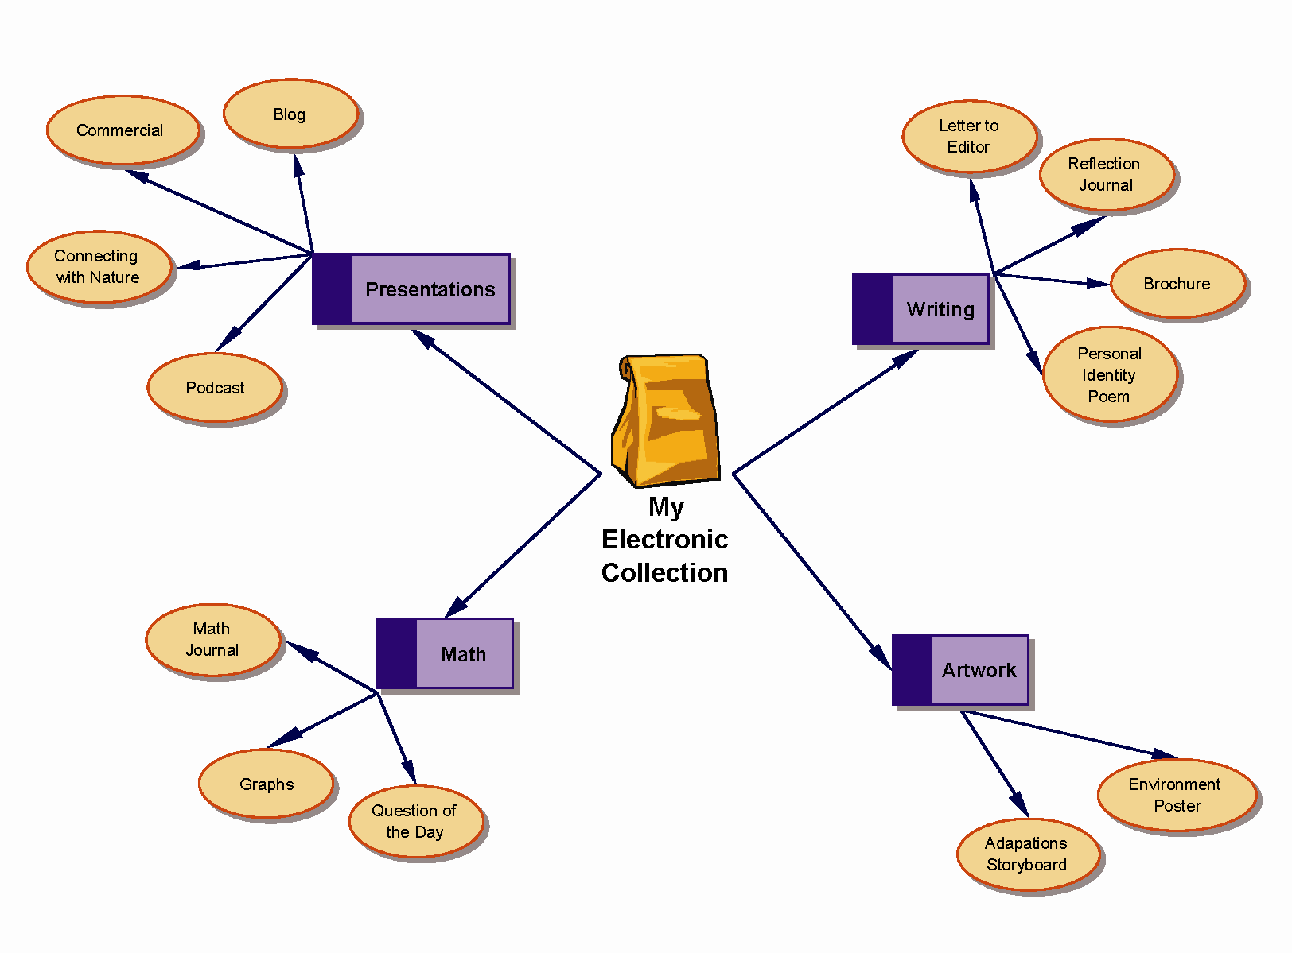

Example of a “Web” Arrangement Made with Concept-Mapping Software

The use of different symbols, colours, and shapes to represent each category and subcategory helps students visualize the relationship between the categories and subcategories and their order of importance.

See BLM OLE.10#2: Sample Outline Based on Concept Map—Web for the corresponding outline.
BLM OLE.10#1b: Sample Concept Map—Top-Down Tree

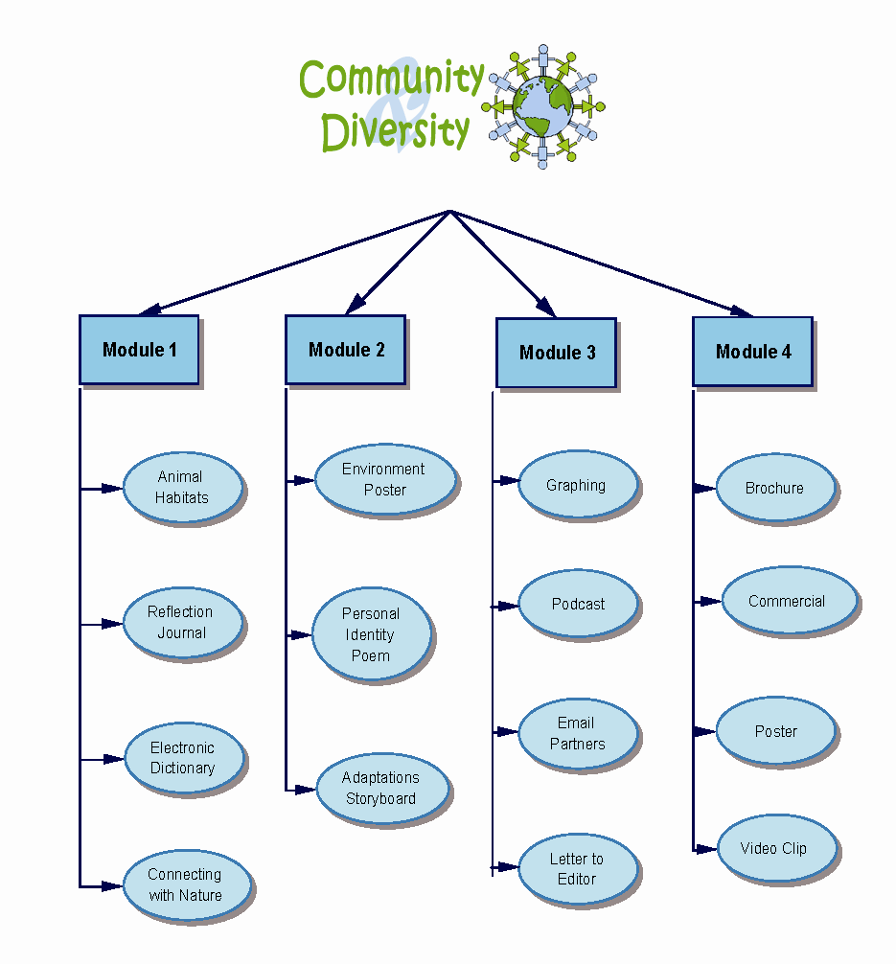

Example of a “Top-Down Tree” Arrangement Made with Concept-Mapping Software

The use of different symbols, colours, and shapes to represent each category and subcategory, combined with the top-down display, helps students visualize the relationships of categories and subcategories and the order of importance (from main category at the top to subcategories further down).

BLM OLE.10#2: Sample Outline Based on Concept Map—Web

My Electronic Collection

Writing
Letter to Editor
Reflection Journal
Brochure
Personal Identity Poem

Artwork
Environment Poster
Adaptations Storyboard

Mathematics
Question of the Day
Math Journal
Graphs

Presentations
Blog
Commercial
Connecting with Nature
Podcast

BLM OLE.10#3: Electronic Collection Learning Centre

Overview
At this learning centre you will work in collaborative groups to help each other update and enhance your Electronic Collection, and create an Electronic Portfolio of samples from your Electronic Collection.

Resources
- BLM OLE.10#4: Electronic Collection Checklist
- BLM OLE.10#5: Creating an Electronic Portfolio
- BLM OLE.10#6: Electronic Portfolio Checklist

Tasks
- Use your most recent printed concept map (from your Personal OLE Binder), to which you have been adding updates, to update your electronic concept map.
- Print this newly updated concept map and insert in your Personal OLE Binder.
- Ensure that all your files can be located in the folders that match the categories on your concept map.

Suggestions for Collaboration
- Divide the learning centre time into sections that enable all members of your group to receive time to update and enhance their Electronic Collection.
- Call on the expertise and feedback of each group member while organizing and enhancing your Electronic Collection.

What to Do with the Results of This Learning Centre
- Keep a record of your questions so that your teacher may address them in a class discussion.
- Keep BLM OLE.10#4: Electronic Collection Checklist in your Personal OLE Binder for future reference and teacher assessment.
- Start creating your Electronic Portfolio when your teacher instructs you to do so, based on the content and structure of your Electronic Collection.

Assessment Criteria
- The Electronic Collection is up to date, organized, and easily accessed.

BLM OLE.10#4: Electronic Collection Checklist

Name |  |  | Date

Title Page  The title page of your Electronic Collection should include  - the title of the Electronic Collection  - your name  - school year  - your teacher’s name | Table of Contents  The table of contents should include  - the title (same as on title page)  - a paragraph explaining the purpose of the Electronic Collection  - a background  - date created and date last updated
Index  The index page should include  - the title (same as on title page)  - a paragraph explaining how the index works  - an alphabetical list of content, including a short description of each file  - a background  - date created and date last updated | Collection of Work Samples  The collection of work should include at least one sample from each of the following:  - writing  - reading report  - artwork  - mathematics or problem solving  - journal entry  - project  Each sample includes  - a title  - date created

Item | Date Created | Update | Update | Update | Update | Update | Update | Update | Update
Title Page
Table of Contents
Index
Collection of Work Samples
Teacher Comments
Remember to record the date of each update. File this checklist in your Personal OLE Binder.
BLM OLE.10#5: Creating an Electronic Portfolio

Overview
You may create an Electronic Portfolio of samples of school work and projects you did throughout a unit, a semester, a year, or any other time frame. Regardless of whether you represent the Electronic Portfolio as a multimedia presentation or as web pages (see ICT.7: Make Your Point), it will include the following five basic components:
- Title Page: Choose a title that reflects the content or focus of the Electronic Portfolio.
- Table of Contents: Create a contents list based on the outline obtained from the concept map created to organize all the files included in the Electronic Portfolio.
- Site Map: Create a site map based on the concept map created to organize all the files included in the Electronic Portfolio.
- Index: Prepare an alphabetical list of files or keywords for subjects addressed within the Electronic Portfolio.
- Collection of Work Samples: Select representative work samples, including writing, artwork, mathematics, journal entries, and projects, in a variety of formats such as electronic, audio, or video.

Electronic Portfolio Contents
Title Page | Include  - an appropriate title reflecting the content of the Electronic Portfolio  - your name  - school year  - your teacher’s name
Table of Contents | - the title  - hyperlinks to sample files, including a short description of each file  - navigational tools at the bottom of the page allowing the user to access the home page, the site map, or the index  - date completed
Site Map | - the title  - a paragraph explaining how to use the site map  - hyperlinks to sample files  - navigational tools on the page allowing the user to access the home page, the table of contents, or the index  - date completed
Index | - the title  - a paragraph explaining how the index works  - content listed in alphabetical order  - hyperlinks to sample files  - navigational tools on the page allowing the user to access the home page, the table of contents, or the site map  - date completed
Collection of Work Samples | - a title for each sample (most samples already have a title and do not need another)  - navigational tools on the page allowing the user to access the home page, the table of contents, the site map, or the index  - date each sample was created and date it was included in the Electronic Portfolio

BLM OLE.10#6: Electronic Portfolio Checklist

Name

Write the date when a section is finished and show the checklist to your teacher for comments.

Electronic Portfolio Item |  | Date Completed | Teacher Comments
Title Page includes
- an appropriate title
- your name
- school year
- your teacher’s name
Table of Contents includes
- the title
- hyperlinks to sample files
- navigational tools
- date completed
Site Map page includes
- the title
- an explanatory paragraph
- hyperlinks to sample files
- navigational tools
- date completed
Index page includes
- the title
- an explanatory paragraph
- an alphabetical list of content
- hyperlinks to sample files
- navigational tools
- date completed
Collection of Work Samples includes
at least one sample of
- writing
- reading report
- artwork
- mathematics or problem solving
- journal entry
- project
- Other:

BLM OLE.10#7: Electronic Portfolio: Peer Feedback

Name

Date |  | Section
Comment

Initials
Action Taken/Reply

Date |  | Section
Comment

Initials
Action Taken/Reply

Date |  | Section
Comment

Initials
Action Taken/Reply

Date |  | Section
Comment

Initials
Action Taken/Reply

