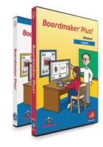
Tools for adapting curriculum
Boardmaker Plus v.6 brings lessons to life. The voice, sound, animation and video capabilities of Boardmaker Plus! help you create lively on-screen activities that engage your students and make learning fun. Whether creating print or on-screen symbol-based activities, it is easy to individualize them for your students. There are over 600 sample boards and 94 interactive templates to get you started. Use them as they are, adapt them to your students’ needs, or create your own from scratch.
BoardmakerShare.com is our online community where you will find thousands of pre-made activities that others have created and posted to share. Available at as a free subscription, BoardmakerShare.com is a great resource for sharing ideas and will save you time by giving you a head start on creating learning activities for your special needs students.
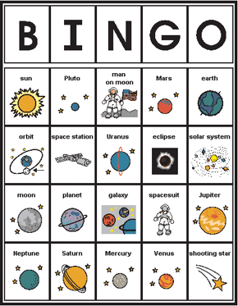
Bring your materials to life with multimedia
It’s easy to bring activities to life and make learning fun with the on-screen interactive features of Boardmaker Plus! The drag and drop feature makes it easy to incorporate videos, photographs or sound files directly from your web browser. The Mayer-Johnson Sounds Library contains more than 150 fun sounds, and synthesized and digitized speech provide powerful feedback options. The creative possibilities are endless:
- Symbolate buttons that read aloud and highlight each word or symbol-word pair as each word is spoken.
- Create dynamic activities for counting, sorting, sequencing and more with movable buttons.
- Link boards together into themed interactive units.
- Try more than 600 sample boards and 94 interactive templates.
- Develop on-screen literacy activities targeting specific skills.
- Motivate students to practice counting, matching, sequencing and sorting skills with movable buttons.
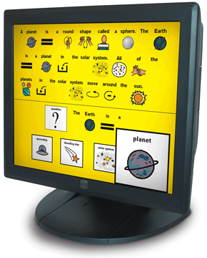
Makes creating print activities easy
Boardmaker Plus! has all the same powerful features as Boardmaker for creating print boards. It includes more than 4,500 Picture Communication Symbols (PCS) in both color and black-and-white, which are supported in 44 languages.
- Create stories, language activities, games and more using a combination PCS, photos or illustrations.
- Create customized symbols by combining elements of different PCS.
- Make symbols appear automatically as you type by using a Symbolate button.
- Personalize materials by simply dragging and dropping familiar images from the Internet, your digital camera or similar sources.
- Quickly reuse activities by adapting button content for students with different abilities.
- Print and cut materials with the help of dash lines that make cutting easy.
- Create colored button borders to add more visual appeal to activities.
- Install optional country-specific symbols for holidays, food and currency.
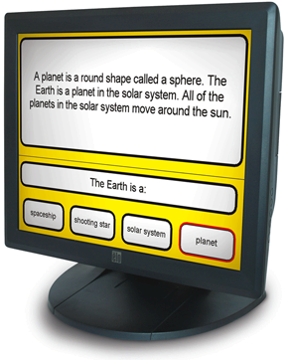

Available at:

The Boardmaker Plus program is avialble through the Mayer Johnson Company 2 www.mayer-johnson.com

System Requirements:
- Windows 2000 or higher
- 512 Mb RAM
- 400 Mb free disk space

Installation:

In the user’s manual review the following:
1) Program Window at a Glance
2) Symbol Finder at a Glance
3) Exploring the Templates and sample Boards

Once the User has completed these steps, it is time to morve onto the next step:

“Building a Board” User’s Guide located at page 11 of the User’s manual.

