Appendix F:
Forms

Student Assessment Checklist

Area | To  Do | Who | Notes | Done
Hearing

Vision

Medical

Dental

Cognitive

Primary
Characteristics

Social

Communication

Repetitive Patterns of Behaviour, Interests, and Activities

Associated Characteristics

Sensory

Anxiety

Resistance/Anger

Problem-solving/ Independence

Scattered Developmental Profile

Building Consensus on Priority Learning Needs

In looking for consensus on learning priorities, ask whether the
priorities being considered will lead to outcomes and activities that
□can be used in more than one setting or situation
□can be used now and in the future
□are likely to result in functional skills for the student
□promote independence
□create opportunities for meaningful contact and interaction with the
student’s peers
□fit the student’s interests and needs
□improve communication
□improve the student’s life at home and in the community
□match the student’s learning strengths
□promote generalization
□promote inclusion
(Adapted from Falvey, M.A. Community-Based Curriculum, 2nd ed., 1989: 41-43)

 | Gathering Information
 | What Do We Know? | What Do We Need  to Know? | How Will We  Find Out? | Who Will  Do It?
Primary
Characteristics

Social
Communication
Repetitive Patterns of Behaviour
Associated Characteristics
Sensory

(continued) | Gathering Information
(continued) | What Do We Know? | What Do We Need  to Know? | How Will We  Find Out? | Who Will  Do It?
Anxiety; Resistance/ Anger

Approaches to Learning; Interests, Preferences

Problem Solving/ Independence

Other Considerations
Hearing
Vision
Medical

Dental
Cognitive

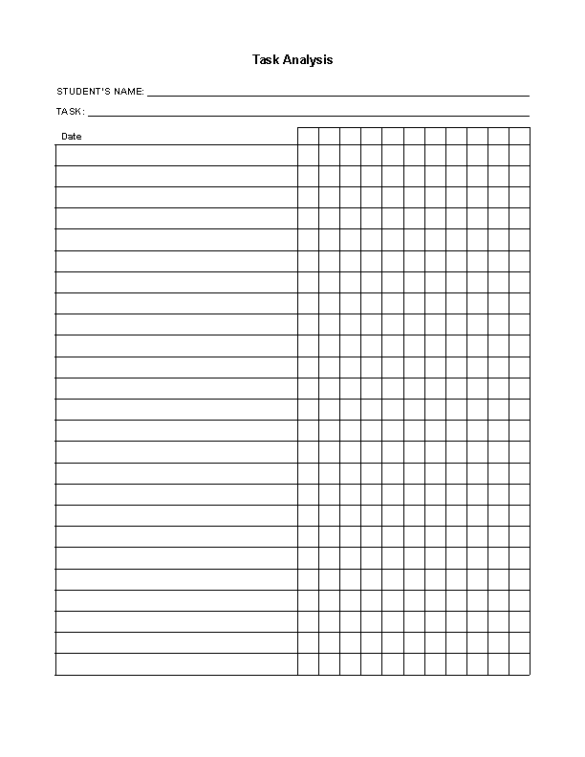
____________________________________________________’s Interpretation Dictionary
STUDENT’S NAME

What _____________does | What it might mean | How to respond to ________

(Adapted from British Columbia Ministry of Education, Teaching Students with Autism: A Resource Guide for Schools, 2000)

