History and Politics:
Arbour, Louise
Axworthy, Lloyd
Baldwin, Robert
Big Bear
Borden, Robert Laird
Bourgeoys, Marguerite
Brown, George
Callwood, June
Campbell, A. Kim
Cartier, George-Étienne
Casgrain, Marie Thérèse (Forget)
Champlain, Samuel
Chrétien, Jean
Clark, Charles (Joe) Joseph
Clarkson, Adrienne
Copps, Sheila Maureen
Crowfoot
Dallaire, Roméo
De Cosmos, Amor
Diefenbaker, John George
Douglas, Tommy
Edwards, Henrietta Muir
Erasmus, George
Hall, Emmett
Harper, Elijah
Howe, Joseph
Kielburger, Craig
King, William Lyon Mackenzie
La Fontaine, Louis-Hippolyte
Laurier, Wilfrid
Léger, Paul-Émile
Lewis, Stephen
Macdonald, John Alexander
Macphail, Agnes Campbell
Manning, Preston
Massey, Vincent
McClung, Nellie Letitia (Mooney)
McKenzie, Lewis
McKinney, Louise Crummy
McLaughlin, Audrey
Murphy, Emily
Okalik, Paul
Parlby, Irene
Pearson, Lester Bowles
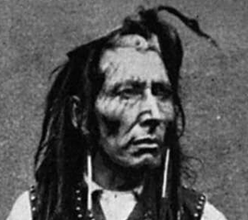

Poundmaker
Sauvé, Jeanne
Secord, Laura
Smallwood, Joseph Roberts
Trudeau, Pierre Elliott
Tubman, Harriet
Woodsworth, James
Vanier, George
Vanier, Jean

Arts and Culture

Albani, Emma

Atwood, Margaret
Berton, Pierre
Blais, Marie-Claire
Borduas, Paul-Émile
Callaghan, Morley
Callwood, June
Cardinal, Douglas
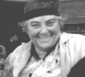

Carr, Emily
Carrier, Roch
Casavant, Joseph
Dafoe, John Wesley
Davies, Robertson
Frum, Barbara
Frye, Northrop
Fulford, Robert
Gould, Glenn
Group of Seven
Gzowski, Peter
Harrison, Ted
Heppner, Ben
(page 1 of 2)
Hind, E. Cora
Johnson, Pauline
Jewison, Norman
Kain, Karen
Karsh, Yousuf
Lampman, Archibald
Laurence, Margaret
Lavallée, Calixa
Leacock, Stephen
Lightfoot, Gordon
Macphail, Agnes Campbell
Maillet, Antonine
McLuhan, Marshall
Mitchell, Joni
Moodie, Susanna
Morrisseau, Norval
Montgomery, Lucy Maud
Mowatt, Farley
Munro, Alice
Munsch, Robert
Odjig, Daphne
Peterson, Oscar
Pratt, Mary
Roberts, Charles G.D.
Ross, Ian
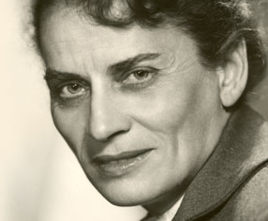

Roy, Gabrielle
Saul, John Ralston
Scott, Duncan Campbell
Shields, Carol
Thomson, Tom
Traill, Catherine Parr
Wicks, Ben

Science, Medicine and Technology
Abbott, Maude
Bailey, Donovan
Banting, Frederick
Bell, Alexander Graham
Bethune, Norman
Bombardier, Joseph-Armand
Bondar, Roberta
de Villiers, Marq
Fessenden, Reginald
Fleming, Sir Sandford
Garneau, Marc
Mance, Jeanne
Payette, Julie
Polanyi, John
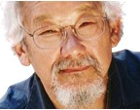

Suzuki, David

Sports
Béliveau, Jean
Daigle, Sylvie
Fox, Terry
Fréchette, Sylvie
Greene, Nancy
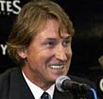

Gretzky, Wayne
Hansen, Rick
Henderson, Paul
Hoffman, Abby
Howe, Gordie
Laumann, Silken
Lemieux, Mario
Morenz, Howie
Plante, Jacques
Richard, Maurice
Schmirler, Sandra
Scott, Barbara Ann

<http://www.maisongabrielleroy.mb.ca/fr/attic.php>
<http://www.davidsuzuki.org/>
<http://www.waynegretzky.com/>
<http://bcheritage.ca/emilycarrhomework/family/emily.htm>
(page 2 of 2)

