beaver | map
flag | 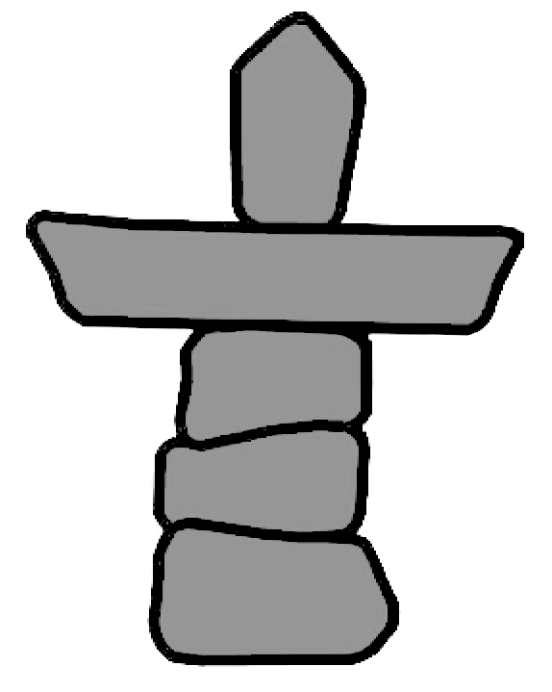  inuksuk
Mountie | maple leaf
moose | polar bear

