beaver | map
flag | inuksuk
Mountie | maple leaf
moose | polar bear

(page 1 of 2)
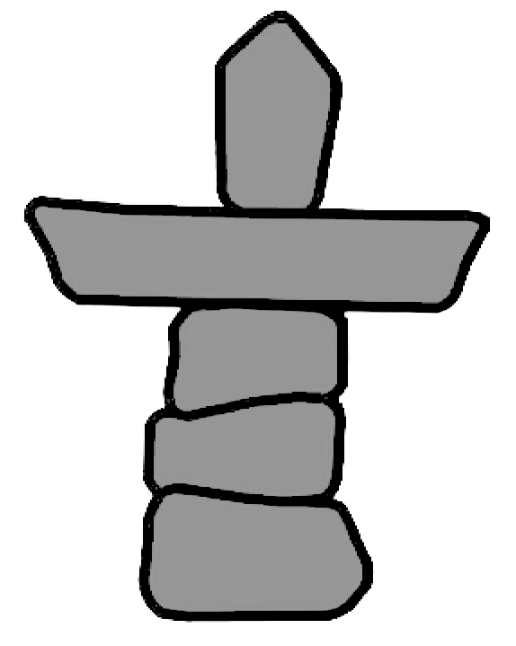

(page 2 of 2)

