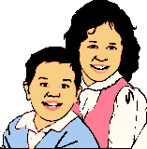
Shelter
Clothing
Love
Basic Needs
Water
Food

