Following is a list of Aboriginal cultural education centres in Manitoba.
Not all centres have facilities and staff for formal programs or speakers.

- Thunderbird House, Winnipeg:
<www.thunderbirdhouse.mb.ca/>
- Manitoba Indian Cultural Education Centre, Winnipeg (library, tours, resources):
<www.schoolnet.ca/aboriginal/micec/index-e.html>
- Dr. Jessie Saulteaux Resource Centre, Beausejour:
<www.mts.net/~drjessie/>
- South East Tribal Council:
<www.seed.mb.ca/profiles.html>
- Cross Lake Cultural Education Program
- Dakota Ojibway Tribal Council
- Brokenhead Ojibway Nation, Scanterbury
- Cultural Education Centre, Ebb & Flow Band
- Interlake Reserves Tribal Council (Fairford)
- Keeseekoowenin Ojibway First Nation:
<http://collections.ic.gc.ca/keeseekoowenin/index.html>
- Norway House First Nation Cultural Education Centre:
<www.schoolnet.ca/autochtone/norway/index-e.html>
- O-Chi-Chak-Ko-Sipi First Nation, Crane River
- Peguis First Nation Cultural Centre:
<www.peguis.ca/>
- Pine Creek First Nation
- Sagkeeng Cultural Centre, Inc.
- Rolling River Cultural Education Program
- Tootinaowaziibeeng Treaty Reserve #63A
- Waterhen First Nation
- West Region Tribal Council Indian Cultural Program
Contact information can be obtained through the Manitoba First Nations Directory:
<www.aboriginalcanada.com/firstnation/dirfnman.htm>
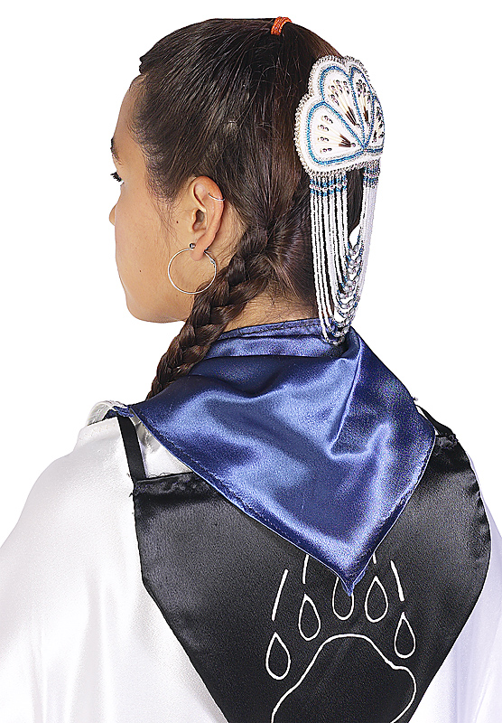

Teachers may also contact local Friendship Centres located in:
- Brandon - Dauphin
- Flin Flon - Lynn Lake
- Portage la Prairie - Riverton
- Selkirk - Swan River
- The Pas - Thompson

