Use these quotations to create a “World News” page
for a newspaper.

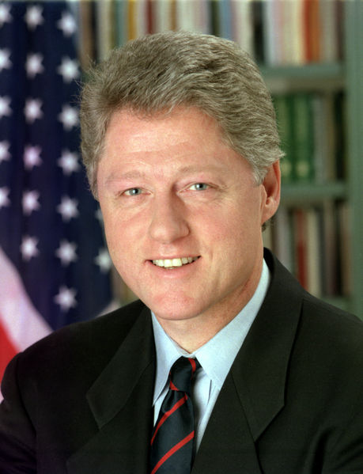

“In a world darkened by ethnic conflicts, that literally tear nations apart, Canada has stood for all of us as a model of how people of different cultures can live and work together in peace, prosperity,
and understanding.”
~ Bill Clinton, U.S. President, in an address to the House of Commons
and Senate, 23 February 1995.
President William Clinton

“I believe that the greatest contribution that Canada can make to Great Britain is to maintain the most friendly possible relations with the United States.”
~ J.S. Woodsworth, MP, refusing to vote in favour of the War Measures Act and war against
Germany, September 1939.

“Every immigrant who landed at Pier 21 has two stories: the story they came from and the story they started when they landed in Canada… There was one thought attached to every single immigrant who set foot here: gratitude.”
~ Rosalie Abella, Justice of the Court of Appeal of Ontario, in an address to mark the dedication of Pier 21 in Halifax, which from 1928 to 1971 served as a point of entry for half a million immigrants, many of them refugees, of whom Justice Abella was one. As quoted in “Welcome to Pier 21,” The Globe and Mail, 2 July 1999.
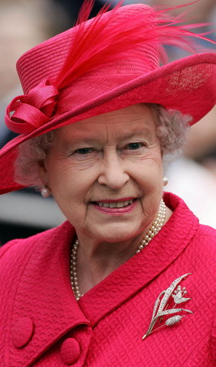
“The greatness of any country or group is to be found in what it gives to the world. It seems to me that it is in that direction that Canada will be great, not by its power but by its giving, by its radiance, by its example.”
~ Elizabeth II, Queen of Canada, address at Expo 67 in Montreal
in April 1967.
Photo: Copyright © Richard Gifford. All rights reserved.

Queen Elizabeth II

“When Canada stamps its foot, the world does not shake. But when Canada, beginning to shake off its dissidence, its inwardness, speaks loud and clear, the world echoes back, whether in its recognition of Canadian artistry or its appreciation of Canadian good-heartedness in an ever-troubled world.”
~ Stephen Brook, English travel writer, Maple Leaf Rag: Travels across Canada, 1987.

“There is nothing wrong with Americans dreaming of a republic which, by the year 2000, encompasses the Maritime and Western provinces of Canada, the Yukon and the Northwest Territories all the way to the pole.”
~ Pat Buchanan, U.S. commentator and Presidential candidate, 1993.
(page 1 of 3)
“Living next to you is in some ways like sleeping with an elephant. No matter how friendly and even-tempered the beast, one is affected by every twitch and grunt.”
~ Pierre Elliott Trudeau, Prime Minister, speech at the National Press Club in Washington,
25 March 1969.

Dear [Uncle] Sam,
Today is Constitution Day in Canada! That doesn’t mean much to you, I know – I doubt if it will make your front pages – but it’s a big thing for us. After centuries we’ve cut our last ties with Europe and we’re officially independent; our Queen says so. In fact she’s up there on Parliament Hill, saying it now with a very English accent. But then we’re used to English accents in this country – to a babel of accents: English, French, Scottish, Irish, Ukrainian, Italian, and many, many others – symbolizing those fierce ethnic and regional loyalties that hold us together as a distinctive people even as they tear us apart. A typically Canadian contradiction.
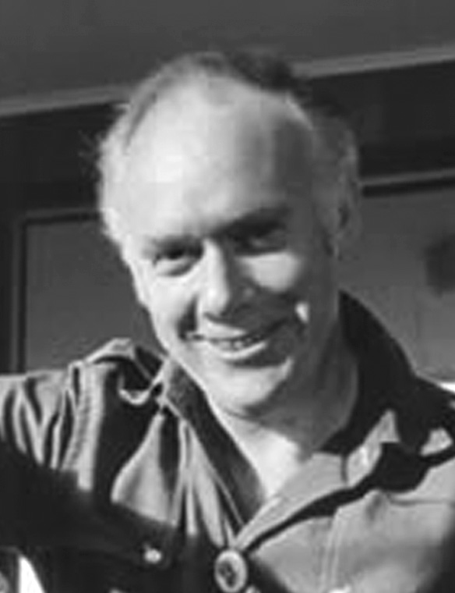
Up on Parliament Hill they’re singing “O Canada” in two languages and more than one version. They’re also singing “God Save the Queen,” because, you see, we still have a Queen and she’s all ours, even if she drops in on us only occasionally from her home at Buckingham Palace. By another typically Canadian contradiction, we have been made to believe that she is not the Queen of England, except when she’s in England, but the Queen of Canada, even when she’s not here. That allows us to be totally independent on this day of days: an odd business, when you think of it, since we have been insisting to you Americans for decades that we’ve really been independent all along.
But then, we’re only acting like Canadians, confusing everybody, especially your countrymen, who can’t see much difference between our two peoples.
~ Pierre Berton, Why We Act Like Canadians: A Personal Exploration
of Our National Character.
Photo: <www.pierreberton.com/›
Pierre Berton

“Despite our reputation, Canada is struggling environmentally. In an extensive OECD study (Organisation for Economic Co-operation and Development), Canada finished 28th out of 29 developed countries in categories such as air, water, waste and climate change. Canadians are known for their love of nature, but there is a large gap between our environmental values and our environmental record.”
~ David Suzuki, as quoted on the David Suzuki Foundation website: <www.davidsuzuki.org/WOL/Sustainability/>

“On behalf of the people of Canada, we protect and present nationally significant examples of Canada’s natural and cultural heritage, and foster public understanding, appreciation and enjoyment in ways that ensure the ecological and commemorative integrity of these places for present and future generations.”
~ Parks Canada Charter: <www.pc.gc.ca/agen/chart/chartr_E.asp>
(page 2 of 3)
“If Canadians cease to exist it is more likely to be death by hypnosis than by foreign investment. The vitality of American media, from the NBC to Penthouse, is such that Canadians are losing consciousness of themselves.”
~ John W. Holmes, Saturday Night, July 1974.

“Peacekeeping comes naturally to Canadians, as history has shown. The image of a Canadian soldier wearing his blue beret, standing watch at some lonely outpost in a strife-torn foreign country with binoculars at the ready, is very much an element of the modern mosaic, and a proud part of our national heritage.”
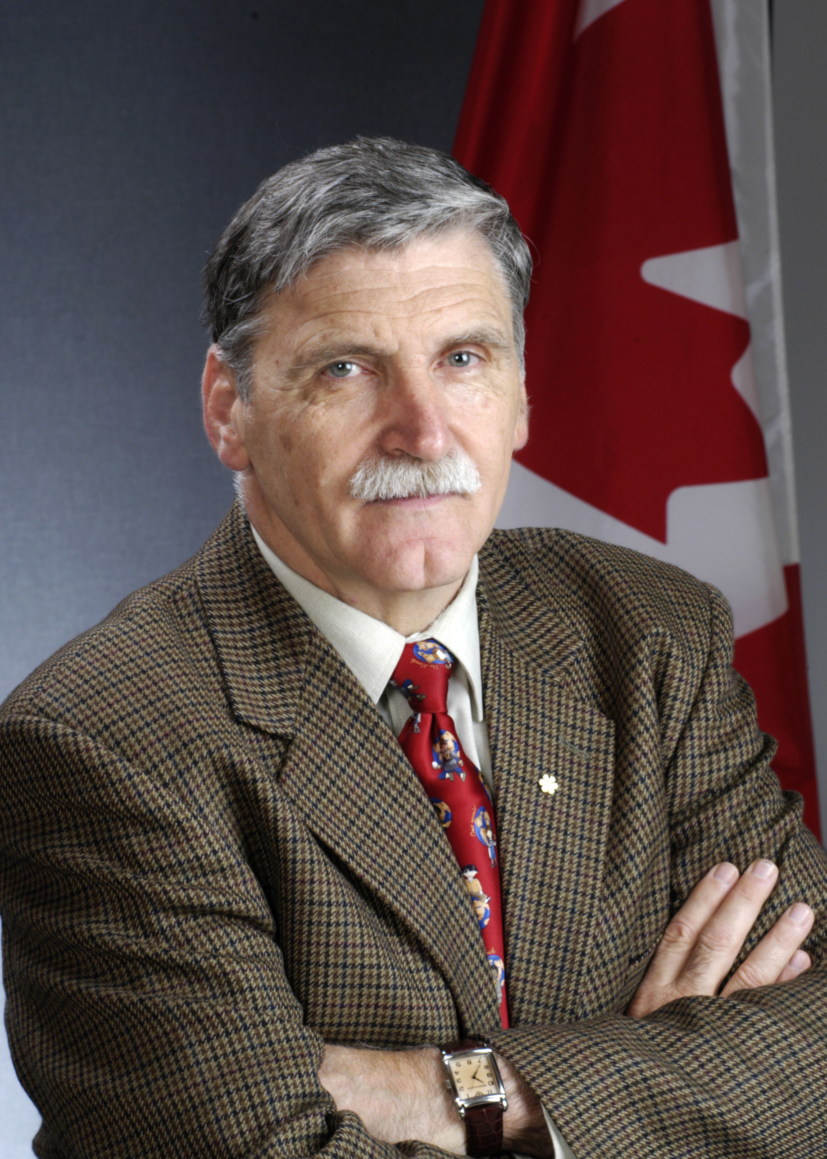
~ Paul D. Manson, General and Chief of Defence Staff, 17 November 1988.

“The U.N. is not a sovereign country. It’s us. It’s all of us. If the U.N. did not intervene, then by extension it is all of us. We all have a responsibility for the genocide in Rwanda.”
~ Roméo Dallaire, Major-General, former commander of the peacekeeping contingent under U.N. command in Rwanda, Central Africa, appearing before a tribunal in Tanzania, as quoted in The Globe and Mail, 26 February 1998.
Photo: Jean-Marc Carisse/Ottawa

“Canada is the only country in the world that has all the American opportunities but none of the problems the Americans face.”
Roméo Dallaire
~ Vlenatyn Moroz, Ukrainian dissident historian and Toronto resident,
quoted by Victor Malarek in The Globe and Mail, 17 April 1981.
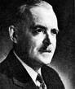
“I think you will agree that, indeed, the world today needs abundant sources of intellectual and moral energies. Canada wants to be one of those sources, and it has already begun to be one of those sources in several international organizations. With this purpose in mind we must further develop and enrich our own national soul.”
~ Louis St. Laurent, Prime Minister, speech in Ottawa, 12 November 1956.
Louis St. Laurent

“The world, in brief, needs Canada.”
~ Charles, Prince of Wales, in an address at Queen’s University in Ontario, as quoted in
The Globe and Mail, 29 October 1991.
(page 3 of 3)

