APEC | 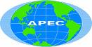 | Asia-Pacific Economic Cooperation | <www.apecsec.org.sg/apec.html>
CIDA | 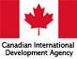 | Canadian International Development Agency (Canadian governmental body) | <www.acdi-cida.gc.ca/index-e.htm>
FAO | 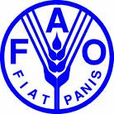 | Food and Agriculture Organization (UN body) | <www.fao.org>
FTAA | 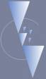 | Free Trade Area of the Americas | <www.ftaa-alca.org/alca_e.asp>
G8 | 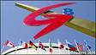 | Group of Eight (Eight leading industrialized democratic nations) | <http://en.civilg8.ru/G8_Group/index.php>
IMF | 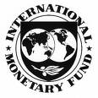 | International Monetary Fund | <www.imf.org>

(page 1 of 4)

ICJ | 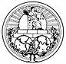 | International Court of Justice | <www.icj-cij.org>
IISD | 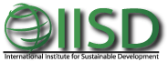 | International Institute for Sustainable Development | <www.iisd.org>
ICC | 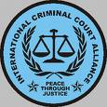 | International Criminal Court | <www.icc-cpi.int/ataglance/whatistheicc/  history.html>
IOC | 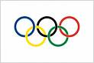 | International Olympic Committee | <www.olympic.org/uk/index_uk.asp>
NAFTA | 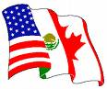 | North American Free Trade Agreement | <www.dfait-maeci.gc.ca/nafta-alena/  menu-en.asp>
NATO | 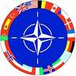 | North Atlantic Treaty Organization | <www.nato.int>

(page 2 of 4)

NORAD | 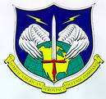 | North American Aerospace Defense | <www.norad.mil>
OAS | 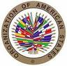 | Organization of American States | <www.oas.org>
OECD | 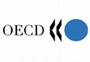 | Organization for Economic Cooperation and Development | <www.oecd.org/home>
OHCHR | 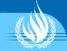 | Office of the UN High Commissioner for Human Rights | <www.ohchr.org/english>
UNAIDS | 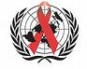 | The Joint United Nations Programme on HIV/AIDS | <www.unaids.org/en/default.asp>
UNDP | 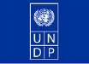 | United Nations Development Programme | <www.undp.org>

(page 3 of 4)

UNESCO | 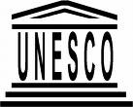 | United Nations Educational, Scientific and Cultural Organization | <www.unesco.org>
UNICEF | 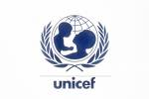 | United Nations Children’s Fund  (originally United Nations International Children’s Emergency Fund) | <www.unicef.org>
WHO | 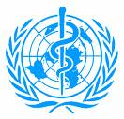 | World Health Organization | <www.who.int/en>
WTO | 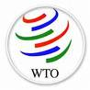 | World Trade Organization | <www.wto.org>
WWF | 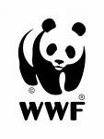 | World Wildlife Fund | <www.panda.org>
(page 4 of 4)

