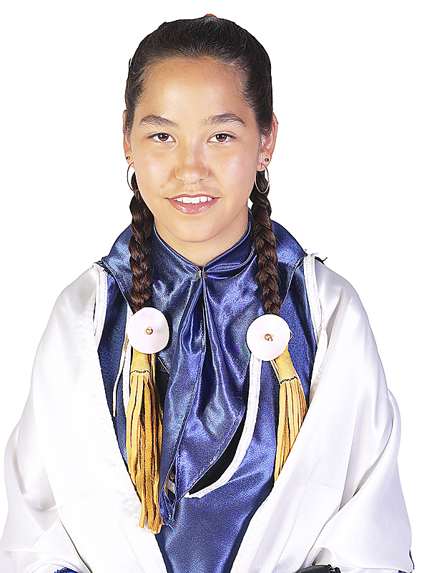
Article 3: Indigenous peoples have the right of
self-determination. By virtue of that right they freely determine their political status and freely pursue their economic, social and cultural development.

Article 7: Indigenous peoples have the collective and individual right not to be subjected to ethnocide and cultural genocide, including prevention of and redress for:
(a) Any action which has the aim or effect of depriving them of their integrity as distinct peoples, or of their cultural values or ethnic identities;
(b) Any action which has the aim or effect of dispossessing them of
their lands, territories or resources;
(c) Any form of population transfer which has the aim or effect of
violating or undermining any of their rights;
(d) Any form of assimilation or integration by other cultures or ways of life imposed on them by legislative, administrative or other measures;
(e) Any form of propaganda directed against them.

Article 9: Indigenous peoples and individuals have the right to belong to an indigenous community or nation, in accordance with the traditions and customs of the community or nation concerned. No disadvantage of any kind may arise from
the exercise of such a right.

Article 10: Indigenous peoples shall not be forcibly removed from their lands or territories. No relocation shall take place without the free and informed consent
of the indigenous peoples concerned and after agreement on just and fair compensation and, where possible, with the option of return.

Article 13: Indigenous peoples have the right to manifest, practise, develop and teach their spiritual and religious traditions, customs and ceremonies; the right to maintain, protect, and have access in privacy to their religious and cultural sites; the right to the use and control of ceremonial objects; and the right to the repatriation of human remains.

Article 14: Indigenous peoples have the right to revitalize, use, develop and transmit to future generations their histories, languages, oral traditions, philosophies, writing systems and literatures, and to designate and retain their
own names for communities, places and persons.

(page 1 of 3)
Article 15: Indigenous children have the right to all levels and forms of education of the State. All indigenous peoples also have this right and the right to establish and control their educational systems and institutions providing education in their own languages, in a manner appropriate to their cultural methods of teaching and learning. Indigenous children living outside their communities have the right to be provided access to education in their own culture and language.

Article 17: Indigenous peoples have the right to establish their own media in
their own languages. They also have the right to equal access to all forms of
non-indigenous media.
States shall take effective measures to ensure that State-owned media duly reflect indigenous cultural diversity.

Article 19: Indigenous peoples have the right to participate fully, if they so choose, at all levels of decision-making in matters which may affect their rights, lives and destinies through representatives chosen by themselves in accordance with their own procedures, as well as to maintain and develop their own indigenous decision-making institutions.

Article 21: Indigenous peoples have the right to maintain and develop their political, economic and social systems, to be secure in the enjoyment of their own means of subsistence and development, and to engage freely in all their traditional and other economic activities. Indigenous peoples who have been deprived of their means of subsistence and development are entitled to just and fair compensation.

Article 24: Indigenous peoples have the right to their traditional medicines and health practices, including the right to the protection of vital medicinal plants, animals and minerals. They also have the right to access, without any discrimination, to all medical institutions, health services and medical care.

Article 25: Indigenous peoples have the right to maintain and strengthen their distinctive spiritual and material relationship with the lands, territories, waters
and coastal seas and other resources which they have traditionally owned or otherwise occupied or used, and to uphold their responsibilities to future generations in this regard.

Article 27: Indigenous peoples have the right to the restitution of the lands, territories and resources which they have traditionally owned or otherwise occupied or used, and which have been confiscated, occupied, used or damaged without their free and informed consent. Where this is not possible, they have the right to just and fair compensation. Unless otherwise freely agreed upon by the peoples concerned, compensation shall take the form of lands, territories and resources equal in quality, size and legal status.
(page 2 of 3)

Article 30: Indigenous peoples have the right to determine and develop priorities and strategies for the development or use of their lands, territories and other resources, including the right to require that States obtain their free and informed consent prior to the approval of any project affecting their lands, territories and other resources, particularly in connection with the development, utilization or exploitation of mineral, water or other resources. Pursuant to agreement with the indigenous peoples concerned, just and fair compensation shall be provided for any such activities and measures taken to mitigate adverse environmental, economic, social, cultural or spiritual impact.

Article 31: Indigenous peoples, as a specific form of exercising their right to
self-determination, have the right to autonomy or self-government in matters relating to their internal and local affairs, including culture, religion, education, information, media, health, housing, employment, social welfare, economic activities, land and resources management, environment and entry by non-members, as well as ways and means for financing these autonomous functions.

Article 32: Indigenous peoples have the collective right to determine their own citizenship in accordance with their customs and traditions. Indigenous citizenship does not impair the right of indigenous individuals to obtain citizenship of the States in which they live.
Indigenous peoples have the right to determine the structures and to select the membership of their institutions in accordance with their own procedures.

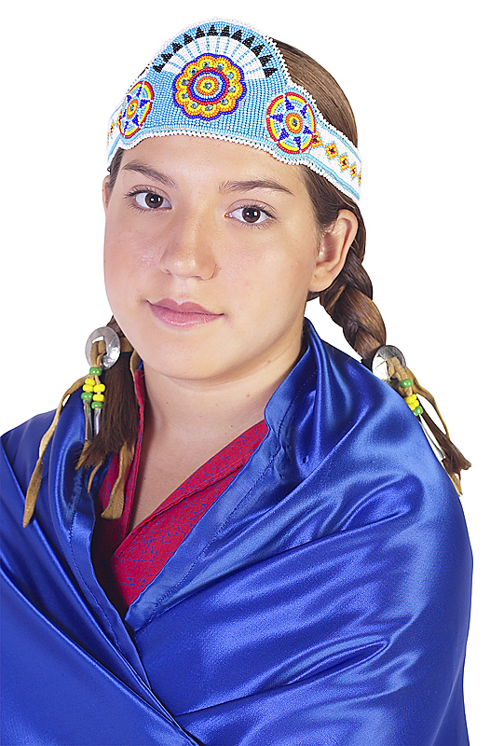
Article 35: Indigenous peoples, in particular those divided by international borders, have the right to maintain and develop contacts, relations and cooperation, including activities for spiritual, cultural, political, economic and social purposes,
with other peoples across borders.

Article 36: Indigenous peoples have the right to the recognition, observance and enforcement of treaties, agreements and other constructive arrangements concluded with States or their successors, according to their original spirit and intent, and to have States honour and respect such treaties, agreements and other constructive arrangements.
(page 3 of 3)

