Note-Taking Frame

Time period of the numbered treaties: | Government reasons for these treaties:
Aboriginal peoples involved in treaty signing with the federal government:

First Nations reasons for signing treaties: | General geographical areas covered by  these treaties:
Examples of effects and issues related to the numbered treaties:

Sources:
(page 1 of 3)

Some facts about the numbered treaties:

There are eleven numbered treaties in all.  (1871 – 1921)  1871 – 1877: Seven treaties, mostly relating to southern and central parts of today’s Prairie provinces, were signed.  1889 – 1921: Four more treaties, mostly relating to the northern areas of Canada, were signed. | The government signed treaties to obtain land and resources to build the railway and create farmland areas for immigrants, to extend Canada’s nation from sea to sea, and to claim  and use natural resources in northern Canada (oil, gold).
Not all Aboriginal peoples signed treaties. The Inuit, most of the peoples of British Columbia, and the Métis people were not approached by the government. (Refer to the chart that follows for a list of some peoples who signed treaties.)
As hunting and food supplies became scarce, Aboriginal peoples became more dependent on food rations from the government, trade with the new immigrants, and agriculture. Treaties promised reserve lands, hunting and fishing rights, money, annual payments, and assistance with education, medical care, and agricultural machinery. Not all promises were kept. | Numbered treaties cover  - most of the Prairie provinces  - northern Ontario  - parts of British Columbia  - Yukon Territory  - Northwest Territories
Effects and issues related to numbered treaties:
  - The railroad, increase in the immigrant population, and newly settled farms eroded hunting habitat and made it less possible to survive on hunting and fishing. First Nations peoples were displaced to designated reserve lands, often the poorest areas for agriculture.
  - Freedom of movement was restricted, and the people were confined to reserves rather than being free to follow a traditional migratory lifestyle.
  - People who were designated as “Indians” by the government did not have the same rights as other citizens until 1960.
  - The arrival of many immigrants to Canada brought European diseases (smallpox, tuberculosis, measles), which spread rapidly among First Nations.
  - Misunderstandings occurred over terms of treaties as some oral promises made by the government and preserved in oral tradition by First Nations were not honoured; in other cases misunderstandings arose because of faulty translation.
  - Treaty commissions have been formed in BC, Saskatchewan, and Manitoba in part to work toward settling treaty claims.
  - Some modern land claims are based on unfulfilled terms of the numbered treaties.
- There are ongoing dispute resolution issues pertaining to treaty rights, land use rights, fishing and hunting rights, natural resource use, respect for traditional territories, et cetera. Some treaty obligations were unfulfilled by government and others were interpreted differently by the signatory parties.
(page 2 of 3)

Treaty Number and Date | Region and First Nations
Treaties 1 and 2, 1871 | Southern Manitoba and Saskatchewan  Ojibway and Cree peoples
Treaty 3, 1873 | Lake of the Woods region in Ontario  Saulteaux (Ojibway) peoples
Treaty 4, 1874 | Southern Saskatchewan (Qu’Appelle region)  Cree and Saulteaux (Ojibway) peoples
Treaty 5, 1875 | Central-northern Manitoba  Saulteaux (Ojibway) and Swampy Cree peoples
Treaty 6, 1876 | Central Saskatchewan and Alberta  Mostly Plains and Woodlands Cree peoples
Treaty 7, 1877 | Southern Alberta  Blackfoot and other nations
Treaty 8, 1899 | Northern Alberta and northeast corner of B.C.  Cree, Dene, Dogrib, and other nations
Treaty 9, 1905 | Northern Ontario (James Bay region)  Ojibway, Cree, and other nations
Treaty 10, 1906 | Northern Saskatchewan (Peace River region)  Primarily Dene and Métis peoples  Provided Métis scrip (certificates to be redeemed for cash or land)
Treaty 11, 1921 | Western part of Northwest Territories  Primarily Dene and Métis of the Mackenzie region

Sources:
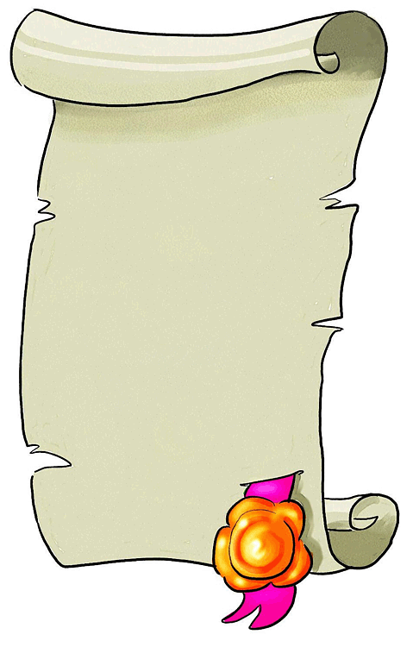
Indian and Northern Affairs Canada, Numbered Treaties:
<http://atlas.gc.ca/maptexts/map_texts/english/trytxt_e.html#NU>
Canada’s Digital Collections, First Nations and Métis, Treaties - Overview:
<http://collections.ic.gc.ca/abpolitics/alberta/fn_metis/treaties.html>
“Treaty Land Entitlement of Manitoba, Inc”
<http://www.tlec.ca/>
“Treaties as a Bridge to the Future”
Office of the Treaty Commissioner, Saskatchewan
<http://www.otc.ca/aboutotc.htm>
“About Us”, BC Treaty commission
<http://www.bctreaty.net/files_3/aboutus.html>
“Specific Land Claims Branch”, INAC
<http://www.ainc-inac.gc.ca/ps/clm/scb_e.html>
(page 3 of 3)

