Role of Citizenship in Social Studies
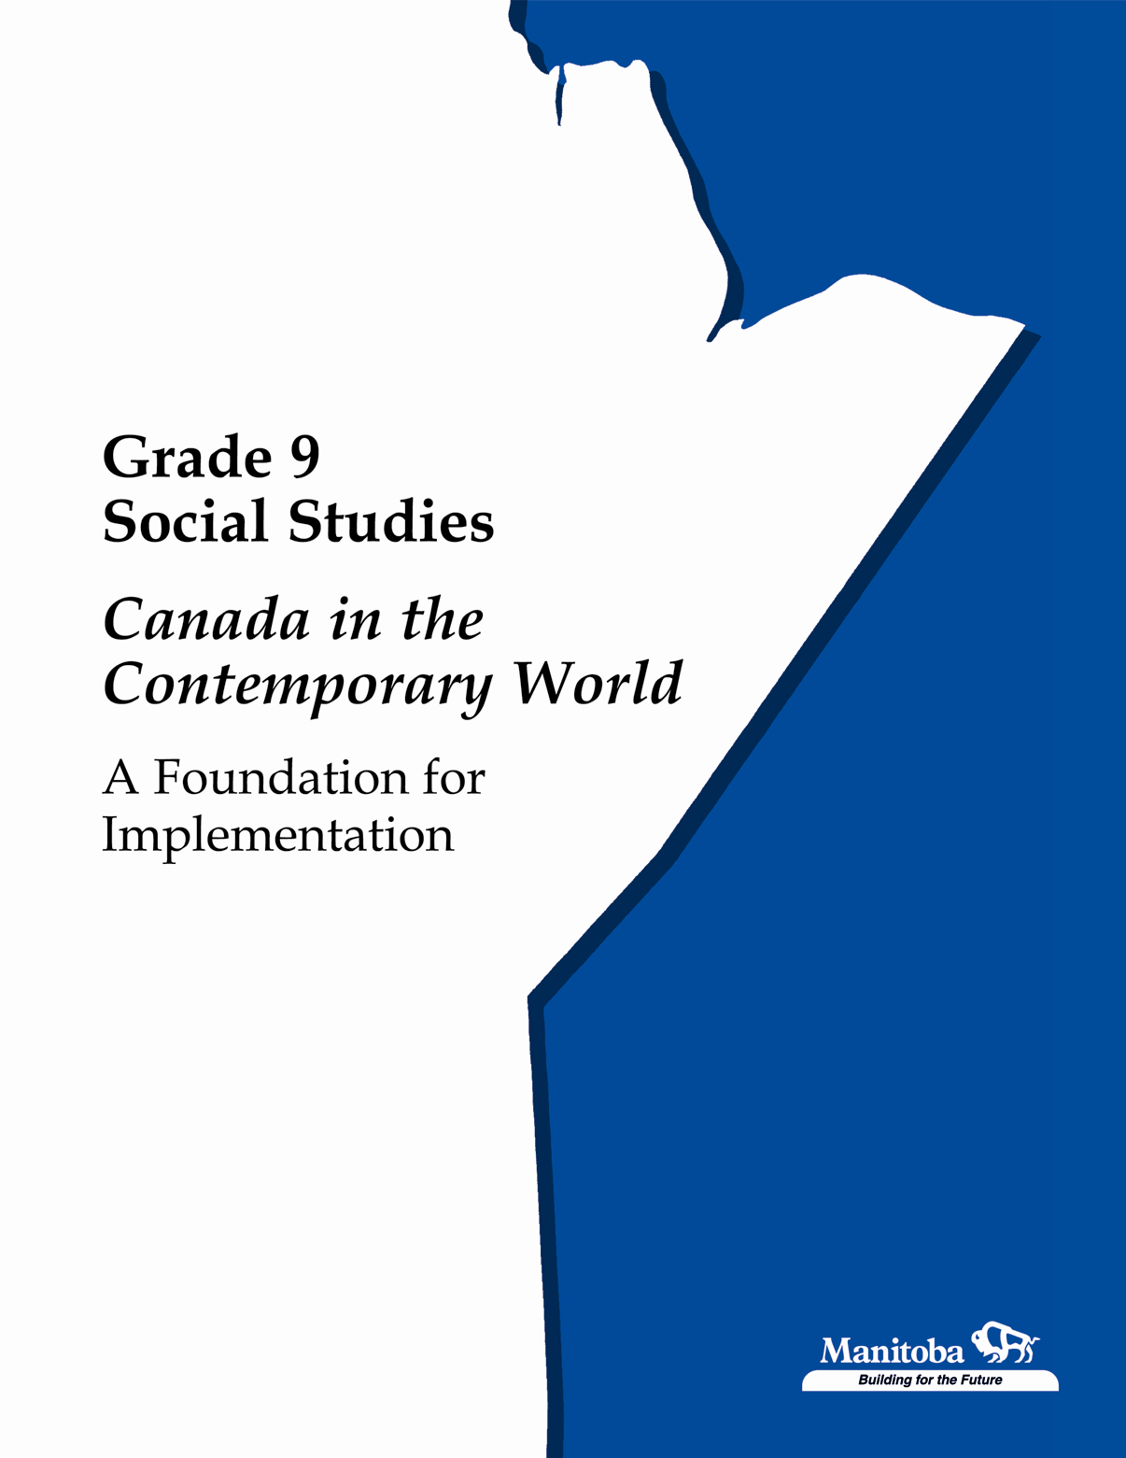
Citizenship is the core concept that provides the learning focus for social studies at all grades. To identify the skills, knowledge, and values that students will need as active democratic citizens, social studies must take into account the society in which students live, and anticipate the challenges they will face in the future. Citizenship is a fluid concept that changes over time: its meaning is often contested, and it is subject to interpretation and continuing debate.

Achievement of the learning outcomes will prepare students to participate in the public dialogue that characterizes any democracy and plays an important role in Canadian society. As students engage in this
dialogue, they will enhance their understanding of citizenship in Canada and the world, and will be better prepared to become active participants in their communities—locally, nationally, and globally.

Rationale for Citizenship Education

Citizenship education is fundamental to living in a democratic society. The concept of citizenship takes on meaning in specific contexts and is determined by time and place. Diverse notions of citizenship have been used in the past and are being used in the present, for both good and ill.

Throughout much of history, citizenship has been exclusionary, class-based, racist, and sexist. In Canada, for instance, First Nations parents were forced to send their children to residential schools in the interests of citizenship. The concept of citizenship must be considered within the context of democracy, human rights, and public debate. Social studies provides opportunities for students to explore the complexities of citizenship.
(page 1 of 3)
Active Democratic Citizenship in Canada

Since citizenship issues are rooted in the past, Canadian history occupies an important place in the social studies curriculum. Canada is regionally diverse and geographically expansive. It is organized as a federal parliamentary monarchy, with a mixed, although largely capitalist, economy. It is a bilingual and multicultural country committed to pluralism, human rights, and democracy.

Canada is regarded as one of the most prosperous, peaceful, and democratic countries in the world, although it still has its share of economic and social injustices and inequities.

Canada is a complex country that requires special qualities in its citizens.
These citizenship qualities include:
- knowledge of Canadian history and geography
- understanding of the distinctive nature of Canadian society, the
Canadian state, and its institutions
- the ability to approach public issues critically, rationally, and democratically
- informed involvement in public affairs
- respect for human rights and democratic ideals and principles
- commitment to freedom, equality, and social justice
- the ability to work through conflicts and contradictions that can arise
among citizens
- willingness to live with ambiguity and uncertainty
- civility and tolerance for dissension and disagreement
- willingness to balance the pursuit of private interests with concern
for the public good
- the ability to balance personal claims of conscience and principle
against the similar claims of others
- a sense of shared identity as Canadians, combined with a realization
that Canadian identity is multifaceted, open to debate, and not
exclusive of other identities

Canadian Citizenship for the Future

For the foreseeable future, Canadian citizens will likely continue to face issues such as:
- balancing the jurisdictional claims of the provinces and the federal government
- redressing past and present injustices inflicted on Aboriginal peoples and other groups in Canada
(page 2 of 3)
- coming to terms with the complexities of Québec’s place in Canada
- balancing regional and cultural diversity with national unity
- protecting Canadian identity and sovereignty
- assuring access to social services and quality of life for all
- eliminating inequalities related to race, gender, age, class, and ethnicity
- protecting the environment
- ensuring the successful functioning of the economy

Citizenship in the Global Context

Canada does not exist in isolation; it is part of a global community that is becoming increasingly interconnected and interdependent. Many of the most serious problems facing the world must be dealt with on a global basis.

The nation-state—including Canada—is under increasing challenge, externally from the forces of globalization, and internally from demands for more local or regional autonomy. The world also continues to be characterized by severe disparities between rich and poor countries. This disparity violates the basic principles of social justice and human dignity, and, at the same time, gives rise to dangerous tensions and rivalries. War and violence continue to be a common means of addressing internal and international disputes, and, because of developments in weapons technology, are becoming ever more destructive. In these circumstances, Canadian citizens need to think and act globally as well as nationally.

Environmental Citizenship

Underlying both national and global realities, and the responsibilities they impose on citizens, is the increasing fragility of the natural environment. Quality of life depends upon the sustainability of the environment. This places a particularly important responsibility on citizens, who must ultimately balance the demands of economic growth and high living standards against respect for the environment and the needs of future generations.

Source: Manitoba Education and Youth (2003), Kindergarten to Grade 8 Social Studies, Manitoba Curriculum Framework of Outcomes, pages 9 – 10.
(page 3 of 3)

