Date | Event
1899 | After much debate, Canada sends volunteer troops to South Africa to support Great Britain in the Boer War.
1914 – 1918  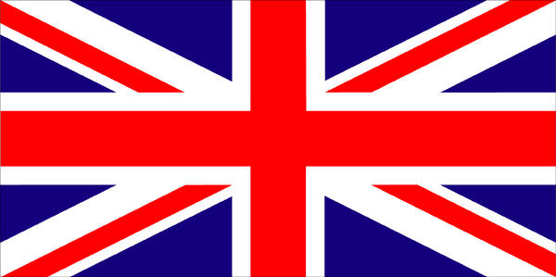 | Canada, as a colony of Great Britain, supports the Allies in the First World War in Europe, fighting in conditions of trench warfare and enduring heavy losses. Over 600,000 Canadians enlist in the Canadian Expeditionary Force. Canadian forces particularly distinguish themselves at the Somme, Vimy Ridge, and the “Last Hundred Days” of the liberation of countries occupied by Germany.
January 10, 1920 | The League of Nations, the forerunner of the United Nations, is established in Geneva. Canada is among the founding members. The League aims to promote international co-operation and to achieve international peace and security. The states of the League of Nations pledge themselves not to go to war before submitting their disputes to arbitration or enquiry.
1939 – 1945 | Serving in the Canadian Army, the Royal Canadian Navy, the Royal Canadian Air Force, and with other Allied Forces, thousands of young Canadians fight in the Second World War from 1939 to 1945. They help defend the United Kingdom when it appears that Nazi invasion is imminent; they attempt to defend Hong Kong against the Japanese; at Dieppe they are significant in a fateful raid against the enemy-controlled coast of France. Above all they play their part in two great campaigns: they fight for 20 months in Italy, and are in the front lines when the Allies return to Continental Europe on D-Day in 1944.
June 1945 | The United Nations is created in San Francisco. Canada is one of the original members to sign the Charter.
1945 - 1989  Cold War | Two superpowers—the Soviet Union in the East, and the United States in the West—build up powerful nuclear weapons in a hostile and tense competition for world power. Countries ally with one side or the other in military alliances. Fears of Communism, spies, and nuclear war grow in the West. Canada is allied with the United States, but it does not actively participate in the build-up of nuclear arms.
December 1948 | U.N. countries sign the Universal Declaration of Human Rights, which Canadian John Humphrey had an important role in writing.
1949 | The British Commonwealth is created; Canada is one of the original members.
1949 | NATO—the North Atlantic Treaty Organization —is created as a military defence alliance because of Cold War tension between western nations and Russia and its allies. NATO includes Canada, the U.S., Britain, and countries of northwestern Europe.
(page 1 of 4)
1950 – 1953 | Canada sends troops to the Korean War in a United Nations-supported military action.
1952 | Lester Pearson becomes Canada’s ambassador to the United Nations.
1956  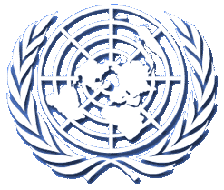 | The first U.N. peacekeeping troops, in a decision negotiated by Lester Pearson, are sent to prevent war in the Suez Crisis.
1957 | Lester Pearson wins the Nobel Peace Prize.
1958 | Canada creates the Canadian International Development Agency (CIDA) to support international cooperation with countries of the world.
1960 – 1964 | Canadian peacekeeping troops help secure peace in the Congo.
1962 | Cuban Missile Crisis: U.S. and the Soviet Union come close to nuclear war.
1964 | Canada participates in a U.N. peacekeeping mission to Cyprus.
1965 | Canada signs the Automobile Pact with the U.S.: this is the beginning of free trade between the two countries.
1967 | Canada sends troops to support ongoing U.N. missions and truce observer operations at various points in the Middle East.
1970 | The Organization of American States (OAS) is created.
1970 | The international organization of the Francophonie is created.
1973 – 1979 | Canadian Forces stand between Egyptians and Israelis in the Sinai to help preserve a fragile peace between these two countries.
1973 | Pierre Elliott Trudeau visits China on a peace mission.
1976 | Olympic Games are held in Montréal.
1977 | Canada establishes protected fishing zones up to 200 miles from its coasts.
1977 | Canada participates in the first Inuit Circumpolar Conference with other northern nations.
1983 | The Inuit Circumpolar Conference is held in Iqaluit (NWT).
1988 | Olympic Games are held in Calgary.
1988 – 1990 | Canadian troops monitor the withdrawal of Soviet troops and the voluntary return of refugees in Afghanistan.
1988 – 1991 | Canadian troops observe the ceasefire that ended an eight-year war between Iran and Iraq.
1989 – 1990 | Canadian troops assist in Namibia's transition to independence. Canadians assist in de-mining operations in war-torn regions of Pakistan.
1989 – 1992 | Canadian troops help bring an end to civil war in Nicaragua.
1990 – 1991  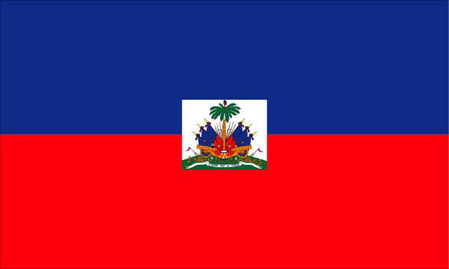 | Canadians send observers to Haiti to help supervise democratic elections.
1991 | Canada sends troops to support the U.S. in the Gulf War against Iraq.  (page 2 of 4)
1991 – 1997 | Canadian troops help supervise the withdrawal of South African and Cuban troops from Angola.
1991 – 2000 | Canadians help establish stable government and clear land mines in Cambodia.
1992 – 1994 | Canadian troops help bring an end to civil war in El Salvador.
1994 | U.S., Canada, and Mexico sign the North American Free Trade Agreement (NAFTA).
1994 | The Canadian government establishes the Lester B. Pearson Canadian International Peacekeeping Training Centre on the site of a former military base in Nova Scotia. The centre provides research, education, and training for peacekeepers from Canada and abroad.
1995 | Canada seizes a Spanish ship that is fishing illegally in Canadian waters.
1997 | Canada sends troops to assist in ongoing U.N. missions and land mine-clearing operations in Bosnia-Herzegovina.
1997 | Canada is one of the first countries to sign the Land Mine Ban Treaty.
1997 | Canada signs the Kyoto Accord, an international agreement to reduce greenhouse gas emissions in order to control climate change.
1999 | Canadians send ongoing support in the rehabilitation of Kosovo and the Balkans: community and humanitarian aid, support for democratic governance, human rights, mine action, war crimes investigation, and police training.
1999 – 2001 | Canadian troops help contain violence and offer humanitarian assistance in East Timor.
July 1999 | The Pan American Games are held in Winnipeg.
June 2001 | Stephen Lewis, a Canadian, is named special U.N. Envoy to Africa on AIDS.
October 2001 | Canada contributes ongoing diplomatic, defence, and development support to the war in Afghanistan.
April 2003 | Canada takes the position that it will not participate in the Iraq war without consent for military action from the United Nations Security Council.
1999-2005 | Canadian Forces take part in a U.N. Mission in Sierra Leone.
2000-2003 | Canadian Forces participate in the United Nations Mission in Ethiopia and Eritrea.
2001-2004 | Canadian Forces participate in the International Campaign Against Terrorism in the Persian Gulf.
2002 | Canadian Forces participate in a large-scale offensive against al-Qaeda and Taliban forces in Afghanistan. This is the first time since the Korean War the Canadian soldiers relieved American soldiers in a combat operation.
2003 | Canadian Forces move to the northern city of Kabul, Afghanistan, where it becomes the commanding nation of the newly formed NATO International Security Assistance Force (ISAF).
(page 3 of 4)
2003 | Canadian Forces participate in a French-led Interim Emergency Multinational Force in Bunia, Democratic Republic of Congo.
2003 | Canadian Forces participate in the United Nations Mission in Liberia.
2004 | Canadian Forces contribute to a stabilization mission in Haiti.
2004-2005 | Canadian Forces participate in tsunami relief efforts in Sri Lanka.
2005 | Canadian Forces provide support to U.S. relief effort in the wake of Hurricane Katrina.
2006 | Canadian Forces take over the leadership of coalition forces based in Kandahar, Afghanistan.

Note: This is not an exhaustive list but a representative snapshot of Canadian international involvement, focusing mainly on military and peacekeeping initiatives.

(page 4 of 4)

