Read the following quotations. In groups, decide by consensus which quote best represents the concept of citizenship.

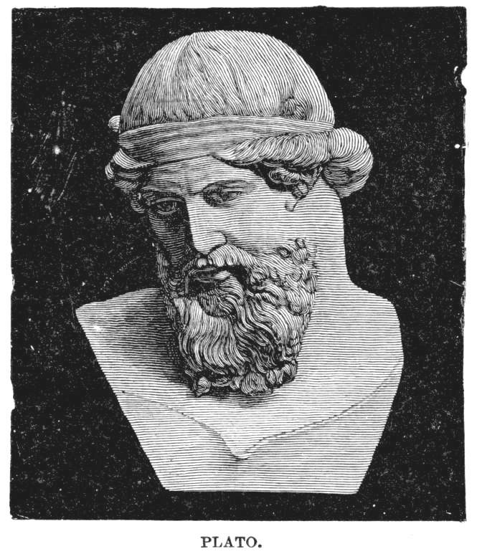
“The cost of not showing an interest in public affairs is to be governed by persons worse than oneself.”
~ Plato, Greek philosopher, 5th century BCE

“I would suggest that any country that does not claim the full loyalty of its citizens old or new, any country that counts citizens old or new who treat it as they would a public washroom – that is, merely as a place to run in an emergency - accepts for itself severe internal weakening. It is perhaps inevitable that for many newcomers Canada is merely a job.”
~ Neil Bissoondath, “A Question of Belonging,” The Globe and Mail, 28 January 1992.
Plato: circa 427 – 347

“There should be a law that Canadians would not be granted citizenship until they’ve crossed this country by car, or, if they can find one, by train. That kind of odyssey would serve to remind us that even if we’ve always suffered from constitutional indigestion, our forefathers performed a series of miracles to originally settle this country.”
~ Peter C. Newman, columnist, Maclean’s, 6 July 1992.

“What is it that the citizens desire? That is the question that every democratic government must ask itself constantly… For if it is to establish an order that citizens will agree to support, the state must go further than merely investigating their needs; it must also encourage them to demand what they consider just. In this way democracy becomes a system in which all citizens participate in government: the laws, in a sense, reflect the wishes of the citizens and thus turn to account the special wisdom of each one; the social order to some extent embodies all the wealth of human experiences that the citizens possess.”
~ Pierre Elliot Trudeau, 1958, “Approaches to Politics,” in Vrai .

“It may not be fashionable to talk about love and solidarity as political and economic duties. These are, we are told, private things best left to private moments. But they are public values as well. There is a will to solidarity, to community, to love. It can break barriers of class, of upbringing, of colour, of language. It reminds us that we have duties as well as rights: responsibilities to the earth itself, duties to take care of ourselves, to take care of others.”
~ Bob Rae, NDP Leader, election campaign address delivered in 1990 before being elected Ontario premier, The Globe and Mail, 1 October 1990.

