Youth Criminal Justice Act
Bill C-7, the Youth Criminal Justice Act (YCJA), received Royal Assent on February 19, 2002, and came into force as of April 1, 2003.
The YCJA, which replaces the Young Offenders Act (YOA), is a key part of the Government of Canada's Youth Justice Renewal Initiative. The Act incorporates the Initiative's new approach to youth justice and forms the backbone of a major restructuring of the youth justice system that has been underway since 1998.

The Youth Criminal Justice Act is based on the following principles:
- It creates a presumption that measures other than court proceedings should be used for a first, non-violent offence.
- It encourages the use of measures other than court processes in all cases where they are sufficient to hold a young person accountable.
- It encourages the involvement of families, victims, and community members.

Manitoba Parental Responsibility Act
The Manitoba Parental Responsibility Act is unique in Canada. This legislation allows Manitoba victims of youth crime to recover damages from parents whose children (up to 18 years of age) have been involved in deliberately taking, damaging, or destroying property.
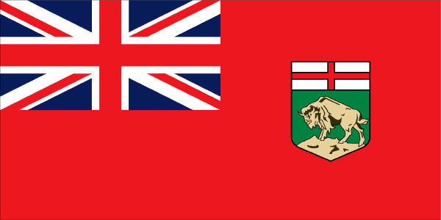
Victims who wish to obtain damages from the parents of a youth convicted of a crime must file a claim in Small Claims Court. The Act does not apply to children who are wards of child and family services agencies.

