“The foundations of justice are that no one shall suffer wrong; then, that the public good be promoted.”
Fundamenta justitiae sunt, ut ne cui noceatur, deinde ut communi utilitati serviatur. [Latin]
~ Cicero, Roman lawyer and orator, c. 100 BCE

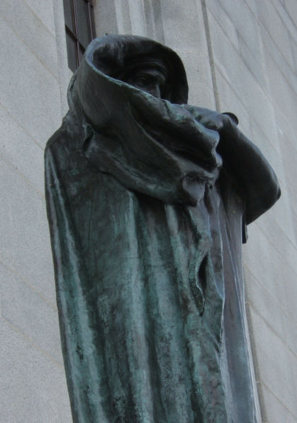
One of the most recognized legal symbols is that of Justice. The idea of a woman portraying justice dates back to the ancient Greek and Roman images ofThemis and Justitia. Themis, the Greek goddess of justice and law, was known for her clear-sightedness. In Roman mythology, Justitia (Justice) was one of the four Virtues. Justitia was often portrayed as blindfolded, holding scales and a sword. She was sometimes depicted holding the fasces (a bundle of rods around an ax symbolizing judicial authority) in one hand and a flame, symbolizing truth, in the other.
Justitia
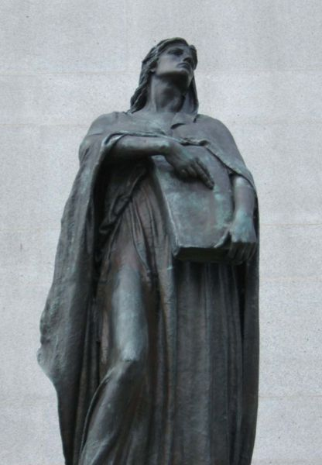
Many Western societies still portray justice as a blindfolded woman carrying a sword and a set of scales. She symbolizes the fair and equal administration of the law, without corruption, greed, prejudice, or favour.

The entrance to the Supreme Court of Canada building in Ottawa is flanked by two huge statues, Justitia and Veritas (Truth). The statue of Justitia is portrayed as a woman holding a two-edged sword, but she does not wear the traditional blindfold. Some have interpreted this to mean that the nine Supreme Court Justices of the highest court of the land must clearly see the consequences of their decisions, and must communicate them to the Canadian public.

The statues Justitia and Veritas are landmarks in their own right, and have an intriguing history. After they were commissioned in 1912, the plaster forms for the statues mysteriously disappeared, only to be found in 1969 in crates in an Ottawa parking lot. They were cast in bronze the next year.
Veritas

Images Copyright © William Norman. All rights reserved. Reproduced from <http://en.wikipedia.org/wiki/Supreme_Court_of_Canada> under the terms of the Wikipedia Image Use Policy.

