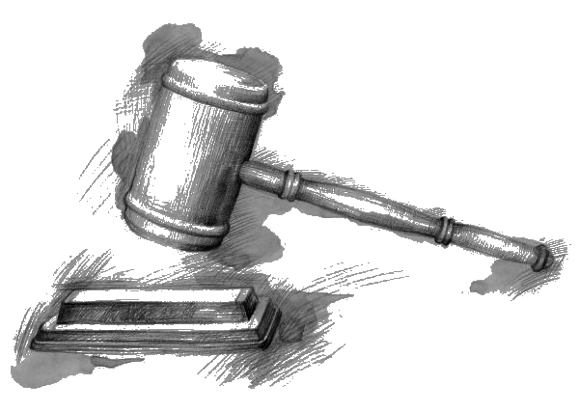
Cut out and arrange the cards in four separate categories:
1. federal 2. First Nations 3. provincial 4. municipal

Crown | Governor General
Prime Minister | Federal Cabinet Ministers
Senators | Members of Parliament
Supreme Court Judges | Leader of the Official Opposition
National Chief, Assembly of  First Nations | Chiefs-in-Assembly or Confederacy of Chiefs
Lieutenant-Governor | Premier of Manitoba
Executive Council of  Manitoba Government  (Provincial Cabinet) | Members of the Legislative Assembly (MLAs)
Manitoba Court of Queen’s  Bench Judges | Mayor or Reeve
City Councillors or Town Councillors | School Trustees

(page 1 of 2)
Copy each position title from the cards on page 1 into its appropriate box. Add details such as how people are chosen for the position and the names of current representatives.

 | Federal | First Nations | Provincial | Municipal  or Local
Executive
Ruling, putting laws into action, making decisions
Legislative
Making laws, changing laws, proposing laws
Judicial
Applying and enforcing laws, interpreting laws
(page 2 of 2)

