Read each of the following quotations. Note the date of each quotation and reflect on the circumstances in Canada at that time. In groups, discuss the quotations and generate questions you have about the cause and effect of discrimination in Canada.

“... I found two nations warring in the bosom of a single State… I cannot doubt that any French Assembly that should again meet in Lower Canada will use what ever power, be it more or less limited, it may have, to obstruct the government, and undo whatever has been done by it. ... I believe that tranquility can only be restored by subjecting the province to the vigorous rule of an English majority; and that the only efficacious government would be that formed by a legislative union. I entertain no doubts as to the national character which must be given to Lower Canada; it must be that of the British Empire; that of the majority of the population of British America; that of the great race which must, in the lapse of no long period of time, be predominant over the whole North American continent. Without effecting the change so rapidly or so roughly as to shock the feelings and trample on the welfare of the existing generation, it must henceforth be the first and steady purpose of the British government to establish an English population, with English laws and language, in this province, and to trust to none but a decidedly English legislature...
If the population of Upper Canada is rightly estimated at 400,000, the English inhabitants of Lower Canada at 150,000, and the French at 450,000, the union of the two provinces would not only give a clear English majority, but one which would be increased every year by the influence of English emigration; and I have little doubt that the French, when once placed, by the legitimate course of events and the working of natural causes, in a minority, would abandon their vain hopes of nationality. I do not mean that they would immediately give up their present animosities, or instantly renounce the hope of attaining their end by violent means. But the experience of the two unions in the British Isles may teach us how effectively the strong arm of a popular legislature would compel the obedience of the refractory population; and the hopelessness of success would gradually subdue the existing animosities, and incline the French Canadians population to acquiesce in their new state of political existence.”
~ Lord Durham's Report of 1838, following a period of rebellion and hostility between majority English-speaking Upper Canada (Ontario) and majority French speaking Lower Canada, recommended a policy of assimilation of the French population in the hopes of creating a unified English-speaking colony.

“We are Québecois. What that means first and foremost – and, if need be, all that it means - is that we are attached to this one corner of the earth where we can completely be ourselves… To be unable to live as ourselves, as we should live, in our own language and according to our own ways, would be like living without an arm or a leg – or perhaps a heart.”
~ René Lévesque, An Option for Québec, 1968

A number of these quotations are included to represent viewpoints from certain times in Canadian history that are considered to be discriminatory. They are meant to be used in a discussion that addresses issues of discrimination, and do not represent the views of Manitoba Education, Citizenship and Youth, school divisions, schools, or teachers.

(page 1 of 5)
“I think a stalwart peasant in a sheep-skin coat, born on the soil, whose forefathers have been farmers for ten generations, with a stout wife and a half-dozen children, is good quality.”
~ Clifford Sifton, Minister of the Interior
1896 – 1905, describing the ideal immigrant to western Canada
(visible minorities were not accepted), as noted in “The Immigrants
Canada Wants”, Macleans, 1 April 1922.

“I want to get rid of the Indian problem… Our object is to continue until there is not a single Indian in Canada that has not been absorbed into the body politic, and there is no Indian question, and no Indian department.”
~ Duncan Campbell Scott, 1920, Deputy Superintendent General of Indian Affairs, on the policy of assimilation of native peoples

“When a senior government official in 1945 was asked how many Jewish refugees would be admitted to Canada after the war, the response seemed to reflect the prevailing view of a substantial number of Canadian citizens: ‘None’ he said, ‘is too many’…. F.C. Blair, the director of immigration policy in Canada during this period, seemed to see a conspiracy behind all attempts to get Canada to accept Jewish refugees, a Jewish attempt ‘to bring immigration regulations into disrepute and create an atmosphere favorable to those who cannot comply with the law … Pressure on the part of Jewish people to get into Canada has never been greater than it is now, and I am glad to be able to add, after 35 years experience here, that it was never so well controlled.’ ”
~ excerpts from Irving Abella and Harold Troper, None is Too Many: Canada and the Jews of Europe (1983).

“Soon it will be too late to know my culture, for integration is upon us and soon we will have no values but yours. Already many of our young people have forgotten the old ways. And many have been shamed of their Indian ways by scorn and ridicule. My culture is like a wounded deer that has crawled way into the forest to bleed and die alone.”
~ Chief Dan George, 1989
I lost my talk
The talk you took away.
When I was a little girl
At Shubenacadie school.
You snatched it away:
I speak like you
I think like you
I create like you
The scrambled ballad, about my world.
~ Poem by Rita Joe, Mik’maq poet, who was born in 1931 and attended residential school to
Grade 8. The experience she discusses would have taken place in the 1930s and 40s.

(page 2 of 4)

A number of these quotations are included to represent viewpoints from certain times in Canadian history that are considered to be discriminatory. They are meant to be used in a discussion that addresses issues of discrimination, and do not represent the views of Manitoba Education, Citizenship and Youth, school divisions, schools, or teachers.

(page 2 of 5)
“We must nevertheless seek to keep this part of the continent free from unrest and from too great an intermixture of foreign strains of blood, as much the same thing lies at the basis of the oriental problem. I fear we would have riots if we agreed to a policy that admitted numbers of Jews.”
~ Prime Minister William Lyon Mackenzie King, Diary entry, 29 March 1938.
“No Chinaman, Japanese or Indian (“Indian” in this context refers to Asiatic Indians) shall have his name placed on the Register of Voters for any Electoral District, or be entitled to vote at any election.”
~ Provincial Elections Act of B.C., 1895.

“Four years ago, the United Nations Human Rights Committee re-assessed Canada’s compliance with its international human rights obligations. It declared that the situation facing aboriginal peoples in Canada is the most serious human rights challenge facing that country. As the U.N. reminded Canada, this fundamental human right includes the right to determine our own political future, to enjoy our natural wealth and resources, and never to be deprived of our own means of subsistence. For Aboriginal Peoples in Canada, full respect for our right of self-determination would mean political, economic and cultural survival. For non-Aboriginal Canadians and governments it would simply mean sharing the extraordinary wealth of that G8 country.”
~ Matthew Coon Come, National Chief of the Assembly of First Nations, 2001

“Women are always a little less significant
Men are always so extraordinary
Women, it is said, are perfectly free
As long as they abide by your laws…”
~ Pauline Julien, women’s rights activist in Québec in 1960s
“Another of Ottawa’s venerable institutions is the Royal Ottawa Golf Club… It does permit women members to join and they swarm about its fairways. But when, in the spring of 1988, one of its oldest and most respected lady members died, the club management refused to lower its flag as tradition called for, explaining that this mark of respect was tendered only to men! … Scandal is the first weapon, the most continuous one, and the last weapon used against a woman anywhere, and particularly one of political importance…. The first woman federal member of Parliament, Agnes MacPhail, wrote, ‘The misery of being under observation and being unduly criticized is what I remember most. Visitors in the Gallery couldn’t help seeing one woman among so many men, but they made no effort to disguise the fact that I was a curiosity and stared whenever I could be seen.’ … Where there are twenty-five men, the public’s interest is split, when there is one woman, she becomes a focus for criticism and curiosity.”
~ Judy LaMarsh (1968), Memoirs of a Bird in a Gilded Cage, federal Cabinet minister 1963–1968, who helped establish the Royal Commission on the Status of Women.
A number of these quotations are included to represent viewpoints from certain times in Canadian history that are considered to be discriminatory. They are meant to be used in a discussion that addresses issues of discrimination, and do not represent the views of Manitoba Education, Citizenship and Youth, school divisions, schools, or teachers.

(page 3 of 5)
“My mother wanted to become a doctor. She didn’t know that it would be years after her time before the faculty of medicine at the University of British Columbia would admit its first Chinese student… Eventually, exclusion against Chinese immigration was lifted and other barriers of discrimination began to fall… In 1947, my mother no longer had to call herself Chinese. With exclusion lifted, and the new citizenship act that Canada brought in that same year, for the first time in her life my mother could call herself Canadian.”
~ Denise Chong, “Being Canadian,” in Canadian Speeches: Issues of the Day. Volume 9, Number 2, May 1995.

“What do I remember of the evacuation?
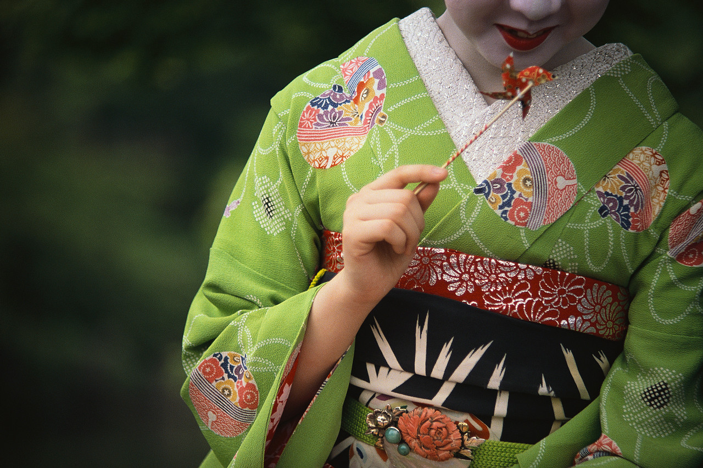
I remember my father telling Tim and me
About the mountains and the train
And the excitement of going on a trip….
I hear families were broken up
Men were forced to work. I heard
It whispered late at night
That there was suffering and
I missed my dolls….
And I remember …
When the war was over but Lorraine and her friends spat on us anyway
And I prayed to the God who loves
All the children in his sight
That I might be white.”
~ Joy Kogawa, “What Do I Remember of the Evacuation?” poem about the internment of
Japanese Canadians in 1942

“Canada was not what I expected. Three weeks after I had settled into a double room in Royal Victoria College, the assistant warden of women called me into her office and explained that I was being given a single room, because the College had been unable to find a roommate to share the double with me…. The less polite face of racism remained hidden until later. Although the women who shared the residence at Royal Victoria College were content just to treat us [as though we didn’t exist, never acknowledging our presence except when necessary and then only with a minimum of courtesy, the landladies and landlords who lived in the neigbourhoods near McGill had no such inhibitions. There was nothing subtle about the racism of the landlords and landladies of Montreal.”
~ Rosemary Brown, “Racism, Canadian Style.” Being Brown:
A Very Public Life (1989).

A number of these quotations are included to represent viewpoints from certain times in Canadian history that are considered to be discriminatory. They are meant to be used in a discussion that addresses issues of discrimination, and do not represent the views of Manitoba Education, Citizenship and Youth, school divisions, schools, or teachers.

(page 4 of 5)
“It always fascinates me how I see the world so differently than many of my non- Aboriginal friends and acquaintances. Obviously, the identity of the person doing the analysis makes a difference. When something particularly horrifying and tragic happens, such as the recent shooting deaths by an RCMP officer of Connie Jacobs and her little son Ty at their home on the Tsuu T'ina reserve in Alberta, different perceptions become more stark. My reaction and the typical reaction of my people is to understand the killings in the context of an historical pattern of state behaviour directed at Aboriginal people generally, and Aboriginal women and children in particular. Behaviour which has disrespected and devalued us, seen our women as inferior mothers and grandmothers, and failed to give us the same consideration and protection White people routinely take for granted. As a result, we are alarmed, angry and are calling for immediate redress in the form of an independent inquiry by First Nations to examine all the surrounding contextual issues, including sexism and racism in institutional practices of the RCMP and other agencies.
A typical reaction of the non-Aboriginal population to the Jacobs killings, on the other hand, is to see the incident as horrifying, but as an isolated one, and perhaps provided by the intemperate action of the Aboriginal women (one can only speculate whether there would have been a greater public outcry and a greater distrust of police conduct if similar killings took place in an upscale Calgary suburb). There is no immediate connection with context—social, economic, political or historic.”
~ “Modern Racism in Canada” 1998, Phil Fontaine <www.hrsdc.gc.ca/asp/gateway.asp?hr=/
en/lp/lo/lswe/we/special_projects/RacismFreeInitiative/speeches/Fontaine.shtml&hs=›

“When I went to school and I’m sure this is true for every Aboriginal person today of my generation, or close to it, that we were taught about the concept of discovery, about the great arrival of Christopher Columbus. We were taught about Jacques Cartier and Samuel de Champlain. We were taught about the massacre of father John de Brébeuf by the Indians of Eastern Canada who tore out his heart, as savages are wont to do, and ate it. We were taught how Indians were really nothing more than part of the countryside when the white men arrived and had no real rights. We were taught that Indians were actually pretty lucky that the white men came here and saved them from their life of barbarism and the terrible living conditions the white men saw. We were taught all of that.
It amazes me today that in some cases our children are still taught that. I know of a young girl back home, the same age as my daughter, who was expelled from school for two days because she refused to write a paper on the benefits of Christopher Columbus’ discovery of North America.
We have a situation in our lifetime when growing up in that kind of environment resulted in our inability to find out who we are. The great question each and every one of us had to answer was beyond our capability of answering as Aboriginal people, because who we were was not who society wanted us to be. I was not what society wanted me to be, and what society wanted me to be was not what I saw myself as being.”
~ “Transcript of Presentation by Associate Chief Judge Murray Sinclair: Elders-Policy Makers-Academics Constituency Group Meeting. Aylmer, Quebec, April 16-18, 1997. <http://canada.justice.gc.ca/en/ps/ajs/pubs/sinclair.html›
(page 5 of 5)
A number of these quotations are included to represent viewpoints from certain times in Canadian history that are considered to be discriminatory. They are meant to be used in a discussion that addresses issues of discrimination, and do not represent the views of Manitoba Education, Citizenship and Youth, school divisions, schools, or teachers.

