Art historians encourage us to consider all works of art and architecture in their historical context (i.e., in relation to the dominant world view of that period). By considering the cultural, political, religious, and economic beliefs and values reflected in art, we gain a better understanding of art as a product of time and place, and an appreciation of the role of art in societies past and present.

But students need to learn how to look at and respond to art. They also need to learn how to analyze the historical context of art and architecture. Art educators generally divide this process into four basic steps:
- Provide the students with one or two guiding questions at each step to help them focus their observations.
- Model the process by viewing and analyzing some examples together as a class.
- Try to set the scene by activating what students know of the time and place they are studying before they view the piece of art.
- Encourage them to take their time, and to respond personally to what they see.
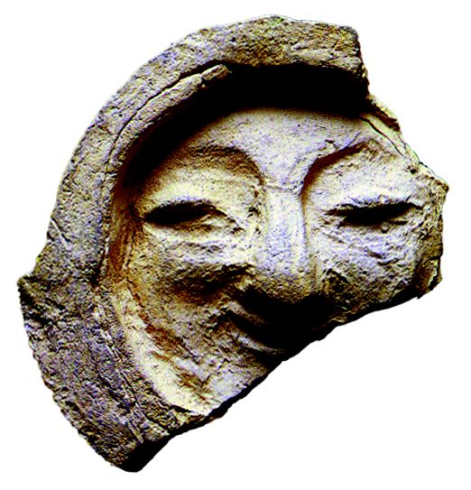

Stage 1: DESCRIPTION
- Describe exactly what you see.
- Describe the lines and patterns in the work.
- Describe the colours used in the work.
- Describe the texture of the work.
- How did the artist create these visual effects?
- What materials and media were used?

Stage 2: ANALYSIS
- Is your eye drawn to any particular area of the work? What stands out the most?
- Is the composition (arrangement of shapes and colours) balanced?
- Does the work make you think of movement? How does the artist show movement?
- For a painting: does it look flat, or does it give a feeling of depth or space? Where might the artist have stood while painting this picture?

Stage 3: INTERPRETATION
- What kind of mood or feeling do you get from the work?
- Why do you think the artist chose this particular subject or style?
- What does this work of art tell you about the time and
place it comes from?
- What does this work of art tell you about the artist?

Stage 4: JUDGEMENT
- Why do you find this work of art interesting?
- What do you like or dislike about the work?
- Do you consider this work to be beautiful?
- Do you think this work expresses something important
about the society from which it came?

(Feldman 21)

