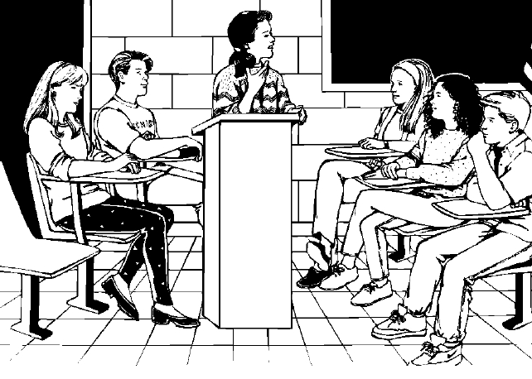
This strategy is, in essence, an informal debate, and one that enables students to discuss
an issue while at the same time developing and applying cooperative learning skills. It encourages the consideration of diverse perspectives without creating an adversarial situation. In a team deliberation, unlike a formal debate, there are no winners or losers.

It is recommended that teachers choose one or two collaborative skills to target during
the activity:

S-100 Collaborate with others to establish and carry out group goals and responsibilities.
S-101 Use a variety of strategies to resolve conflicts peacefully and fairly.
Examples: clarification, negotiation, compromise...
S-102 Make decisions that reflect fairness and equality in their interactions
with others.
S-104 Negotiate constructively with others to build consensus and solve problems.

Prior to the deliberation, teachers may choose to develop, with the input of the students,
a short set of indicators that describe what these target skills would “look like” and “sound like” when practised successfully.

The following sequence of steps is suggested in carrying out a team deliberation. Teachers may adapt the procedure based on their time and the abilities of their students.

1) Propose a question that lends itself to a for or against position.
- The question may be selected by the teacher with some input from the students.
- The question must deal with a subject that is familiar to the students, and information or sources must be available to support both the negative and affirmative positions.

2) Determine teams and roles.
- Place students in teams of four, assigning two students to the affirmative position and two students to the negative position.
- Allow time for students to gather information on their assigned position. Provide guidance in assessing the validity of sources, and background information to assist students as needed (e.g., useful Internet addresses, articles, editorials, et cetera).

3) Students prepare their initial statement or point of view.
- Students work with their partners to prepare a brief statement, supported by evidence and solid reasoning.

(page 1 of 2)
4) Pairs present their statements.
- Each pair of students presents their position statement to the other pair in their team, sharing speaking tasks between the two of them. Students listen and note important points without interrupting or commenting as the other pair presents.

5) Pairs switch affirmative and negative positions.
- Each pair now changes position, and they prepare a short statement in support of the opposite point of view from their initial statement. Their position must be supported by solid evidence and reasoning.

6) Pairs present their second statement of position.
- Each pair presents again, this time taking the opposite position. Once again, the other pair listens attentively and notes important details.

7) Groups of four make a collective decision.
- Each group of four objectively examines both the affirmative and negative positions, summarizing the most convincing arguments and evidence for each point of view on the question. The group seeks to make a consensus decision as to which position they found to be most defensible.

7) Groups of four share their decisions with the class.
- Each group of four presents a short statement summarizing their decision for the entire class.

8) Students evaluate their collaborative skills.

- Each student evaluates his or her participation and interaction based on the descriptors of the targeted skills developed at the outset. The teacher may choose to provide the students with a rubric or scale, or may simply ask students to self-evaluate using comments.*
(page 2 of 2)
(page 2 of 2)

* Adapted from a strategy by Linda McDowell.

