Who are the indigenous peoples of the world?

Dictionaries define indigenous as "originating in a particular region or country; native; innate; inherent; natural.” The word dates back to the Latin indigena, meaning native or original inhabitant. The word indigenous has many meanings.

In every region of the world, many different cultural groups live together and interact, but not all of these groups are considered indigenous or native to their particular geographic area.

In fact, it is those groups who claim a shared sense of identity who are internationally recognized as “indigenous peoples.” Throughout human history, peoples have migrated to various regions of the Earth, and cultures have mingled and exchanged influences. For these reasons the identification of indigenous peoples is not always straightforward and simple.
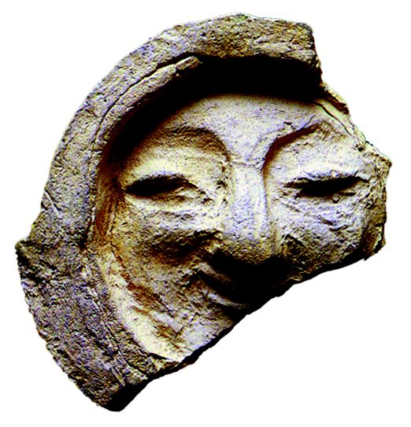
Indigenous peoples inhabit large areas of the Earth's surface. Spread across the world from the Arctic to the South Pacific, they number, at a rough estimate, some 300 million people.

Indigenous or Aboriginal peoples are so-called because they were living on their lands before settlers came from elsewhere; they are the descendants—according to one definition—of those who inhabited a country or a geographical region at the time when people of different cultures or ethnic origins arrived. The new arrivals later became dominant through conquest, occupation, settlement, or other means.

Most indigenous peoples around the world have retained social, cultural, economic, and political characteristics that are clearly distinct from those of the other segments of the national populations.
Throughout human history, whenever dominant neighbouring peoples have expanded their territories or settlers from far away have acquired new lands by force, the cultures and livelihoods—even the very existence—of indigenous peoples have been endangered. The threats to indigenous peoples' cultures and lands, to their status and other legal rights as distinct groups and as citizens, do not always take the same forms as in earlier times. Although some groups have been relatively successful, in most of the world indigenous peoples are still actively seeking recognition of their identities and ways of life.
(page 1 of 3)
In spite of cultural and ethnic diversity, there are often striking similarities between the problems, grievances, and interests of the various indigenous peoples and, therefore, in their presentations to international forums. Participation of indigenous communities and organizations in United Nations meetings has served to highlight these similarities.
It has often been the case—particularly since the emergence of new nations in the wave of decolonization which followed the Second World War—that indigenous peoples insist on retaining their separate identity and cultural heritage. It is now generally admitted that policies of assimilation and integration aimed at bringing these groups fully into the mainstream of majority populations are
usually counter-productive.

Fact Sheet No.9 (Rev.1), The Rights of Indigenous Peoples
Office of the High Commissioner for Human Rights
<www.unhchr.ch/html/menu6/2/fs9.htm#intro>

(page 2 of 3)
Examples of Indigenous Peoples

Africa
- Kung San of the Kalahari Desert (Botswana, Angola,
Namibia)
- Berbers of Morocco
- Hadzabe People of Tanzania
- Mbuti (Pygmies) of Zaire
- Maasai in East Africa
- Bantu and other ethnic minorities in Somalia
- Ogoni in Nigeria
- Tuareg people of Algeria, Libya, Mali, Niger and Burkina Faso
- Sahrawi of the Western Sahara

Asia
- Ainu people of Japan
- Assyrians of the Middle East (Aramaic speaking Christians)
- The Kazakhs, Mongols, Tajik, Tibetans, Ugyur, and Eurasian Nomads of Kazakhstan, eastern Russia, and China
- The Miao and Hmong of southern China, Laos and Thailand
- The Shan and Karen peoples of Burma /Myanmar
- The Chakma of Pakistan
- The Kurds of Iraq, Iran, Syria, Turkey and parts of the former Soviet Union

Australasia
- Maori of New Zealand
- Aborigines and Torres Strait Islanders of Australia

Europe and the Americas
- Saami of Sweden, Norway, Finland, Denmark
- Inuit and Aleutians of Canada and circumpolar Europe
- American Indians of the U.S.
- First Nations and Métis of Canada
- Mayans of Guatemala and Mexico
- Aymaras of Bolivia and other Indians of South America
(page 3 of 3)

