The Glories Of Kinsay [Hangchow] (c. 1300)
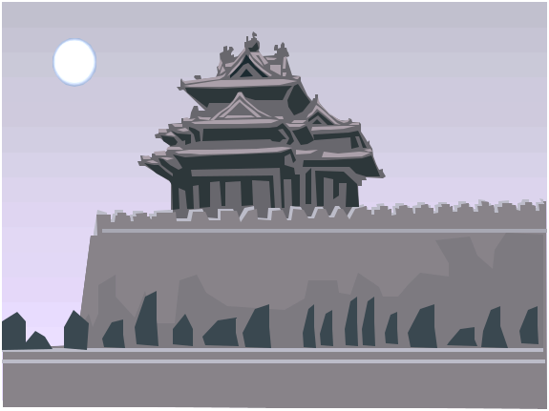

Here begins the introduction of this book which is called the description of the world. Lords, Emperors, and Kings, Dukes, and Marquesses, Counts, Knights, and Burgesses, and all people who wish to know the different generations of men and the diversities of the different regions of the world, then take this book and have it read and here you will find all the greatest marvels and the great diversities....

When you have left the city of Changan and have travelled for three days through a splendid country, passing a number of towns and villages, you arrive at the most noble city of Kinsay, a name which is as much as to say in our tongue "The City of Heaven," as I told you before. And since we have got thither I will enter into particulars about its magnificence; and these are well worth the telling, for the city is beyond dispute the finest and the noblest in the world…

… And there are in it twelve thousand bridges of stone, for the most part so lofty that a great fleet could pass beneath them. And let no man marvel that there are so many bridges, for you see the whole city stands as it were in the water and surrounded by water, so that a great many bridges are required to give free passage about it And though the bridges be so high the approaches are so well contrived that carts and horses do cross them…

…Inside the city there is a Lake which has a compass of some 30 miles and all round it are erected beautiful palaces and mansions, of the richest and most exquisite structure that you can imagine, belonging to the nobles of the city. There are also on its shores many abbeys and churches of the Idolaters. In the middle of the Lake are two Islands, on each of which stands a rich, beautiful and spacious edifice, furnished in such style as to seem fit for the palace of an Emperor. And when any one of the citizens desired to hold a marriage feast, or to give any other entertainment, it used to be done at one of these palaces. And everything would be found there ready to order, such as silver plate, trenchers, and dishes, napkins and table-cloths, and whatever else was needful. The King made this provision for the gratification of his people, and the place was open to every one who desired to give an entertainment. Sometimes there would be at these palaces an hundred different parties; some holding a banquet, others celebrating a wedding; and yet all would find good accommodation in the different apartments and pavilions, and that in so well ordered a manner that one party was never in the way of another…
(page 1 of 3)
(page 2 of 3)
…and since they were conquered by the Great Khan they use paper-money. Both men and women are fair and comely, and for the most part clothe themselves in silk, so vast is the supply of that material, both from the whole district of Kinsay, and from the imports by traders from other provinces…

…Other streets are occupied by the Physicians, and by the Astrologers, who are also teachers of reading and writing; and an infinity of other professions have their places round about those squares. In each of the squares there are two great palaces facing one another, in which are established the officers appointed by the King to decide differences arising between merchants, or other inhabitants of the quarter. It is the daily duty of these officers to see that the guards are at their posts on the neighbouring bridges, and to punish them at their discretion if they are absent…

All along the main street that we have spoken of, as running from end to end of the city, both sides are lined with houses and great palaces and the gardens pertaining to them, whilst in the intervals are the houses of tradesmen engaged in their different crafts. The crowd of people that you meet here at all hours, passing this way and that on their different errands, is so vast that no one would believe it possible that victuals enough could be provided for their consumption, unless they should see how, on every market-day, all those squares are thronged and crammed with purchasers, and with the traders who have brought in stores of provisions by land or water; and everything they bring in is disposed of.

The houses of the citizens are well built and elaborately finished; and the delight they take in decoration, in painting and in architecture, leads them to spend in this way sums of money that would astonish you…

You must know also that the city of Kinsay has some 3000 baths, the water of which is supplied by springs. They are hot baths, and the people take great delight in them, frequenting them several times a month, for they are very cleanly in their persons. They are the finest and largest baths in the world; large enough for 100 persons to bathe together…

And the Ocean Sea comes within 25 miles of the city at a place called Ganfu, where there is a town and an excellent haven, with a vast amount of shipping which is engaged in the traffic to and from India and other foreign parts, exporting and importing many kinds of wares, by which the city benefits. And a great river [the Ts'ien T'ang] flows from the city of Kinsay to that sea-haven, by which vessels can come up to the city itself. This river extends also to other places further inland…

Know also that the Great Khan hath distributed the territory of Manzi into nine parts, which he hath constituted into nine kingdoms. To each of these kingdoms a king is appointed who is subordinate to the Great Khan, and every year renders the accounts of his kingdom to the fiscal office at the capital…

Excerpts from The Book of Ser Marco Polo the Venetian concerning the Kingdoms and Marvels of the East, trans. and ed. by Henry Yule, 3rd ed. revised by Henri Cordier (London: John Murray, 1903), Vol II, as cited in the Medieval Source Book:
<www.fordham.edu/halsall/source/polo-kinsay.html>
(page 3 of 3)

