Latin Expression | Meaning
curriculum vitae
non-sequitur
ad infinitum
et cetera
in camera
circa
dictum
magnum opus
ipso facto
memento
nota bene (N.B.)
per capita
persona non grata
post mortem
summa cum laude
in loco parentis
dramatis personae

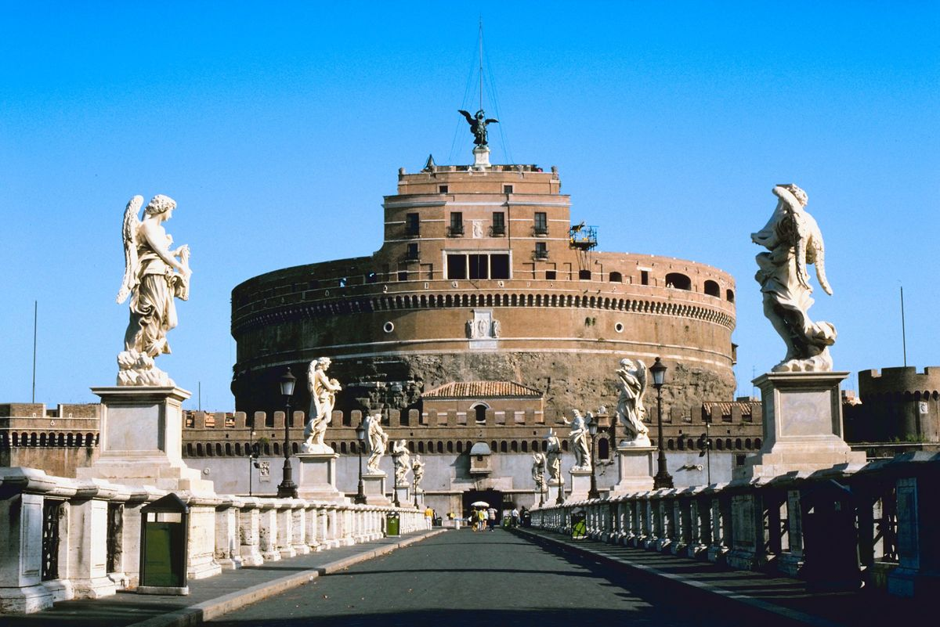
Other topics:
- Prepare a chart with examples of the use of
Latin in botanical or plant names.
- Prepare a chart comparing the Roman alphabet
to the modern English alphabet.
- Find some examples of Latin expressions used
in coats of arms or mottoes of universities,
cities, et cetera.

