 | 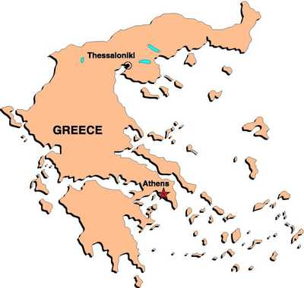  Athens | Canada
Criteria for Citizenship
Participation in Government
Decision Making

Election Process

Responsibilities
of Citizens

Rights and Freedoms
of Citizens
Answer this question on the back of this sheet:
What do these two forms of democracy have in common?

