Greek myths were an important part of the education of Greek citizens. The myths were often recited aloud, not simply to entertain, but to teach about many subjects, such as the following:
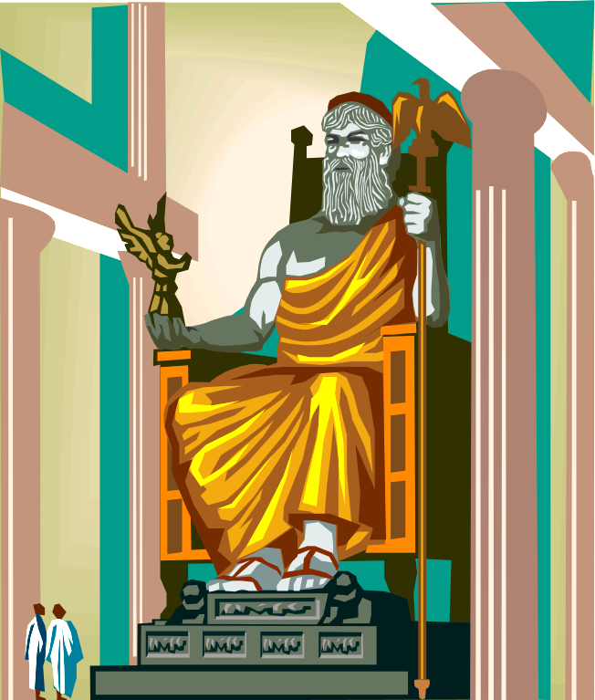
- Responsibilities of humans
- Weaknesses and strengths of humans
- Emotions
- Rivalry and conflicts
- Ideas about evil and good
- Ideas about love and hate
- Right and wrong behaviour
- Ideas about the nature and role of women, men, and children
- Family relationships and inter-generational conflicts
- Explanations of nature and the physical world
- Stories of origins
- Attitudes toward heroism and courage
- Explanations of the mysteries of life

Most Greek myths include elements of fantasy, adventure, and violence, but they were not viewed by the Greeks as simply “exciting stories.” Many of them were used as “paradeigma” or education by example; others were warnings to human beings about behaviour the gods found unacceptable. The Greek gods sometimes personified ideas or events in human life that are difficult to understand, such as Death, Time, or Fate.

Most Greek gods had similar characteristics, both good and bad, to human beings. They were portrayed as men or women, but they were thought to be immortal and to hold special powers. The gods could exercise their powers on one another and on human beings as they wished, for their own vengeance or pleasure. For this reason it was important to pay attention to the gods and to appease them by making food offerings such as nectar and ambrosia, or by making animal sacrifices at the temples.

The most important Greek gods were the 12 Olympians, who were said to live on Mount Olympus and to have descended from the first generation of Gods: the Titans. Greek stories and legends also include stories of demigods and heroes, who had some of the special powers of the gods but who were not immortal. These included Atlas, Achilles, Heracles, Daedelus and Icarus, and Narcissus.
(page 1 of 2)

The Romans later adopted most of the Greek gods, giving them Roman names and adapting their stories to their own society and values. The Roman name of each god or goddess is indicated in parentheses.

Greek God | Roman Name | Realm
Aphrodite | Venus | goddess of love and beauty
Apollo | Apollo | god of the arts, especially poetry and music, archery, and divination or soothsaying
Ares | Mars | god of war
Artemis | Diana | goddess of the hunt and protector of children
Athena | Minerva | goddess of wisdom, war, and crafts; patron of Athens
Demeter | Ceres | goddess of agriculture and fertility
Dionysus | Bacchus | god of wine, mysteries, and the theatre
Hades | Pluto | god of the Underworld (did not dwell at Olympus)
Hephaestus | Vulcan | god of smiths and metal-workers
Hera | Juno | goddess of marriage; consort of Zeus
Hermes | Mercury | god of merchants; messenger of Zeus
Poseidon | Neptune | god of the sea and earthquakes
Zeus | Jupiter, Jove | god of the sky, gods, and thunder; ruler of Olympus
(page 2 of 2)

