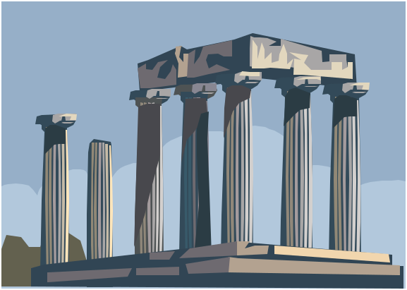
polis or city-state
social roles
families
children
citizens
non-citizens
right to vote
agora or marketplace
centre of Greek society
open-air theatres
temples
slaves
heroism
women
myths
priests
craftspeople
soldiers
servants
Sparta
Athens
self-governed
public meeting places
law and justice
urban centres
government
farmers
military defence
service to the polis
poets and playwrights

