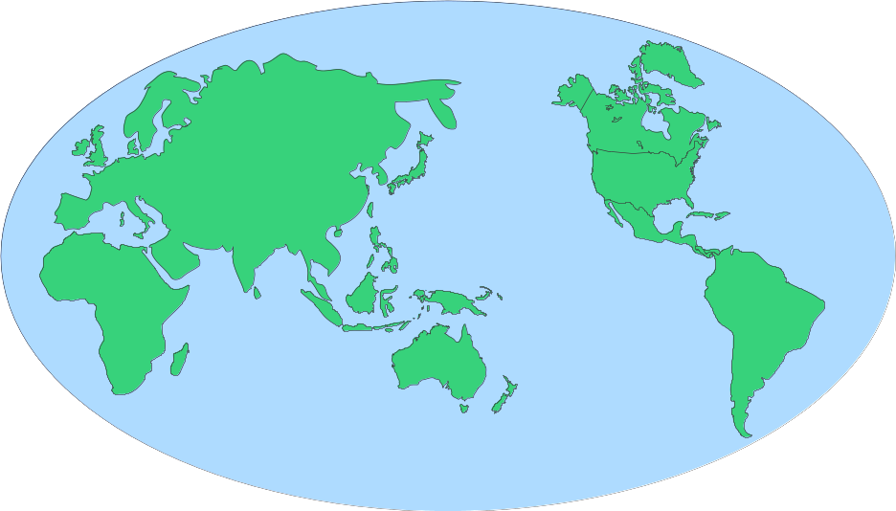
Use historical maps, an atlas, or other resources to locate these places on the wall map of the world. Ask one member of your group to label or draw these places on the appropriate blank outline map. Note that the place names that are underlined are modern country names that roughly correspond to a region of an ancient civilization.

Persia

Iran
Asia Minor
Turkey
Babylon
Jerusalem
Persepolis or Parsa
Mesopotamia
Iraq
Arabian Sea
Persian Gulf
Egypt
Nile River
Mediterranean Sea
Black Sea
Caspian Sea
Royal Road

Mayan Civilization

Central America
Yucatan Peninsula
Mexico
Guatemala

China

South China Sea
India
Bay of Bengal
Gobi Desert
Great Wall of China
Silk Route

Greece

Crete
Macedonia
Aegean Sea
Ionian Sea
Sparta
Athens
Thebes
Troy
Delphi
Mount Olympus
Corinth

Rome

Italy
Sardinia
Corsica
Sicily
Adriatic Sea
Tiber River
Gaul
France
Britain
Atlantic Ocean
Germania
Germany
Carthage

