All religions, arts and sciences are branches of the same tree. All these aspirations are directed toward ennobling man's life, lifting it from the sphere of mere physical existence and leading the individual towards freedom.
~ Albert Einstein

Formerly, when religion was strong and science weak, men mistook magic
for medicine; now, when science is strong and religion weak, men mistake medicine for magic.
~ Thomas Szasz, M.D.

Science is facts; just as houses are made of stones, so is science made of facts; but a pile of stones is not a house and a collection of facts is not necessarily science.
~ Henri Poincaré

Science without religion is lame, religion without science is blind.
~ Albert Einstein

Science knows no country, because knowledge belongs to humanity, and is the torch which illuminates the world. Science is the highest personification of the nation because that nation will remain the first which carries the furthest the works of thought and intelligence.
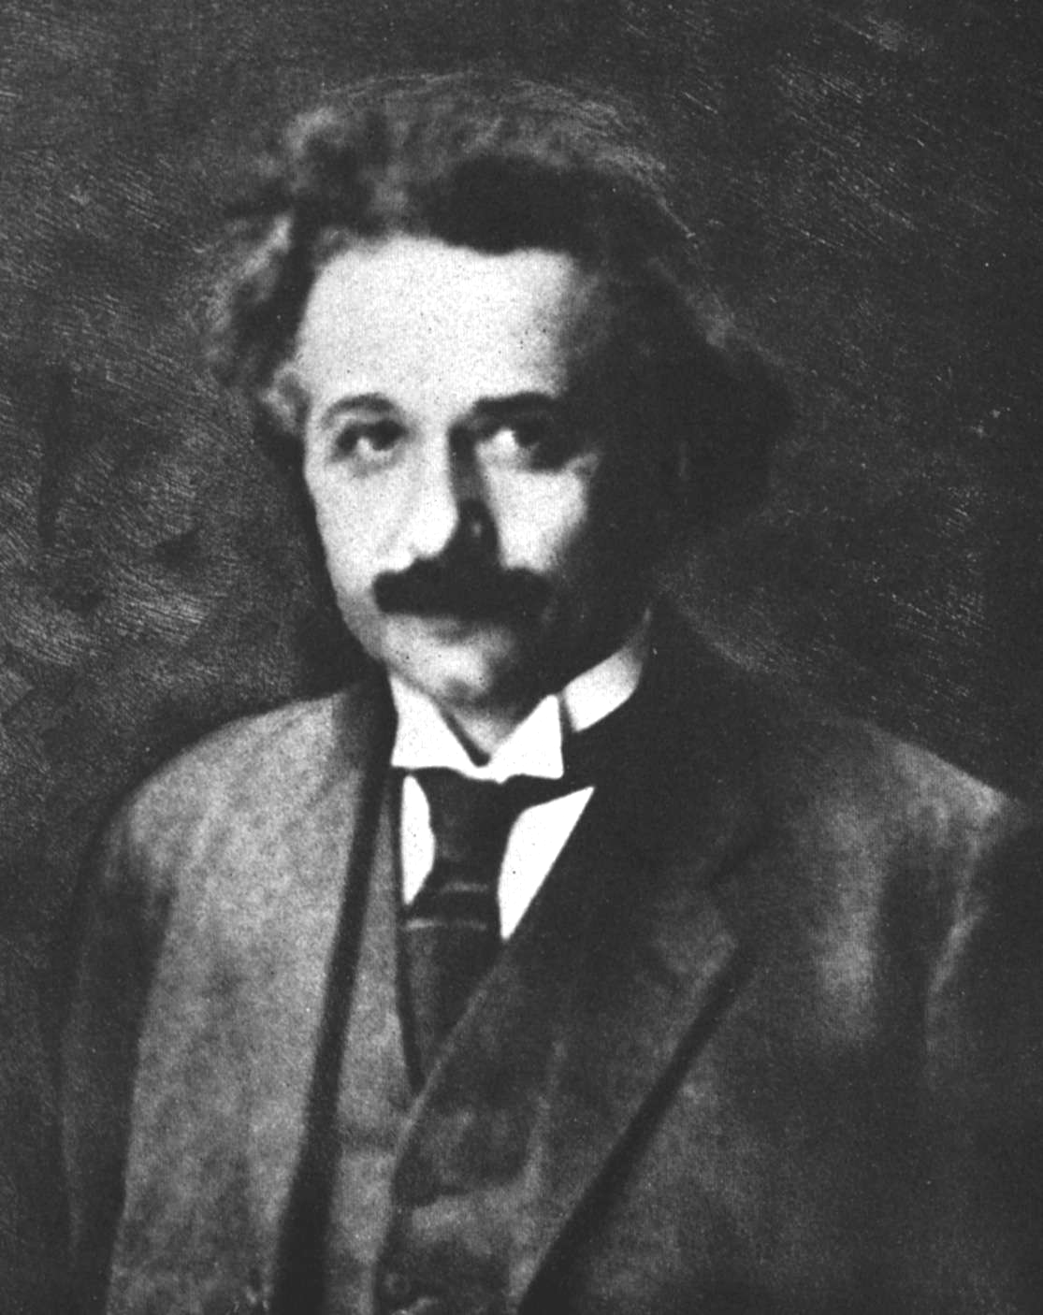
~ Louis Pasteur

Scientists were rated as great heretics by the church, but they were truly religious men because of their faith in the orderliness of the universe.
~ Albert Einstein

