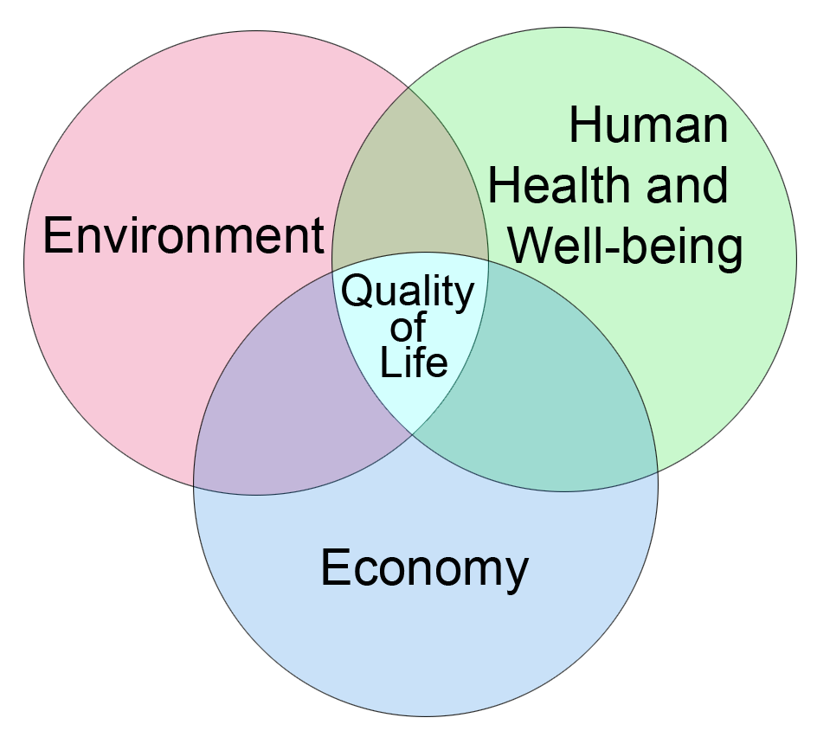

Sustainable Development is an approach to daily decisions that integrates probable consequences to the environment, the economy, and human health and well-being. It is a way of making decisions that balances the needs of today without sacrificing the ability of future generations to meet their own needs.
- Manitoba Conservation, 1999

Source:
Education for a Sustainable Future, A Resource for Curriculum Developers, Teachers, and Administrators. Manitoba Education and Training, 2000.

