Hunter-Gatherer  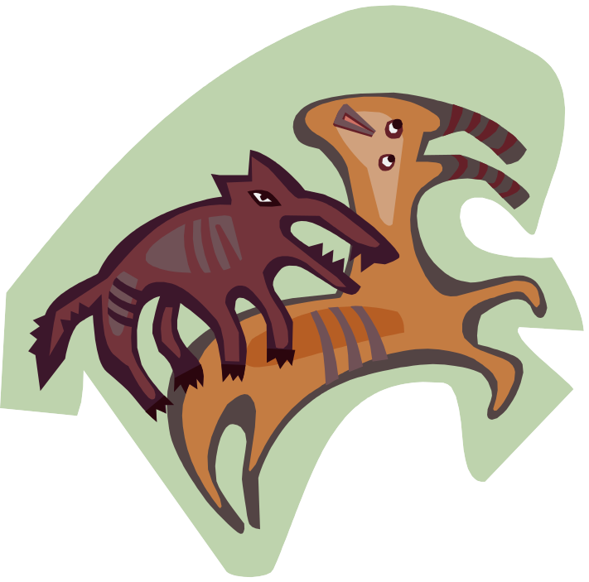 | Agrarian
Food sources: | Food sources:
Division of labour: | Division of labour:
Community size, population growth : | Community size, population growth:
Movement of population: | Movement of population:

(page 1 of 2)

Hunter-Gatherer | Agrarian
Shelter and clothing: | Shelter and clothing:
Relationship to natural environment: | Relationship to natural environment:
Advantages of this lifestyle: | Advantages of this lifestyle:
Disadvantages: | Disadvantages:
(page 2 of 2)

