Everyone has a personal set of beliefs and values that they
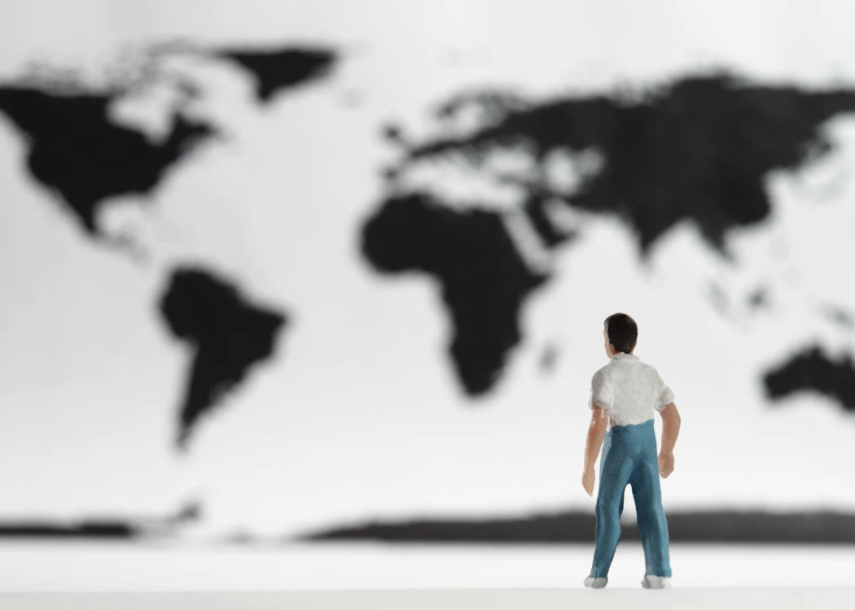
use to make sense of the world. This is a person’s “world view.”

Your world view is your way of seeing things, and it includes
- Beliefs about human beings and their place in the world
- Religious beliefs about life and death
- Beliefs and opinions about groups and societies
What is your world view?
- Value judgements about what is worthwhile or important
- Values or guideposts for how you think people should behave
- Beliefs about how the world is organized and how it works
- Beliefs about how people can or should decide what is true or false
- Beliefs about how decisions should be made and who should make them
- Beliefs about how human beings should act
- Opinions about what is positive or negative, right or wrong

Read the following statements carefully, and think about your own reaction to them. They will tell you something about your own beliefs and values. Add other statements of your own.

- The Earth is flat.
- Change is usually for the better.
- Science and technology will eventually solve all our problems.
- People were more caring in the past.
- Education is a very important part of life.
- People are on Earth for a purpose.
- What is good for the whole society or community is more important than
what is good for one individual.
- Laws should be made by kings and queens.
- Human beings are smarter than they used to be.
- Men and women are equal.
- Slavery is always wrong.
- Everybody should listen to Beethoven.
- Societies are constantly making progress.
- Everything happens for a reason.
- The world is a very organized place.
- We know that things are true or false if science can prove them with
physical evidence (the five senses).
- It is always possible to prove what is true or false.
- Most things happen because of chance.
- Every person should have a goal in life.
- Most people have very similar goals.
(page 1 of 2)
- Having a large family is very important.
- Having a religion is very important.
- Having lots of possessions is important.
- Everyone is entitled to a good life.
- Societies have finally learned how to sustain themselves/their environments
for future generations.
- The world was made by a Creator.
- Governments should reflect the will of the people.
- Cultures always change and disappear.
- Nothing really ever changes in human societies.
- People usually make the wrong decisions.
- Wars and violence are an inevitable part of human history.
- Stories and legends help us understand the world.
- People are basically good.
- People are basically bad and need to be controlled.
- Old people and young people never understand one another.
- Human beings should be responsible for taking care of the natural environment.
- Every human being has an important role to play in the world.
- There is life after death.
- There is no afterlife.
- There is never a reason for violence.
- Women and men should play completely different roles in society.
- All human beings are equal.
- Not everyone should be entitled to an education.
- Art and music are important parts of having a good life.
- Most societies have the same goals.
- There are naturally different classes of people in all societies.

In the box below, list those things that are the biggest influences on how you see the world. Then, on a separate piece of paper, draw a web of the ideas that come to mind to describe how you see the world. Be creative designing your web, and use your own words.

(page 2 of 2)

