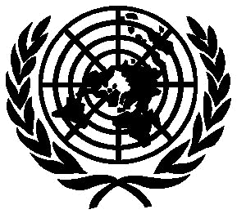
In 1987, the United Nations World Commission on Environment and Development issued a call for the creation of a new charter to define the basic principles for sustainable development in the world. The drafting of an Earth Charter was part of the 1992 Earth Summit held in Rio de Janeiro.
In 1994 Maurice Strong (Secretary-General of the Earth Summit and Chairman of the Earth Council) and Mikhail Gorbachev (President of Green Cross International) launched a new Earth Charter initiative with support from the Dutch government. An Earth Charter Commission was formed in 1997 to oversee the project, and a secretariat was set up in Costa Rica.
A new phase in the Earth Charter Initiative began with the official launching of the Earth Charter at the Peace Palace in The Hague on June 29, 2000. This initiative was intended to establish a foundation for global society and to help build a sustainable world―one that is based on respect for nature, universal human rights, economic justice, and a culture of peace.
Since its launch in 2000, the Earth Charter Initiative has actively been seeking the endorsement or support of individuals and organizations around the world.

Structure of the Earth Charter

The Preamble describes the challenges and choices facing humanity. It comprises 16 basic principles, divided into four parts:

I. Respect and Care for the Community of Life

The four principles in Section I are the basis for the remaining 12 principles. The first and most important principle―Respect Earth and life in all its diversity―is the foundation of all the other principles in the Charter.

II. Ecological Integrity

III. Social and Economic Justice

IV. Democracy, Nonviolence, and Peace

The Conclusion of the Charter is a call for commitment
and action.

The Earth Charter Initiative:
<www.earthcharter.org/>

