- Geography
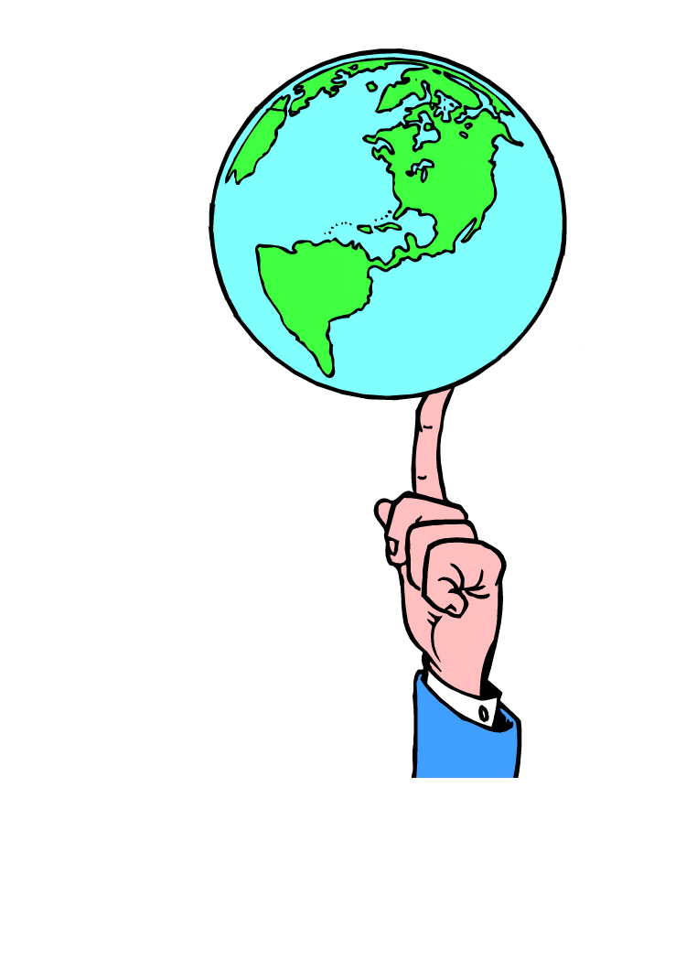
  - Where is this society located?
  - What is the climate like? Are there distinct seasons?
  - What kind of vegetation does it have?
  - What are the main landforms in this country?
  - Does it have arable land? Is there agriculture in this country?
  - What natural resources does it have? What are its sources of
fresh water?
  - How is its population distributed? Is it densely populated?
  - Is the population mostly urban or rural? What are its major cities?
  - How does the natural environment affect the people’s ways of life?
  - How are the activities of humans affecting the environment?
- History
  - What are some major events that influence this society to this day?
  - Are there wars currently going on in this society?
  - Was this society ever a colony of another country? If so, when did it become independent?
  - Have any natural disasters happened that still have an effect on life in this society?
- Politics
  - What type of government does this society have?
  - What kind of justice system does this society have?
  - Is this society democratic? Does this society have free elections?
  - Are human rights respected in this society?
- Culture
  - What are the main ethnic groups in this society?
  - Are there indigenous peoples in this society?
  - What kind of social organization does this society have (e.g., class system, family structure, etc.) ?
  - What religions predominate in this society?
  - What languages are spoken in this society?
  - What are some of the important values of people living in this society?
  - Are indigenous peoples in this society preserving their cultures?
  - What styles of visual art does this society have?
  - How do people express themselves in music and dance?
  - What kind of literature does this society have?
  - What kind of educational system does this society have?
(page 1 of 2)
  - Do most people receive a high school education in this society?
  - Is this society losing some aspects of its traditional culture or ways of life?
  - How is this society being affected by the cultures of the western developed nations?
  - What kinds of homes do people live in? What types of architecture do they have?
  - What styles of dress do people wear?
  - What types of food do people eat?
  - What kinds of celebrations does this society have?
  - What types of games do people play? What do people do for leisure activities? What sports do people prefer?
- Economy
  - What types of work do most people in this society do? Are they well-paid?
  - Do children in this society work? What do they do?
  - Do people have fair working conditions?
  - What is the unit of money of this society?
  - Are there industries in this country? What do they export or trade?
  - How much money does the average family earn per year in this society?
  - Is poverty a major concern in this society?
  - What is the quality of life like for people in this society?
  - Do most people have adequate food, water, and shelter in this society?
  - Is there adequate health care in this society?
  - What are the major health problems faced by people in this society?
  - Does this society depend on aid from more-developed nations?
- Technology
  - What kinds of tools and technologies are used by people in everyday life and work?
  - Do most people have access to televisions, radio, Internet, computers?
  - Do most people have access to newspapers and books?
  - Does this society produce high-tech products? Which products?
  - Are technology and science being used to help increase quality of life in this society (e.g., medical treatments, irrigation, sanitation, etc.)?
  - How do most people travel in this society?
  - Does this society have a good system of roads? Trains? Airports?

