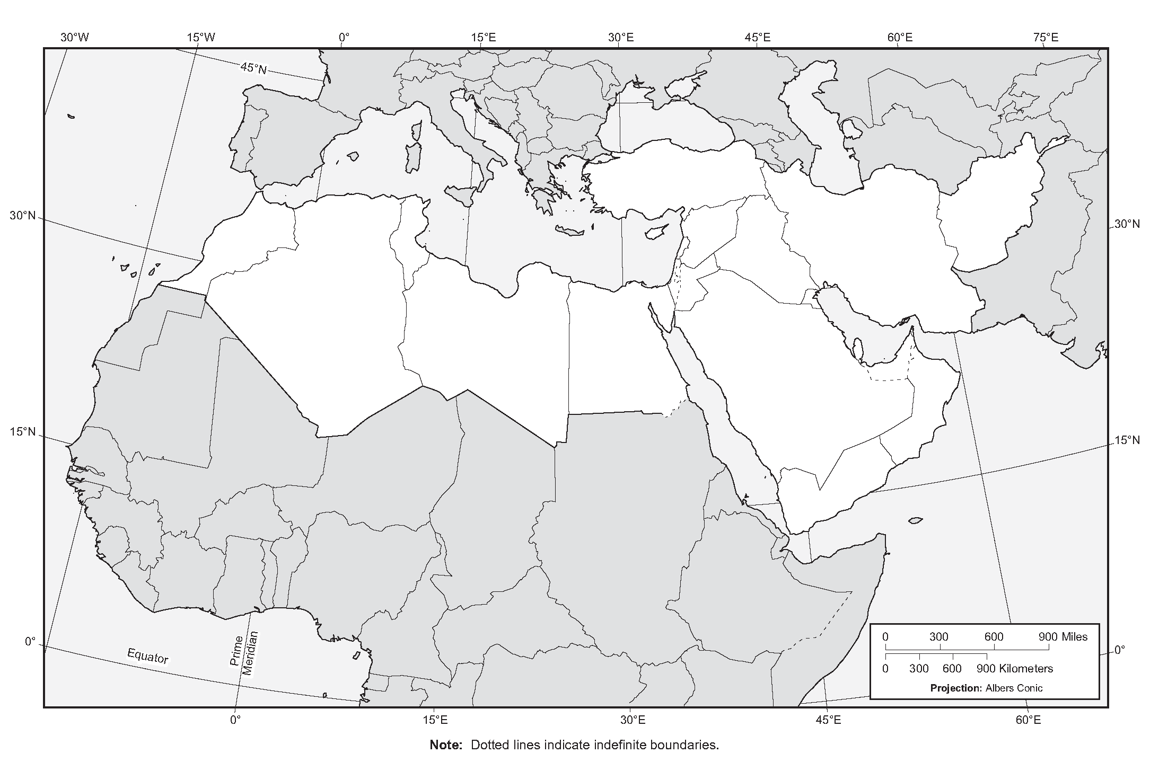
Note : Dotted lines indicate indefinite boundaries.

