No one in the society should be entitled to superfluous or luxury goods until the essentials of life are made available to everyone. At first glance, that distribution would appear to [exist] in Canada. Thanks to our abundant natural wealth and to the techniques of the industrial era, it no longer seems necessary to trample on one another in the scramble for riches. Consequently, most people take it for granted that every Canadian is assured a reasonable standard of living. Unfortunately, that is not the case.

The Just Society will be one in which all of our people will have the means and the motivation to participate. The Just Society will be one in which personal and political freedom will be more securely ensured than it has ever been in the past. The Just Society will be one in which the rights of minorities will be safe from the whims of intolerant majorities. The Just Society will one in which those regions and groups which have not fully shared in the country’s affluence will be given a better opportunity. The Just Society will be one where such urban problems as housing and pollution will be attacked through the application of new knowledge and new techniques. The Just Society will be one in which our Indian and Inuit population will be encouraged to assume the full rights of citizenship through
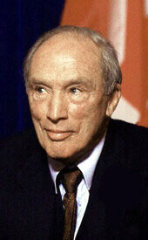
policies which will give them both greater responsibility for their own future and more meaningful equality of
opportunity. The Just Society will be a
united Canada, united because all of its
citizens will be actively involved in the
development of a country where equality
of opportunity is ensured and individuals
are permitted to fulfill themselves in the
fashion they judge best…

…On the never-ending road to perfect justice
we will, in other words, succeed in creating
the most humane and compassionate society
possible.

Pierre Elliott Trudeau, as cited in The Essential Trudeau, ed. Ron Graham. (pp.16 – 20).

