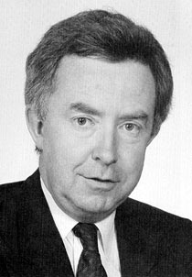
Prime Minister Joe Clark, the youngest Prime Minister of Canada, was elected to the office in 1979. As leader of the Progressive Conservative party, he became prime minister in a minority government (i.e., his party won more seats than the other parties, but still had less than 50 percent of the total seats). After only seven months in power, the Conservative government lost a budget vote in Parliament, forcing Clark to call an election. The Conservatives lost that election to the Liberals, and Pierre Elliott Trudeau was returned to power. Joe Clark was re-elected as an MP and served in that position for many years.

In a campaign speech during the 1979 election, Mr. Clark said that Canada is a nation of many different communities and regions. He also said that most Canadians do not necessarily think of the nation as being more important than their personal goals and their local communities. The following is a quotation from that speech.

In an immense country, you live on a local scale. Governments make the nations work by recognizing that we are fundamentally a community of communities….
…Whatever cultures we come from, whatever heritage we bring to these shores, we are all of us North American in aspiration. We want to build. We want to grow. Generally, the goals of Canadians are personal goals. A few people in our history have helped build our nation by consciously pursuing national goals, but many more have built this nation by pursuing the personal goals which the nature of this nation allows. The personal goal of most Canadians has been freedom and some security for their family. That caused the settlement of new regions, caused the immigration of new citizens, caused the transplanting of old roots to new ground. A policy designed to make the nation grow must build upon and must not frustrate the instinct of most Canadians to build a stake for themselves.

- Joe Clark, as cited in Who Speaks for Canada?, D. Morton and M. Weinfied, eds.
- Photo: <http://upload.wikimedia.org/wikipedia/en/8/8d/Joeclark2.jpg>

