What makes a person a “Canadian”?

Personal identity is the sum of all those things that make you unique, and that set you apart from the rest of the world. Personal identity is how you see yourself.

In this questionnaire, rank the following characteristics from the most important (#1) to the least important (#14). Which characteristics are “Canadian” and different from other countries and peoples?

Characteristics of Canadian Identity | Ranking  1 = highest  14 = lowest
Our history

Our multicultural society

The rights and freedoms of our citizens

Arts and artists

English-French bilingualism

The land and natural environment

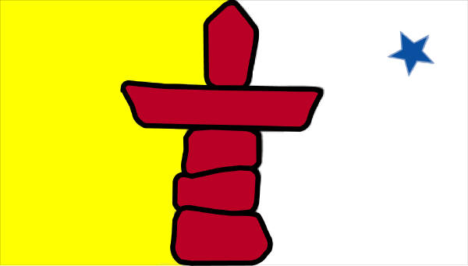  Canada’s northernness and climate | (page 1 of 2)
Peace, justice, and other shared values

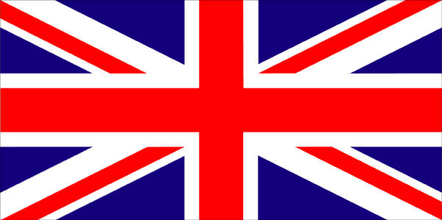
Our close ties to Britain

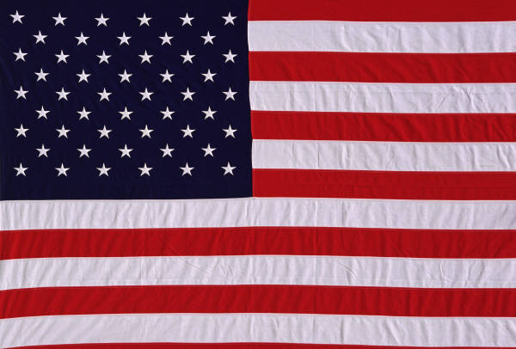
Our close relationship to the U.S.

Aboriginal peoples and cultures in Canada

Our government and leaders

The flag and other symbols

Other (please describe):

(page 2 of 2)

