Read and discuss the following text with a partner, making sure that you understand the main ideas.
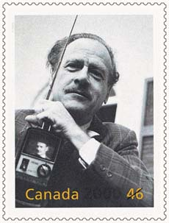

Then, with your partner, draw an illustration to represent what Marshall McLuhan was saying when he talked about a
“global village.”

Be prepared to share your diagram with the class, and explain what you think about this idea of the “global village.”

Marshall McLuhan is often referred to as a communications “guru” (wise person). He is regarded as an important Canadian philosopher and has written several books about media and communication.
McLuhan was born in Edmonton, Alberta in 1911. His father was a real estate and insurance salesman and his mother was an actress. He went to the University of Manitoba, where he won a gold medal for academic achievement, and then to Cambridge University.
In 1961, McLuhan wrote an important book entitled The Gutenberg Galaxy. In that book, he talked about how electronic media – television, telephone, radio – affects people and societies. He is famous for many of his ideas, including the idea of a “global village.”
Many people consider his ideas about the effect of electronic media to be very much ahead of his time. He observed that electronic media connect people around the world so quickly and so completely that it makes the world seem like a village. (And remember, he was writing about the global village decades before cell phones and the Internet were invented.) He saw the world as a place in which every single person, no matter where he or she lived, was connected to each other through “instant electronic communication.”
He also believed that, with mass communication, no one is ever very far from anyone else in the world. “Under instant circuitry,” he said, “nothing is remote in time or in space. It’s now.”
McLuhan thought that instant communication allowed people to share the same experience at the same time, no matter where in the world they happen to be. It was as if no distance
separated them. McLuhan said our modern “electronic” life was like living in a large village – a global village – where every person becomes part of everyone else’s stories and experiences.

Image: <http://en.wikipedia.org/wiki/Mcluhan>

