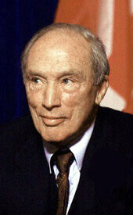
Bilingualism unites people; dualism divides them. Bilingualism means you can speak to the other; duality means you live in one language and the rest of Canada will live in another language.
- Pierre Elliott Trudeau, speaking to the Senate in Ottawa on March 20, 1988, as quoted in The Essential Trudeau, Ron Graham, ed.
Trudeau was against changing the Constitution to give Quebec greater independence from Canada. He believed that a bilingual Canada would allow Quebec to be less isolated and allow French Canadians to preserve their language and culture while remaining an important part of Canada. The “duality” he is talking about is two separate governments and cultures.

French Canada can survive not by turning in on itself but by reaching out to claim its full share of every aspect of Canadian life. English Canada should not attempt to crush or expect to absorb French Canada. All Canadians should capitalize on the advantages of living in a country which has learned to speak in two great world languages.
- Pierre Elliott Trudeau, in a statement upon introducing the Official Languages Bill, October 17, 1968.

(page 1 of 2)
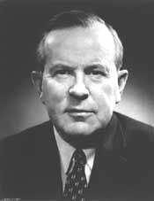
It is necessary to recognize, from the historic and cultural point of view, that our country is primarily formed of two peoples and that these two peoples must have equal rights and an equal opportunity in the expansion and also the direction of their economy. But we must also recognize that it just so happens that the Canadian nation is a combination of these two peoples who founded and made our country grow. When the day comes when we will no longer be able to speak of Canadian unity in our country, Canada will have ceased to exist and then our two cultures will be in grave danger.
- Lester B. Pearson, 1963, as cited on Prime Ministers of Canada, Speeches:
<http://www.nlc-bnc.ca/primeministers/h4-4030-e.html>

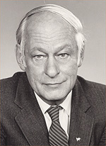
To be unable to live as ourselves, as we should live, in our own language and according to our own ways, would be like living without an arm or a leg – or perhaps a heart.
- René Lévesque, premier of Quebec who was in favour of an independent Quebec, 1968, as cited in Handler, 1984.

(page 2 of 2)

