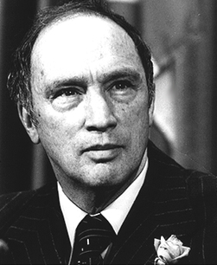
Uniformity is neither desirable nor possible in a country the size of Canada. We should not even be able to agree upon the kind of Canadian to choose as a model, let alone persuade most people to emulate it. There are few policies potentially more disastrous for Canada than to tell all Canadians that they must be alike. There is no such thing as a model or ideal Canadian. What could be more absurd than the concept of an “all-Canadian” boy or girl? A society which emphasizes uniformity is one which creates intolerance and hate. A society which eulogizes the average citizen is one which breeds mediocrity. What the world should be seeking, and what in Canada we must continue to cherish, are not concepts of uniformity but human values: compassion, love, and understanding.

- Pierre Elliott Trudeau, Remarks at the Ukrainian-Canadian Congress, October 9, 1971, as cited in The Essential Trudeau, ed. Ron Graham.
Photograph: <http://www.primeministers.ca/trudeau/quickfacts.php>

(page 1 of 2)
Group Task
- Read the quote by Pierre Elliott Trudeau in the box on the first page.

- Before discussing this quote, make sure you know what the following words mean:
❑ uniformity  emulate  eulogizes  mediocrity

- As a group, paraphrase Trudeau’s main points (i.e., rewrite the paragraph in your own words, as clearly and briefly as possible).
____________________________________________________________
____________________________________________________________
____________________________________________________________
____________________________________________________________
____________________________________________________________
____________________________________________________________
____________________________________________________________
____________________________________________________________
____________________________________________________________
____________________________________________________________
- Do you agree with Trudeau’s vision of what it means, and does not mean, to be Canadian? Explain why or why not.
____________________________________________________________
____________________________________________________________
____________________________________________________________
____________________________________________________________
____________________________________________________________
____________________________________________________________
____________________________________________________________
____________________________________________________________
____________________________________________________________
____________________________________________________________
(page 2 of 2)

