The Butterfly
The last, the very last,
So richly, brightly, dazzlingly yellow.
Perhaps if the sun's tears would sing
against a white stone…
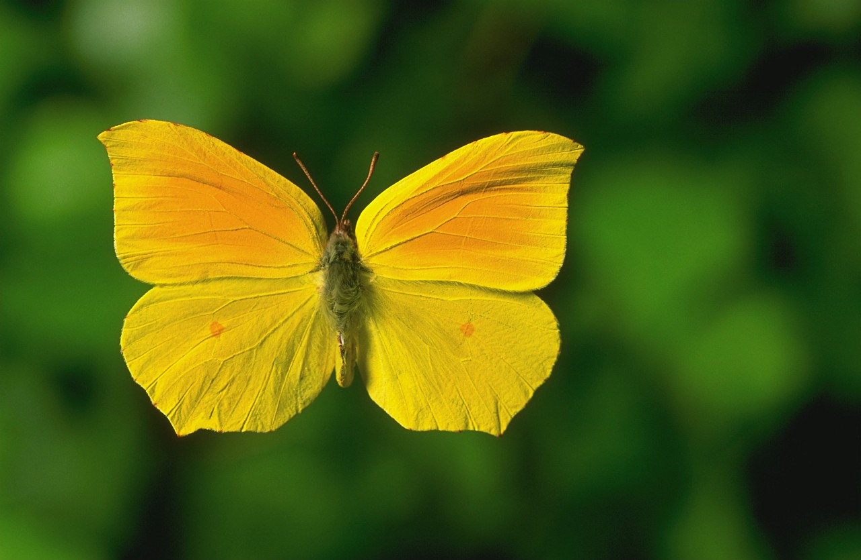
Such, such a yellow
Is carried lightly ‘way up high.
It went away I'm sure because it wished to
kiss the world goodbye.
For seven weeks I've lived in here,
Penned up inside this ghetto
But I have found my people here.
The dandelions call to me
And the white chestnut candles in the court.
Only I never saw another butterfly.
That butterfly was the last one.
Butterflies don't live in here,
In the ghetto.

Pavel Friedmann 4.6.1942

The poem is preserved in typewritten copy on thin paper in the collection of poetry by Pavel Friedmann, which was donated to the National Jewish Museum during its documentation campaign. It is dated June 4, 1942 in the left corner.
Pavel Friedmann was born January 7, 1921, in Prague and deported to Terezín* on April 26, 1942. He died in Oswiecim* (Auschwitz) on September 29, 1944.

*Terezín was a Nazi concentration camp.

(page 1 of 3)
Homesick
I've lived in the ghetto here more than a year,
In Terezín, in the black town now,
And when I remember my old home so dear,
I can love it more than I did, somehow.
Ah, home, home,
Why did they tear me away?
Here the weak die easy as a feather
And when they die, they die forever.
I'd like to go back home again,
It makes me think of sweet spring flowers.
Before, when I used to live at home,
It never seemed so dear and fair.
I remember now those golden days…
But maybe I'll be going there again soon.
People walk along the street,
You see at once on each you meet
That there's a ghetto here,
A place of evil and of fear.
There's little to eat and much to want,
Where bit by bit, it's horror to live.
But no one must give up!
The world turns and times change.

Yet we all hope the time will come
When we'll go home again.
Now I know how dear it is
And often I remember it.

9.3.1943. Anonymous

This poem is preserved in manuscript, written in pencil on a sheet of lined paper torn from a notebook. The date "9.III. 1943" is in the upper right corner. All other facts are missing.
(page 2 of 3)
Fear
Today the ghetto knows a different fear,
Close in its grip, Death wields an icy scythe.
An evil sickness spreads a terror in its wake,
The victims of its shadow weep and writhe.
Today a father's heartbeat tells his fright
And mothers bend their heads into their hands.
Now children choke and die with typhus here,
A bitter tax is taken from their bands.
My heart still beats inside my breast
While friends depart for other worlds.
Perhaps it's better – who can say? –
Than watching this, to die today?
No, no, my God, we want to live!
Not watch our numbers melt away.
We want to have a better world,
We want to work – we must not die!

Eva Picková, 12 years old, Nymburk

The poem is preserved in a copy turned over to the State Jewish Museum in Prague by
Dr. R. Feder in 1955. It is signed at the bottom, "12 year old Eva Picková from Nymburk".
Eva Picková was born in Nymburk on May 15, 1929, deported to Terezín* on April 16, 1942, and perished in Oswiecim (Auschwitz) on December 18, 1943.

*Terezín was a Nazi concentration camp.

“The Butterfly”; “Homesick”; “Fear”
Source:
John and Molly Pollock Holocaust Collection:
<http://www.centennialcollege.ca/holocaust_pollock/selected_materials/holocaust_
experiences/butterfly/butterfly.htm>
Reprinted with permission. All rights reserved.
(page 3 of 3)

