We received no cash in relief and for the first year no
clothing whatever was supplied. Relief vouchers
covered food, fuel, and rent, and nothing else.
But we needed other things —many other things —like
tobacco and cigarette papers, toothpaste, razor blades,
lipstick, face powder, the odd bottle of aspirin, streetcar
fare, a movie once a week, a pair of women's stockings once
a month, a haircut once a month, and a permanent twice a year.
Most people tried to find twenty-five cents a week, every week, for a newspaper. Unexpected needs continually cropped up, like needles and thread, darning wool, a bit of cloth for fancy work, a pattern for remaking a dress, a half-dollar every other month for a cooperative half-keg of beer for a neighbourhood party....
- James Gray, an author who lived in Vancouver during the Depression as quoted in The Great Depression, Trends: Source: <http://trinculo.educ.sfu.ca/pgm/depress/popcul/trends.html>

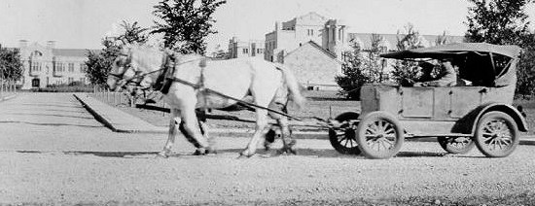
Bennett Buggies: two-wheel, motorless, horse-drawn vehicles
made from dismantled automobiles and used by farmers of
the Prairies during the Depression, when R.B. Bennett was
Prime Minister (1930-35).

The New York stock market crash of October 1929 destroyed fortunes
in the United States, broke banks, and closed factories, mines, shops, and
offices. Canada felt the consequences first in the West, which was
stuck with a 1928 bumper crop of wheat stockpiled in warehouses, $200
million in grain… Wheat dove from $1.60 a bushel to thirty-eight cents.
In 1931 the British pound was almost worthless and the Canadian dollar
fell with it… Unemployed men went from town to town past factories
that were shuttered. They begged food, hunted for scrap in alleys,
and rode west in empty freight cars. Of a population of 10 million, 400,000
were out of work and a million had only part-time jobs. …Hungry and ashamed,
people lined up outside food kitchens.
…The tragedy was compounded by a drought in Saskatchewan and Alberta that turned wheat fields to bone-dry dust. The wailing wind across the desert drove people mad. Dust was everywhere, indoors and out. It clogged nostrils and made food gritty. Saskatchewan, the hardest hit, was abandoned by 66,000 people in the early thirties; one in every four farm families. In some areas, one could travel a day and never see an occupied building. The province went broke and asked Ottawa for help to pay relief. Manitoba lost 24,000 people; Alberta, 21,000. The Maritimes were crushed because the fish was close to worthless.
- June Callwood, Portrait of Canada (pp. 267 – 268)

