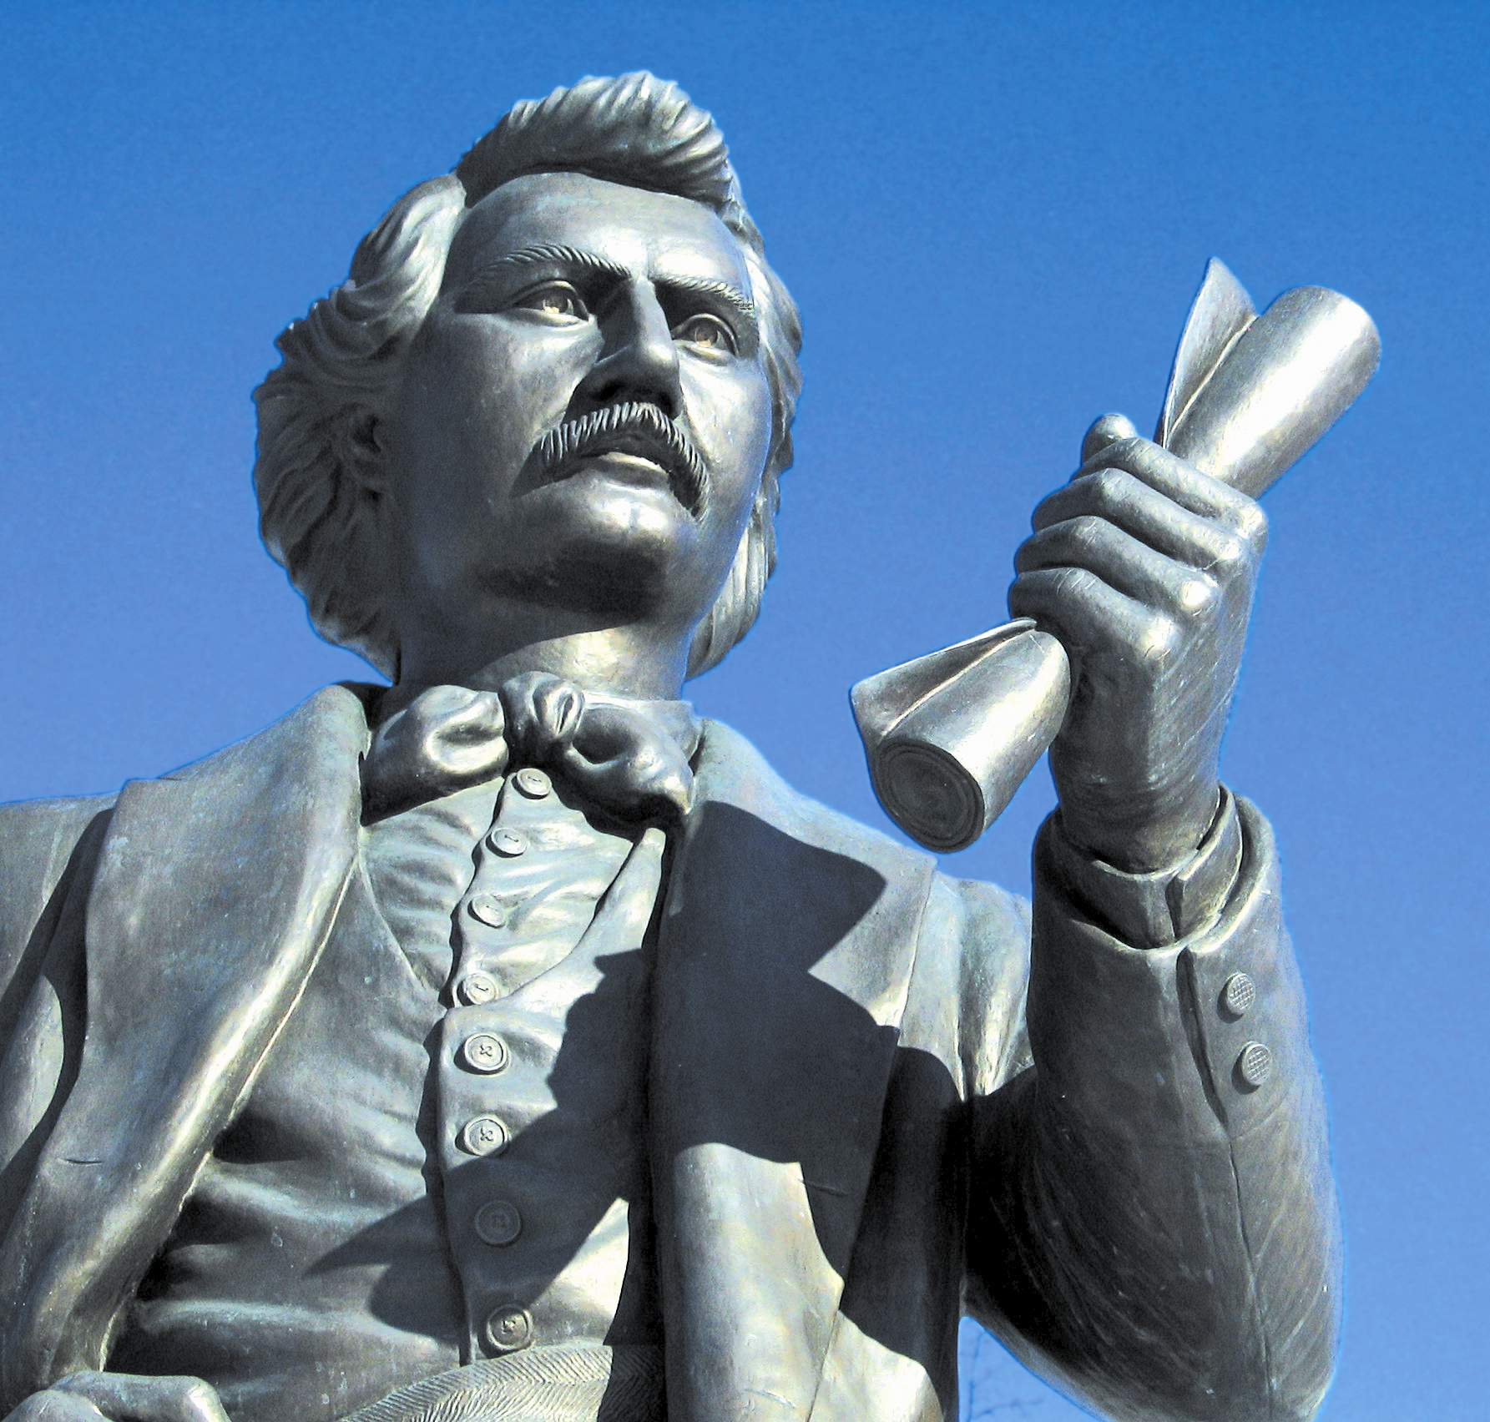
. . .A general amnesty would be a serious reflection
on the loyal people of Red River Settlement who,
throughout this whole affair, have shown a true
spirit of loyalty and devotion to their Sovereign and
to British institutions. Months before Mr. McDougall
left Canada it was announced that he had been
appointed Governor. He had resigned his seat in the
Cabinet, and had addressed his constituents prior
to his departure. The people of the Settlement had
read these announcements, and on the publication of his Proclamation in the Queen's name, with the Royal Arms at its head, they had every reason to consider that the Queen herself called for their services. These services were given cheerfully, they were enrolled in the Queen's name to put down a rising that was a rebellion that was trampling under foot all law and order and preventing British subjects from entering or passing through British territory. For this they were imprisoned for months, for this they were robbed of all they possessed, and for this — the crime of obeying the call of his Sovereign — one true-hearted loyal Canadian was cruelly and foully murdered. An amnesty to the perpetrators of these outrages by our Government we hold to be a serious reflection on the conduct of the loyal inhabitants and a condemnation of their loyalty.
It is an encouragement of rebellion; Riel was guilty of treason when he refused permission to Mr. McDougall, a British subject, to enter British territory, and drove him away by force of arms; he set law at defiance, and committed an open act of rebellion. He also knew that Mr. McDougall had been nominated Governor, knew that he had resigned his seat in the Cabinet, knew that he had bid farewell to his constituents, yet he drove him out by force of arms; and when the Queen's proclamation was issued — for all he knew by the Queen's authority — he tore it up, scattered the type used in printing it, defied it, and imprisoned, robbed and murdered those whose only crime in his eyes was that they had obeyed it. . .

Primary source: Letter against granting amnesty to Riel and the participants in the 1869 – 1870 Resistance, from Dr. J. S. Lynch to Governor-General Sir John Young, July 1, 1870, as cited in: <http://207.61.100.164/candiscover/cantext/western/1870lync.html>.

(page 1 of 2)

In May of 1992, the Legislative Assembly of Manitoba unanimously passed a resolution recognizing “the unique and historic role of Louis Riel as a founder of Manitoba and his contribution in the development of the Canadian Confederation.” A commemorative plaque to this effect has been installed on the grounds of the Manitoba Legislative Building.

Riel might be a hero and a leader to the Métis, but he has no credentials as a hero to all Canadians, and no school should teach his life that way.

Source: J. Granatstein, Who Killed Canadian History? 1998.

When I studied the history of Quebec and Canada, one of the saddest events was undoubtedly the conviction and subsequent execution of Louis Riel. . . .
Louis Riel is a great Canadian, a great patriot, a man who fought for his people and his language in that environment. Louis Riel heard the cry of his people and defended them. We all remember that Louis Riel was born in St. Boniface, on October 22, 1844. He was born in western Canada. His father, Louis Riel, was a Métis, and his mother, Julie de la Gimonière, was the first daughter to be born in a family of white settlers in western Canada. In 1858, he studied at the Montreal seminary, so he knew French very well. Then he went back home. They say he did not have the calling to be a priest, even though he came from a very religious family.
In those days, the federalists, the Ottawa centralists, wanted western Canada to remain a territory, under the control of Ottawa, for as long as possible. People who lived in that region did not agree. Louis Riel founded Manitoba as we all know.
The Ontario Anglo-Protestants wanted to see Louis Riel hang. Louis Riel surrendered in 1885. . . His trial was riddled with irregularities, everybody agrees on that. The trial was held in Regina and the jury was made up of six English speaking jurors.
Had the trial been held in Winnipeg, the outcome would have been different. In Winnipeg the jury would have consisted of six French speaking jurors and six English speaking jurors. At that time Manitoba was already a province.

Source: M. Jean Leroux, Québec M.P., in a debate in the House of Commons regarding An Act to Revoke the Treason of Louis Riel, 22 November 1996, as recorded in Hansard:
<http://collection.nlc-bnc.ca/100/201/301/hansard-e/35-2/114_96-12-05/114PB1E.html>
(page 2 of 2)

